四年级上册英语听力题库
- 听录音，给图片排序。
1.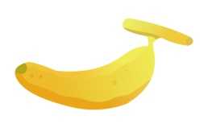2.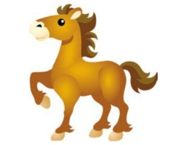3.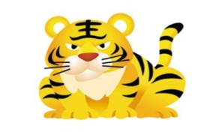4.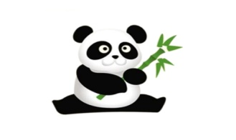5.
( ) ( ) ( ) ( ) ( )
二、听录音，将所听到的单词序号填入题前括号内。
( ) 1. A. fruit B. fat C.friend
( ) 2. A. black B.bag C. book
( ) 3. A. grape B.great C.green
( ) 4. A. make B. monkey C. mango
( ) 5. A. apple B. banana C. orange
三、.听录音，将所听到的句子序号填入题前括号内。
( )1.A. I have two books. B. I have a book.
( ) 2..A.I like pineapples. B. I like apples.
( ) 3..A. Look at my toy elephant. B. Look at our toy elephant.
( ) 4..A. Do you have any grapes? B. Do you have any oranges?
( ) 5..A. Who’s the woman? B. Who’s that woman?
四、听录音，选择合适的应答句。
( ) 1. A. Yes, I do. B. Yes, please.
( ) 2. A. No, I don’t. B. Yes ,it is.
( ) 3. A. No, thanks. B. I have two.
( ) 4. A. Yes, I do. B. Yes, I am.
( ) 5. A. It’s cute. B. They’re cute.
五、听录音，判断所听内容是否与图片相符。相符的写“T”，不符的写“F”。 听两遍
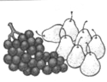
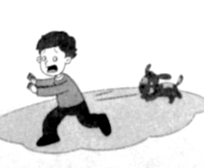
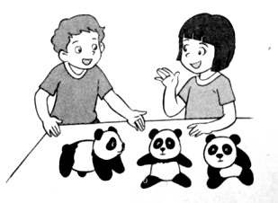
1. 2. 3.

（ ） （ ） （ ）
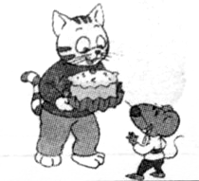
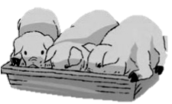

4. 5. 6.

（ ） （ ） （ ）
六、根据所给情境，判断正误，正确写“T”，错误写“F”。
1. 你不确定对方是否有一个机器人，你会问：（ ）
2. 你想知道远处的那些东西是什么，你会问：（ ）
3. 你想知道这个女孩是谁，你会问：（ ）
4. 别人问你是否想要一个馅饼，你会回答：（ ）
5. 你想告诉别人你不喜欢狮子，你会说：（ ）

四年级上册英语听力材料

一、听录音，给图片排序。 听两遍
1. tiger tiger
2. banana banana
3. pineapple pineapple
4. horse horse
5. panda panda
二、听录音，将所听到的单词序号填入题前括号内。 听两遍
1. fruit fruit
2. bag bag
3. great great
4. mango mango
5. banana banana
三、听录音，将所听到的句子序号填入题前括号内。 听两遍
1. I have two books. I have two books.
2. I like apples. I like apples.
3. Look at our toy elephant. Look at our toy elephant.
4. Do you have any grapes? Do you have any grapes?
5. Who’s that woman? Who’s that woman?
四、听录音，选择合适的应答句。 听两遍
1. Do you like tigers? Do you like tigers?
2. Do you have a mango? Do you have a mango?
3. How many grapes do you have?
How many grapes do you have?
4. Are you Mike? Are you Mike?
5. Look at these toy animals. Look at these toy animals.
五、听录音，判断所听内容是否与图片相符，相符打√，不符打×。听两遍
1.What are these? They are apples and grapes.
2.–Do you like dogs? –No, I don’t.
3.–Are they monkeys? -- No, they’re pandas.
4.– Would you like a pie, Bobby? – Yes, please.
5.– What time is it? – It’s six o’clock. It’s time for lunch.
6.– Look at my pigs. –How cute. How many pigs do you have?
– I have three.
六、根据所给情境，判断正误，正确写“T”，错误写“F”。 听两遍
1. Do you like robots?
2. What’s that?
3. Who’s this woman?
4. Yes, I do.
5. I don’t like lions.

