PEP小学四年级上学期英语期中精品试题
听力部分（50分）
听音，选择你所听到的单词。10分
1、（ ）A classroom B classmate C computer
2、（ ）A twenty B thirty C twelve
3、( ) A thin B strong C thirteen
4、（ ）A science B sports C short hair
5、（ ）A math book B notebook C schoolbag
二、听录音，用数字标出图片的序号。12分

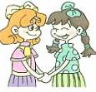

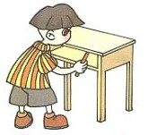
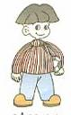
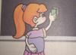
（ ） （ ） （ ） （ ） （ ） （ ）
听录音，圈出正确的答案。12分
1. A B 2. A B 3. A B
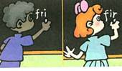
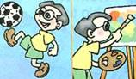
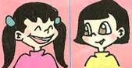

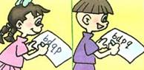
4、A B 5、A B 6. A B
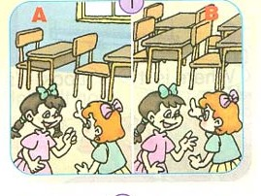
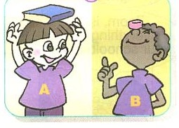

四、听音。判断图片内容是否与录音内容相符，相符的打“√”，不符的打“╳”。（１０分）
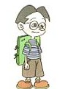
1. ( ) 2. ( ) 3. ( ) 4.（ ） 5.（ ）
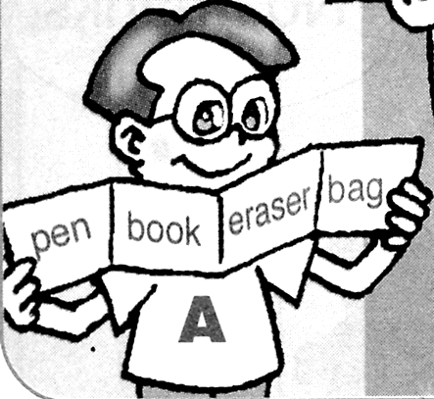
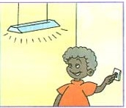
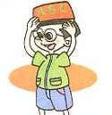
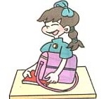

听音，选择你所听到的问题的答语.6分。
1.（ ）A It’s near the window. B It’s so big.
2.（ ）A His name is Mike. B My name is Zhang Peng.
3.（ ）A. I can see 42. B I have 42
4.（ ）A It’s a panda. B It’s black and yellow.
5.（ ）A A board, two lights. B 3pencils, 2 books
6. ( ) A. Her name is Amy. B. His name is Mike.
笔试部分（50分）
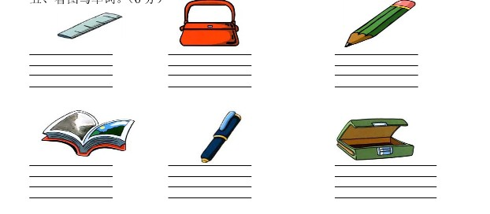
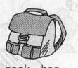
根据图画写出下列单词，注意正确占格。8分。


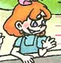

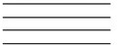
二、把下列句子按顺序排列成对话。12分
( ) It’s pink. Look!
( ) Really? What color is it?
( ) What are they for?
( ) Wow! How nice!
( 1 ) Hi, Amy. I have a new schoolbag.
( ) It’s heavy. There are many new books in it.
( ) For Hope School .
三、请为每一位孩子的照片配上合适的介绍。12分。
( ) （ ） （ ）
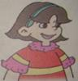
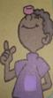
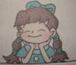

（ ） （ ） （ ）
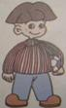
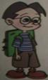
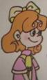

1. She has short hair, big eyes and a big mouth. She is cute.
2. She has long hair, small eyes and a small nose. She is very quiet.
3. She has short hair. She is thin. She has big eyes. She is very nice.
4. He is strong. He has short hair and big eyes. He likes sports.
5. He is tall and thin. He is very funny. He is black.
6. He is thin. He has a pair of glasses(眼镜). He likes painting.
四、配对，将问题的答语写在提前的括号内。（14分）
( )1.What colour is it? A. 20 pencils and many books.
( )2.What is in your bag? B. His name is Mike.
( )3.Let’s clean the window. C. Her name is Amy.
( )4. May I have a look? D. It’s near the door.
（ ）5.Where is my seat? E It’s black and white.
（ ）6.What is his name? F. Good idea.
( ) 7.What is her name? G. Sure, here you are.
五、阅读短文内容，对的在前面的括号内打“√”，不对的打“×”。4分。
We have a new computer room. It is on the second floor（二楼）. This way, please. Look, two fans and eight lights are in it. And there are so many computers in it. How many computers ? There are 45. They’re so cool. This is a picture and that is a map. The floor is green. The wall is white. I like our computer room .
（ ）1.Our computer room is on the first floor.
（ ）2.There are eight lights in it .
（ ）3. The floor is green .
（ ）4.We have 44 classmates .

