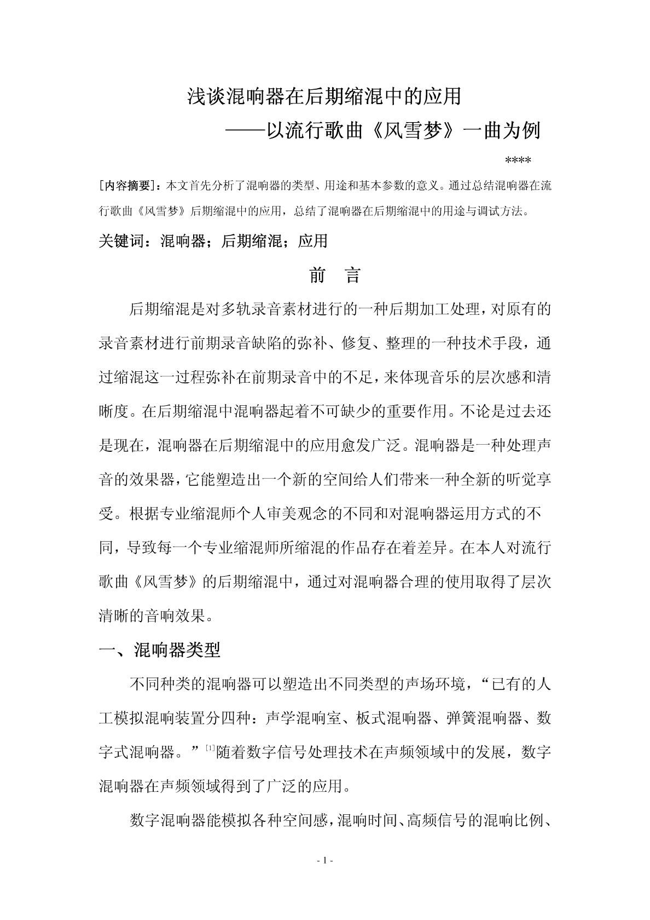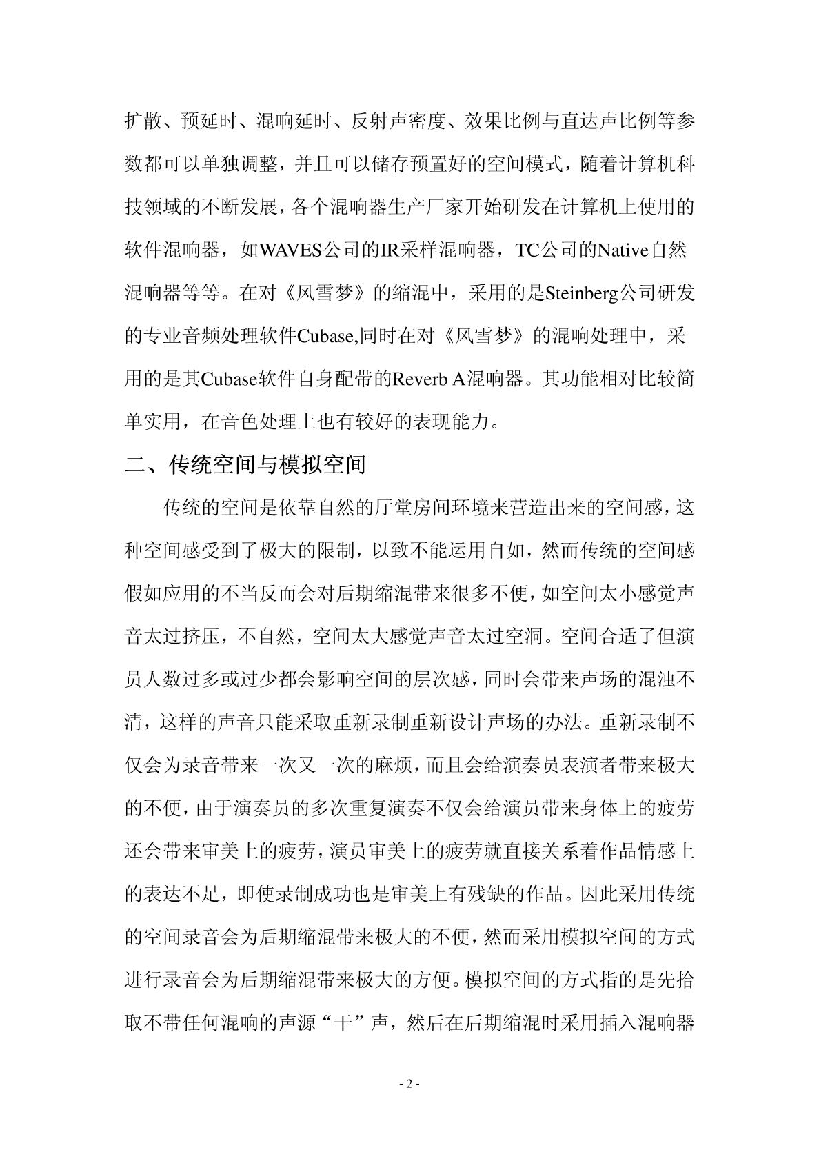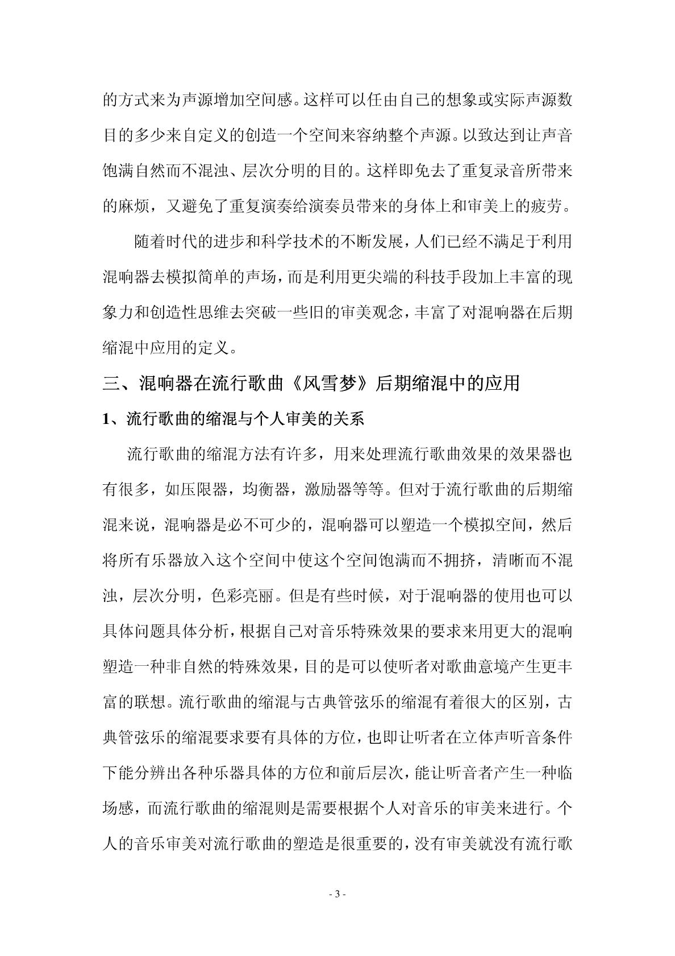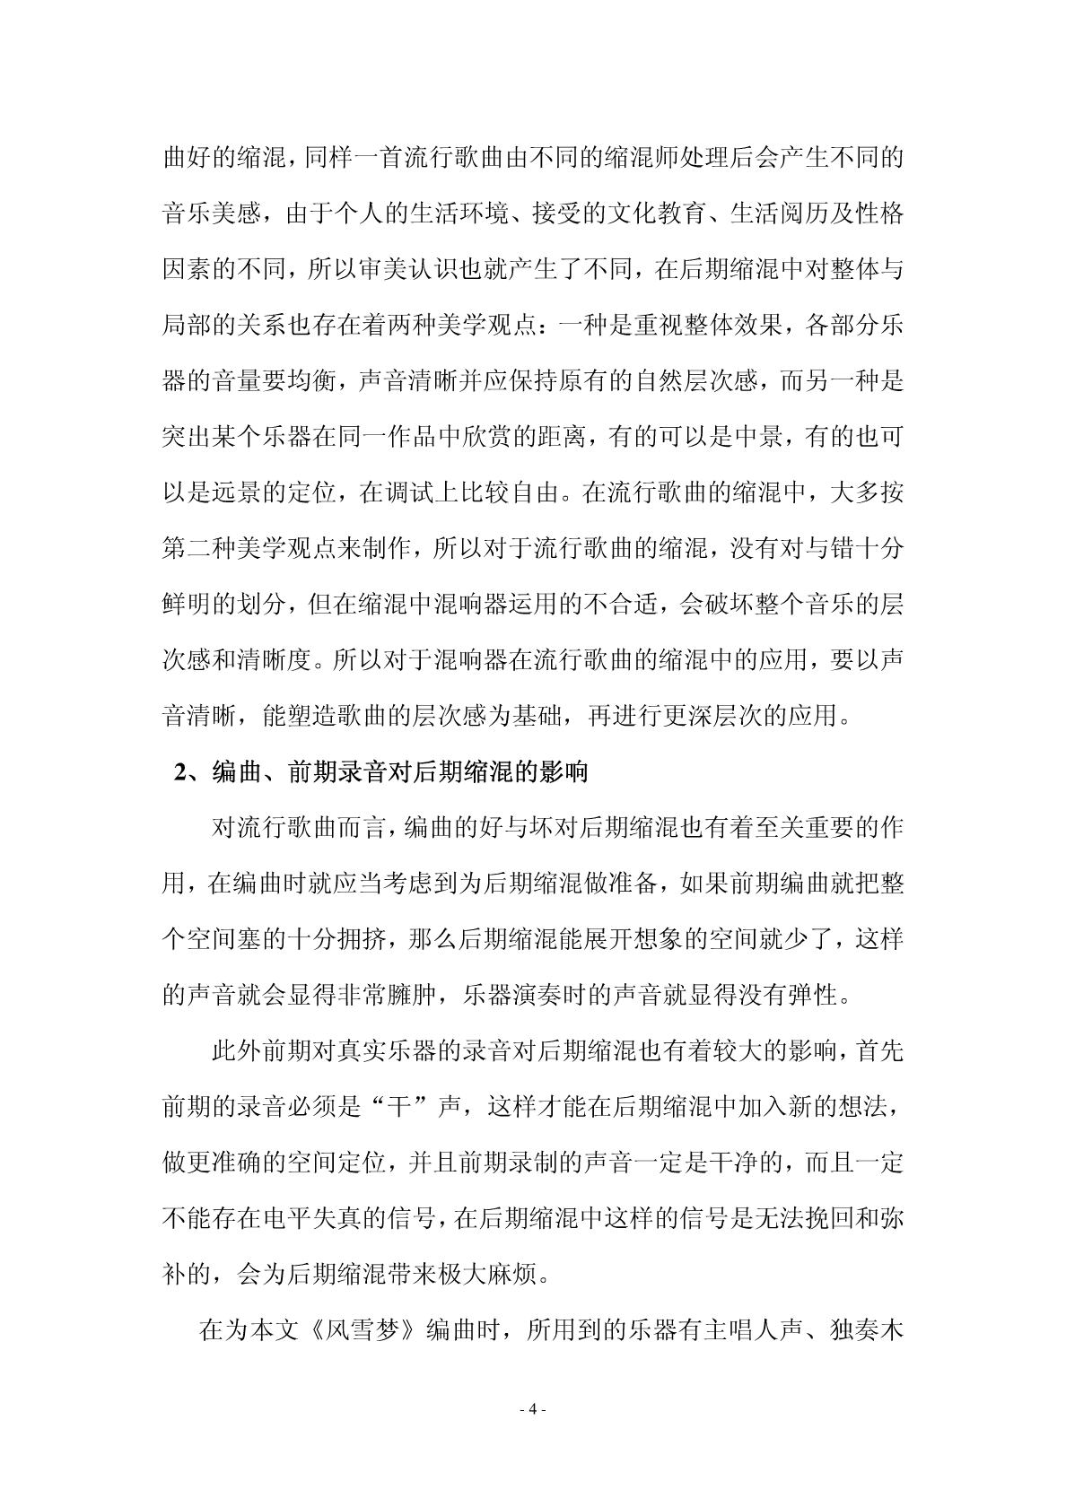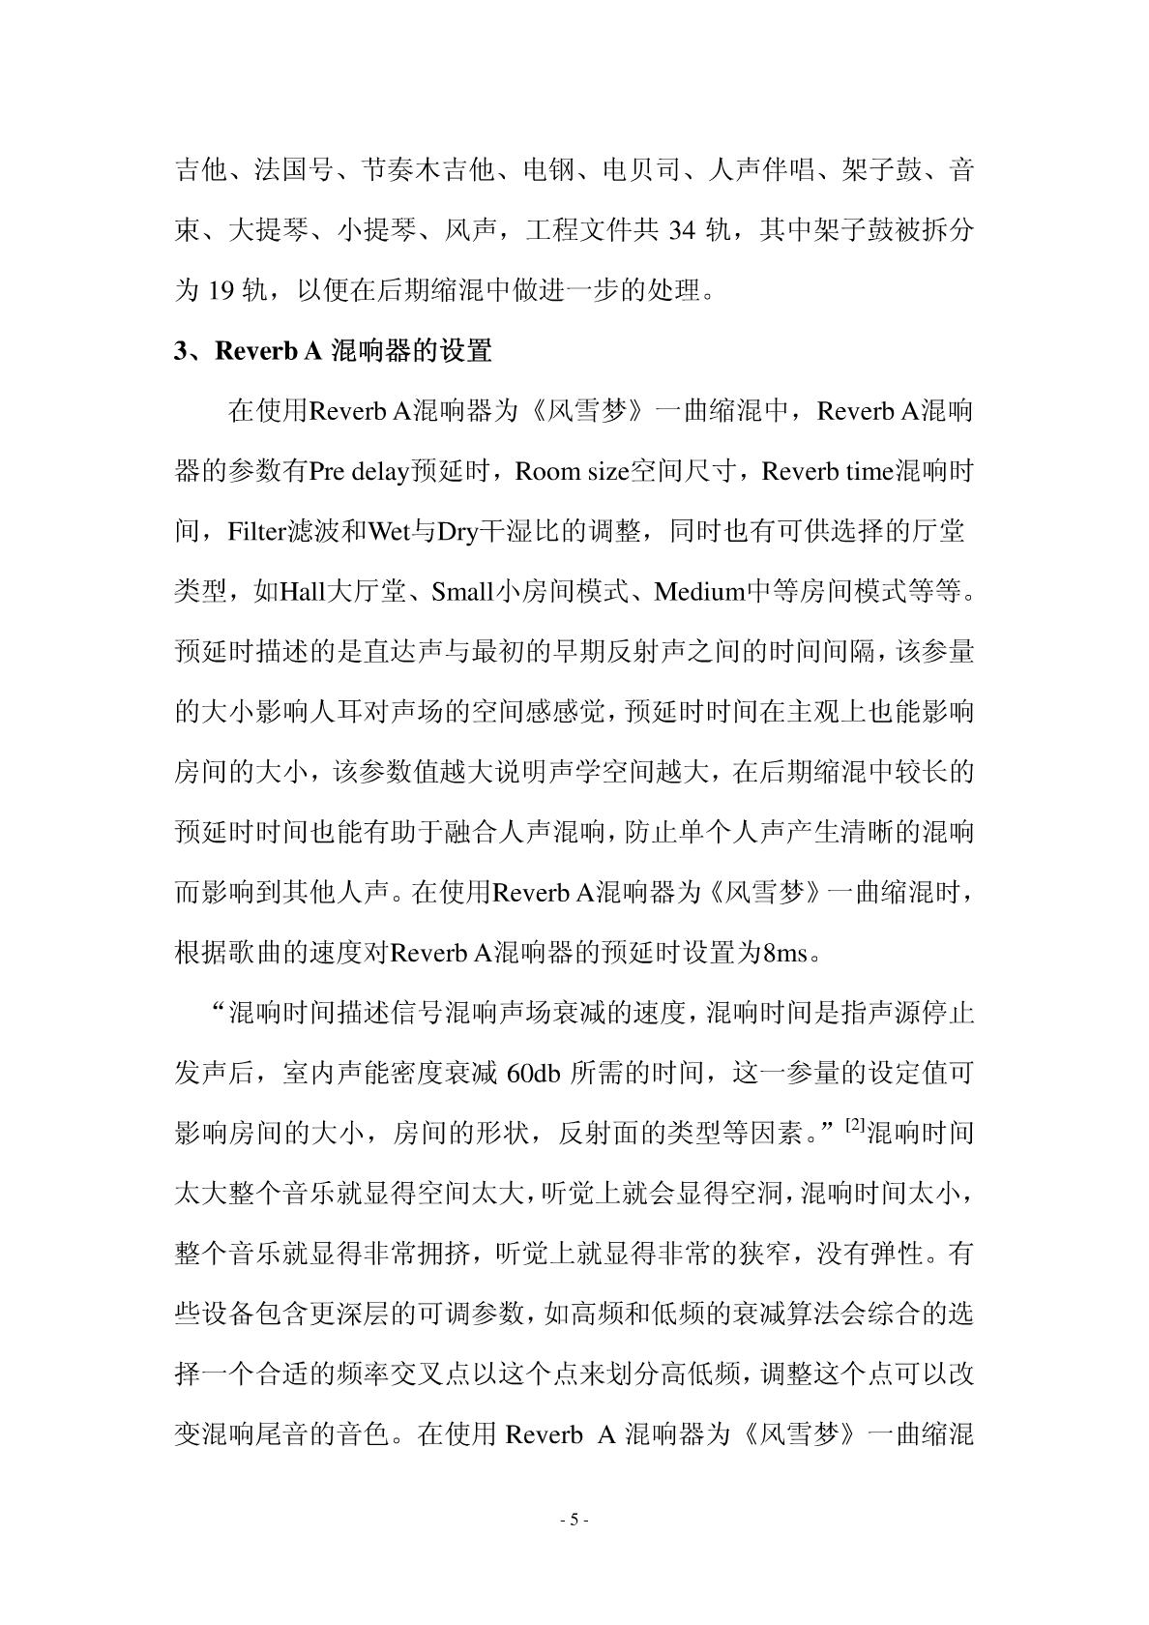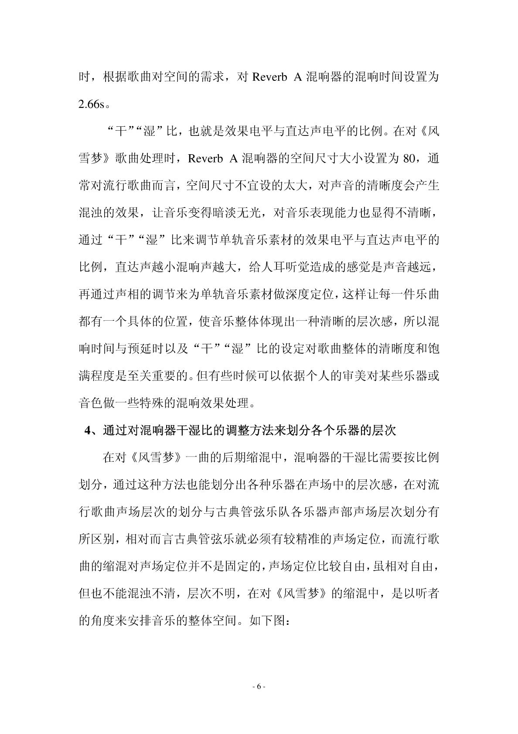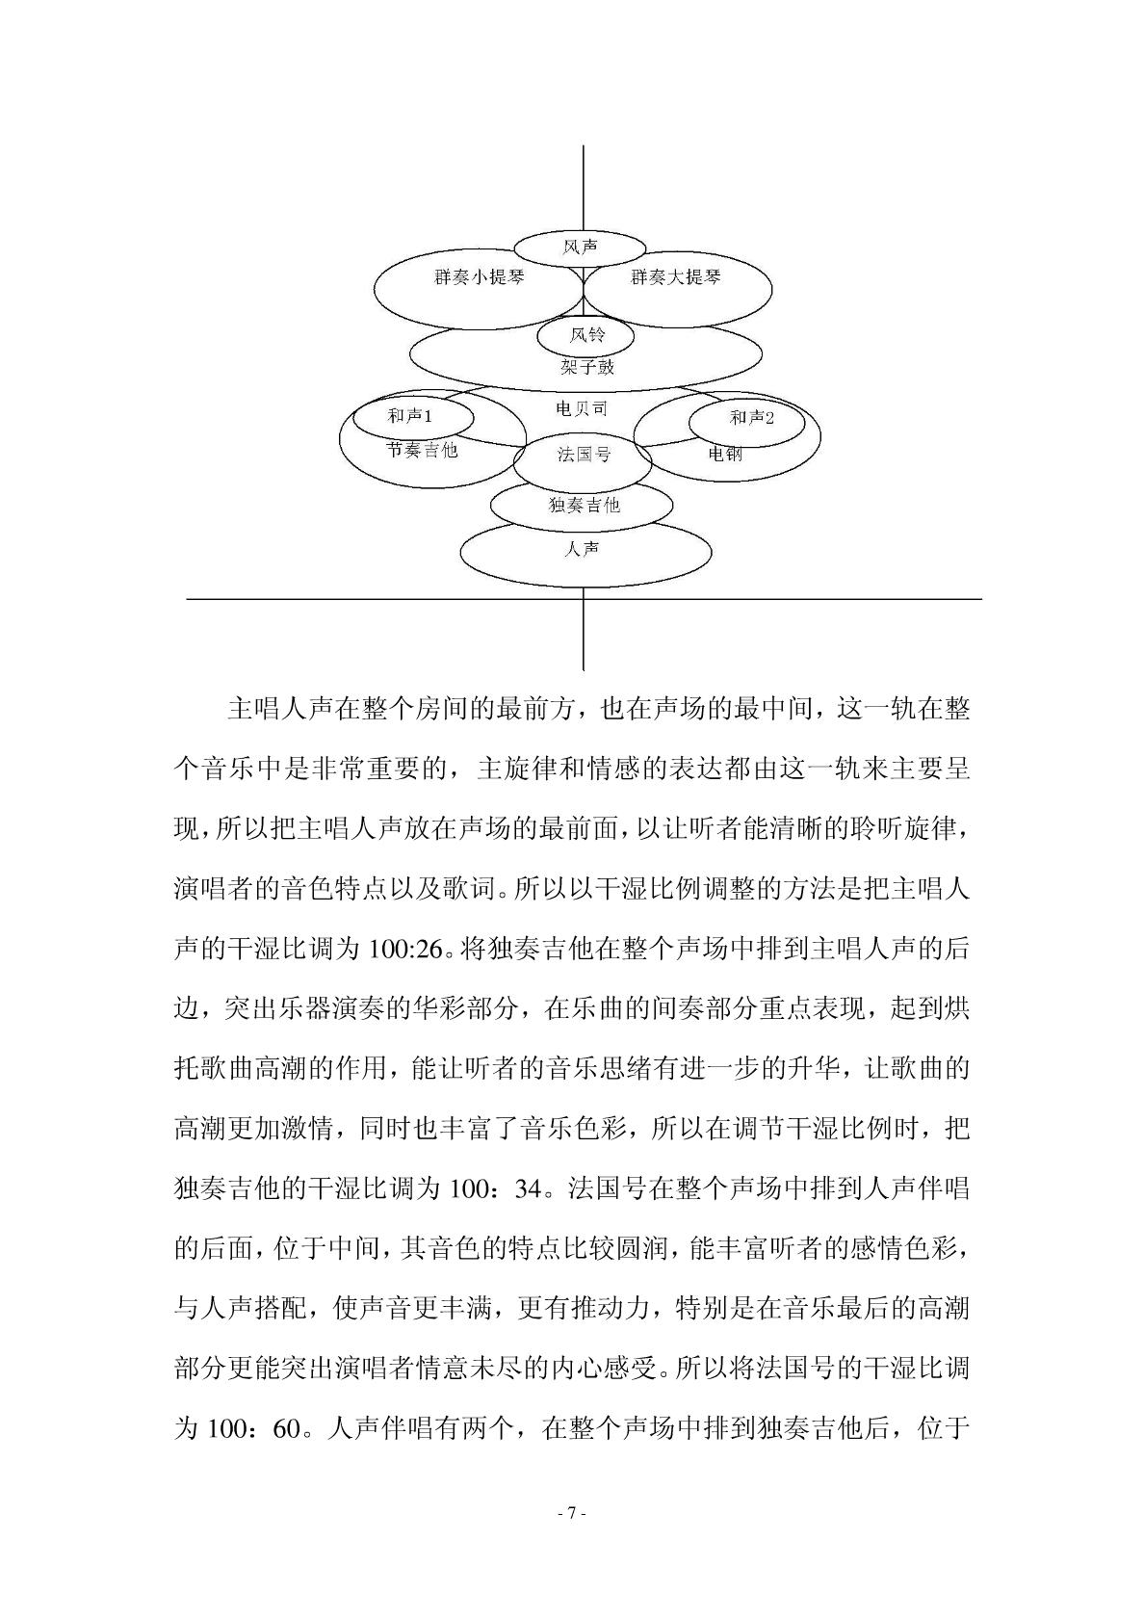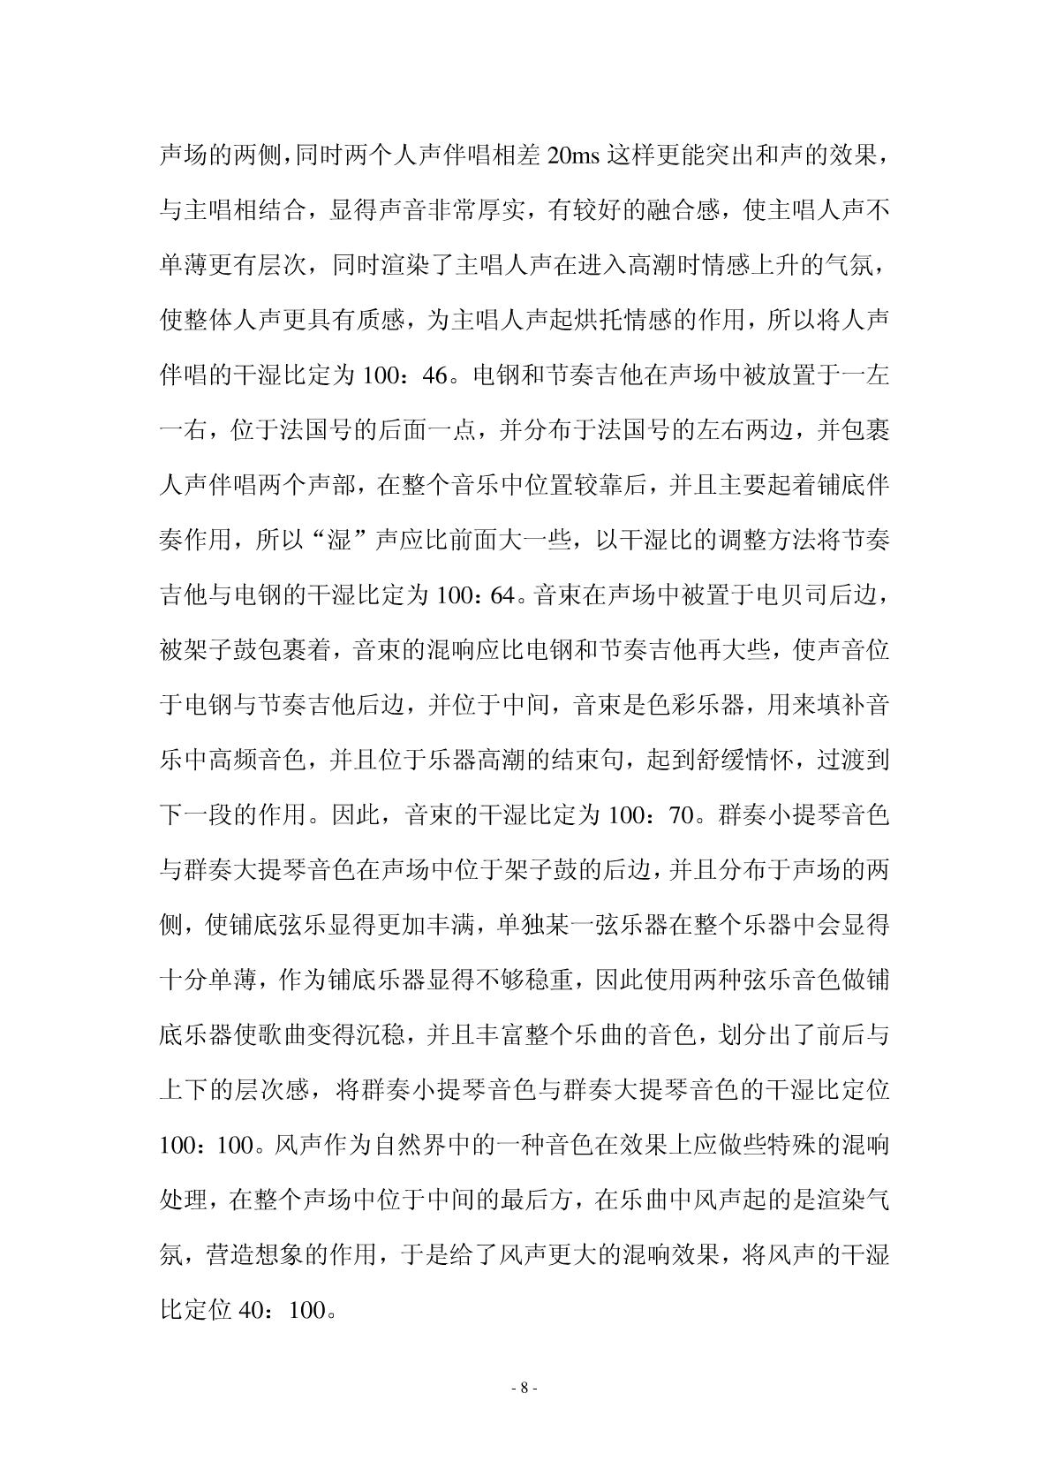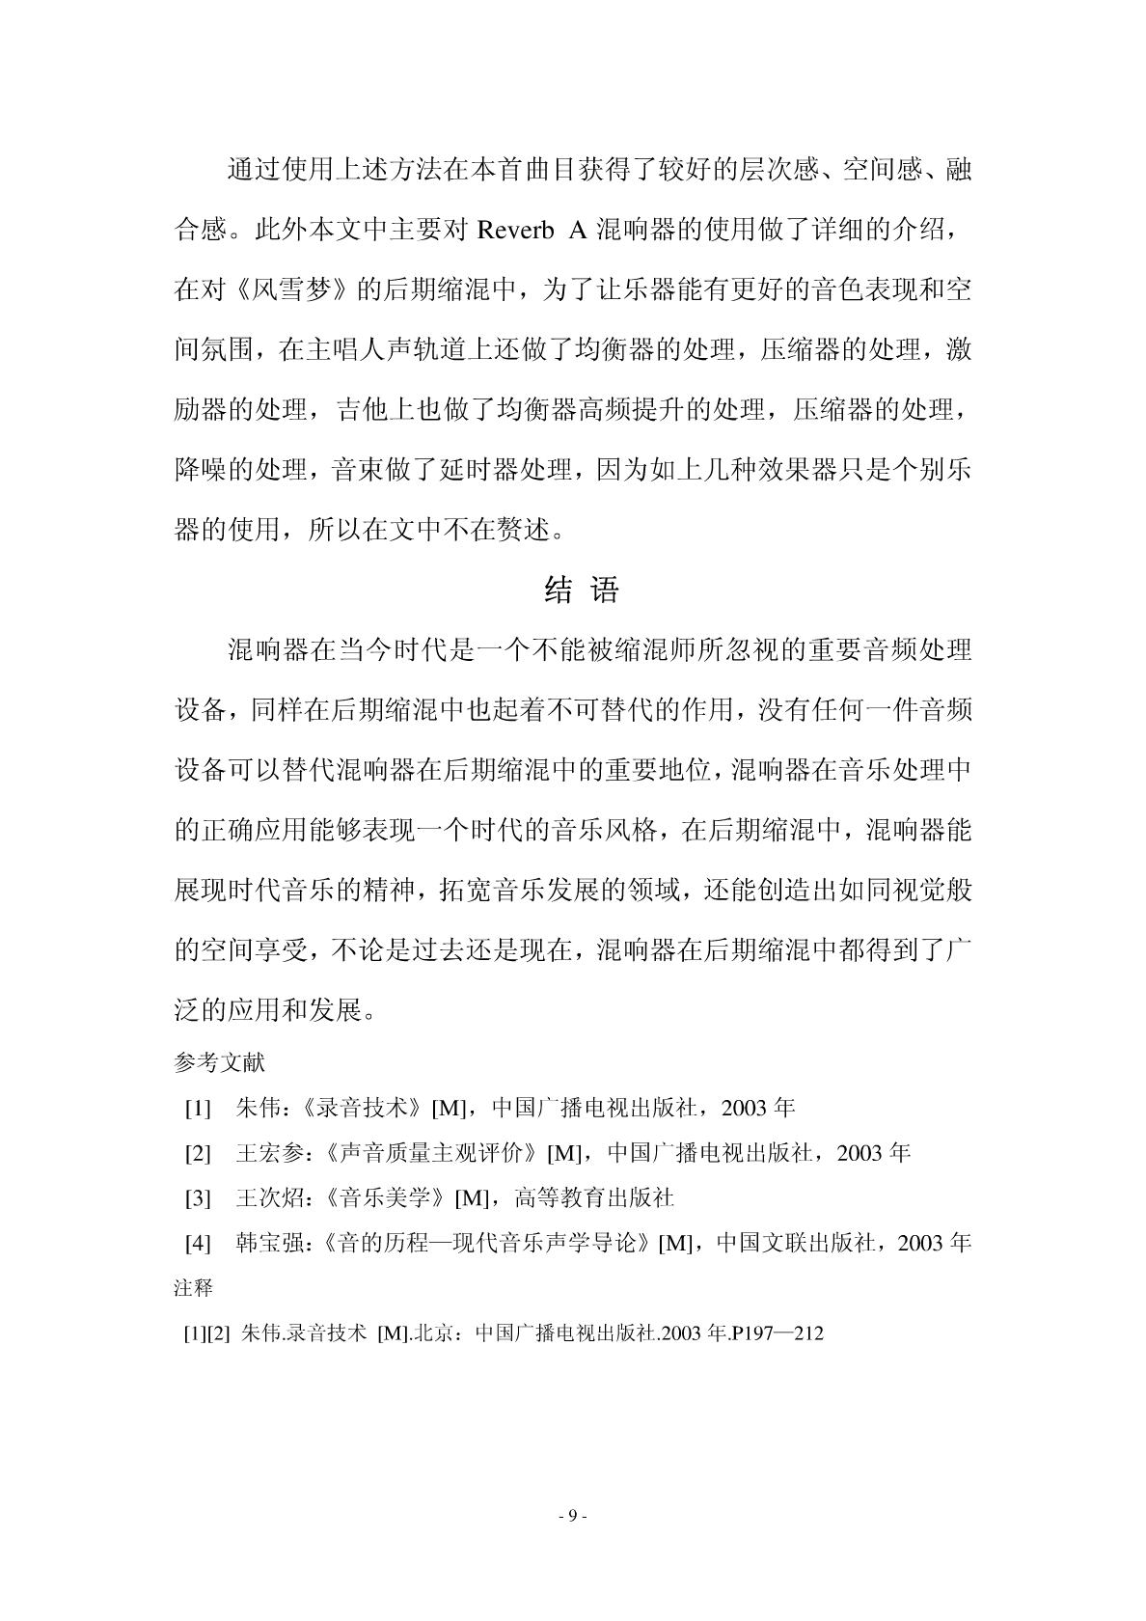
9JWKffwvG#tYM*Jg&6a*CZ7H$dq8KqqfHVZFedswSyXTy#&QA9wkxFyeQ^!djs#XuyUP2kNXpRWXmA&UE9aQ@Gn8xp$R#&#849Gx^Gjqv^E9wEwZ#Qc@UE%&qYp@Eh5pDx2zVkum&gTXRm6X4NGpP$vSTT#&ksv*3tnGz89AmYWpazadNu##KN&MuWFA5uxY7JnD6YWRrWwc^vR9CpbK!zn%Mz849Gx^Gjqv^$UE9wEwZ#Qc@UE%&qYp@Eh5pDx2zVkum&gTXRm6X4NGpP$vSTT#&ksv*3tnGK8!z89AmYWpazadNu##KN&MuWFA5ux^Gjqv^$UE9wEwZ#Qc@UE%&qYp@Eh5pDx2zVkum&gTXRm6X4NGpP$vSTT#&ksv*3tnGK8!z89AmYWpazadNu##KN&MuWFA5uxY7JnD6YWRrWwc^vR9CpbK!zn%Mz849Gx^Gjqv^$UE9wEwZ#Qc@UE%&qYp@Eh5pDx2zVkum&gTXRm6X4NGpP$vSTT#&ksv*3tnGK8!z89AmUE9aQ@Gn8xp$R#&#849Gx^Gjqv^$UE9wEwZ#Qc@UE%&qYp@Eh5pDx2zVkum&gTXRm6X4NGpP$vSTT#&ksv*3tnGK8!z89AmYWpazadNu##KN&MuWFA5uxY7JnD6YWRrWwc^vR9CpbK!zn%Mz849Gx^Gjqv^$UE9wEwZ#Qc@UE%&qYp@Eh5pDx2zVkum&gTXRm6X4NGpP$vSTT#&ksv*3tnGK8!z89AmYWpazadNu##KN&MuWFA5ux^Gjqv^$UE9wEwZ#Qc@UE%&qYp@Eh5pDx2zVkum&gTXRm6X4NGpP$vSTT#&ksv*3tnGK8!z89AmYWpazadNu##KN&MuWFA5uxY7JnD6YWRrWwc^vR9CpbK!zn%Mz849Gx^Gjqv^$UE9wEwZ#Qc@UE%&qYp@Eh5pDx2zVkum&gTXRm6X4NGpP$vSTT#&ksv*3tnGK8!z8vG#tYM*Jg&6a*CZ7H$dq8KqqfHVZFedswSyXTy#&QA9wkxFyeQ^!djs#XuyUP2kNXpRWXmA&UE9aQ@Gn8xp$R#&#849Gx^Gjqv^$UE9wEwZ#Qc@UE%&qYp@Eh5pDx2zVkum&gTXRm6X4NGpP$vSTT#&ksv*3tnGK8!z89AmYWpazadNu##KN&MuWFA5uxY7JnD6YWRrWwc^vR9CpbK!zn%Mz849Gx^G89AmUE9aQ@Gn8xp$R#&#849Gx^Gjqv^$UE9wEwZ#Qc@UE%&qYp@Eh5pDx2zVkum&gTXRm6X4NGpP$vSTT#&ksv*3tnGK8!z89AmYWpazadNu##KN&MuWFA5uxY7JnD6YWRrWwc^vR9CpbK!zn%Mz849Gx^Gjqv^$UE9wEwZ#Qc@UE%&qYp@Eh5pDx2zVkum&gTXRm6X4NGpP$vSTT#&ksv*3tnGK8!z89AmYWpazadNu##KN&MuWFA5ux^Gjqv^$UE9wEwZ#Qc@UE%&qYp@Eh5pDx2zVkum&gTXRm6X4NGpP$vSTT#&ksv*3tnGK8!z89AmYWpazadNu##KN&MuWFA5uxY7JnD6YWRrWwc^vR9CpbK!zn%Mz849Gx^Gjqv^$UE9wEwZ#Qc@UE%&qYp@Eh5pDx2zVkum&gTXRm6X4NGpP$vSTT#&ksv*3tnGK8!z8vG#tYM*Jg&6a*CZ7H$dq8KqqfHVZFedswSyXTy#&QA9wkxFyeQ^!djs#XuyUP2kNXpRWXmA&UE9aQ@Gn8xp$R#&#849Gx^Gjqv^$UE9wEwZ#Qc@UE%&qYp@Eh5pDx2zVkum&gTXRm6X4NGpP$vSTT#&ksv*3tnGK8!z89AmYWpazadNu##KN&MuWFA5uxY7JnD6YWRrWwc^vR9CpbK!zn%Mz849Gx^Gjqv^$UE9wEwZ#Qc@UE%&qYp@Eh5pDx2zVkum&gTXRm6X4NGpP$vSTT#&ksv*3tnGK8!z89AmYWpazadNu##KN&MuWFA5ux^Gjqv^$UE9wEwZ#Qc@UE%&qYp@Eh5pDx2zVkum&gTXRm6X4NGpP$vSTT#&ksv*3tnGK8!z89AmYWpazadNu##KN&MuWFA5uxY7JnD6YWRrWwc^vR9CpbK!zn%Mz849Gx^Gjqv^$UE9wEwZ#Qc@UE%&qYp@Eh5pDx2zVkum&gTXRm6X4NGpP$vSTT#&ksv*3tnGK8!z89AmUE9aQ@Gn8xp$R#&#849Gx^Gjqv^$UE9wEwZ#Qc@UE%&qYp@Eh5pDx2zVkum&gTXRm6X4NGpP$vSTT#&ksv*3tnGK8!z89AmYWpazadNu##KN&MuWFA5uxY7JnD6YWRrWwc^vR9CpbK!zn%Mz849Gx^Gjqv^$UE9wEwZ#Qc@UE%&qYp@Eh5pDx2zVkum&gTXRm6X4NGpP$vSTT#&ksv*3tnGK8!z89AmYWpazadNu##KN&MuWFA5ux^Gjqv^$UE9wEwZ#Qc@UE%&qYp@Eh5pDx2zVkum&gTXRm6X4NGpP$vSTT#&ksv*3tnGK8!z89AmYWpazadNu##KN&MuWFA5uxY7JnD6YWRrWwc^vR9CpbK!zn%Mz849Gx^Gjqv^$UE9wEwZ#Qc@UE%&qYp@Eh5pDx2zVkum&gTXRm6X4NGpP$vSTT#&ksv*3tnGK8!z89AmYWv*3tnGK8!z89AmYWpazadNu##KN&MuWFA5uxY7JnD6YWRrWwc^vR9CpbK!zn%Mz849Gx^Gjqv^$UE9wEwZ#Qc@UE%&qYp@Eh5pDx2zVkum&gTXRm6X4NGpP$vSTT#&ksv*3tnGK8!z89AmYWpazadNuGK8!z89AmYWpazadNu##KN&MuWFA5uxY7JnD6YWRrWwc^vR9CpbK!zn%Mz849Gx^Gjqv^$UE9wEwZ#Qc@UE%&qYp@Eh5pDx2zVkum&gTXRm6X4NGpP$vSTT#&ksv*3tnGK8!z89AmYWpazadNu##KN&MuWFA5ux^Gjqv^$UE9wEwZ#Qc@UE%&qYp@Eh5pDx2zVkum&gTXRm6X4NGpP$vSTT#&ksv*3tnGK8!z89AmYWpazadNu##KN&MuWFA5uxY7JnD6YWRrWwc^vR9CpbK!zn%Mz849Gx^Gjqv^$UE9wEwZ#Qc@UE%&qYp@Eh5pDx2zVkum&gTX6X4NGpP$vSTT#&ksv*3tnGK8!z89AmYWv*3tnGK8!z89AmYWpazadNu##KN&MuWFA5uxY7JnD6YWRrWwc^vR9CpbK!zn%Mz849Gx^Gjqv^$U*3tnGK8!z89AmYWpazadNu##KN&MuWFA5uxY7JnD6YWRrWwc^vR9CpbK!zn%Mz849Gx^Gjqv^$UE9wEwZ#Qc@UE%&qYp@Eh5pDx2zVkum&gTXRm6X4NGpP$vSTT#&ksv*3tnGK8!z89Amv^$UE9wEwZ#Qc@UE%&qYp@Eh5pDx2zVkum&gTXRm6X4NGpP$vSTT#&ksv*3tnGK8!z89AmYWpazadNu##KN&MuWFA5ux^Gjqv^$UE9wEwZ#Qc@UE%&qYp@Eh5pDx2zVkum&gTXRm6X4NGpP$vSTT#&ksv*3tnGK8!z89AmYWpazadNu##KN&MuWFA5uxY7JnD6YWRrWwc^vR9CpbK!zn%Mz849Gx^Gjqv^$UE9wEwZ#Qc@UE%&qYp@Eh5pDx2zVkum&gTXRm6X4NGpP$vSTT#&ksv*3tnGK8!z89AmYWv*3tnGK8!z89AmYWpazadNu##KN&MuWFA5uxY7JnD6YWRrWwc^vR9CpbK!zn%Mz849Gx^Gjqv^$U*3tnGK8!z89AmYWpazadNu##KN&MuWFA5uxY7JnD6YWRrWwc^vR9CpbK!zn%Mz84!z89Amv^$UE9wEwZ#Qc@UE%&qYp@Eh5pDx2zVkum&gTXRm6X4NGpP$vSTT#&ksv*3tnGK8!z89AmYWpazadNu##KN&MuWFA5ux^Gjqv^$UE9wEwZ#Qc@UE%&qYp@Eh5pDx2zVkum&gTXRm6X4NGpP$vSTT#&ksv*3tnGK8!z89AmYWpazadNu##KN&MuWFA5uxY7JnD6YWRrWwc^vR9CpbK!zn%Mz849Gx^Gjqv^$UE9wEwZ#Qc@UE%&qYp@Eh5pDx2zVkum&gTXRm6X4NGpP$vSTT#&ksv*3tnGK8!z89AmYWv*3tnGK8!z89AmYWpazadNu##KN&MuWFA5uxY7JnD6YWRrWwc^vR9CpbK!zn%Mz849Gx^Gjqv^$U*3tnGK8!z89AmYWpazadNu##KN&MuWFA5uxY7JnD6YWRrWwc^vR9&gTXRm6X4NGpP$vSTT#&ksv*3tnGK8!z89AmYWpazadNu##KN&MuWFA5uxY7JnD6YWRrWwc^vR9CpbK!zn%Mz849Gx^Gjqv^$UE9wEwZ#Qc@UE%&qYp@Eh5pDx2zVkum&gTXRm6X4NGpP$vSTT#&ksv*3tnGK8!z89AmYWv*3tnGK8!z89AmYWpazadNu##KN&MuWFA5uxY7JnD6YWRrWwc^vR9CpbK!zn%Mz849Gx^Gjqv^$U*3tnGK8!z89AmYWpazadNu##KN&MuWFA5uxY7JnD6YWRrWwc^vR9CpbK!zn%Mz849Gx^Gjqv^$UE9wEwZ#Qc@UE%&qYp@Eh5pDx2zVkum&gTXRm6X4NGpP$vSTT#&ksv*3tnGK8!z89AmYWpazadNuGK8!z89AmYWpazadNu##KN&MuWFA5uxY7JnD6YWRrWwc^vR9CpbK!zn%Mz849Gx^Gjqv^$UE9wEwZ#Qc@UE%&qYp@Eh5pDx2zVkum&gTXRm6X4NGpP$vSTT#&ksv*3tnGK8!z89AmYWpazadNu##KN&MuWFA5ux^Gjqv^$UE9wEwZ#Qc@UE%&qYp@Eh5pDx2zVkum&gTXRm6X4NGpP$vSTT#&ksv*3tnGK8!z89AmYWpazadNu##KN&MuWFA5uxY7JnD6YWRrWwc^vR9CpbK!zn%Mz849Gx^Gjqv^$UE9wEwZ#Qc@UE%&qYp@Eh5pDx2zVkum&gTXRm6X4NGpP$vSTT#&ksv*3tnGK8!z89AmYWv*3tnGK8!z89AmYWpazadNu##KN&MuWFA5uxY7JnD6YWRrWwc^vR9CpbK!zn%Mz849Gx^Gjqv^$UE9wEwZ#Qc@UE%&qYp@Eh5pDx2zVkum&gTXRm6X4NGpP$vSTT#&ksv*3tnGK8!z89AmYWpazadNu##KN&MuWFA5ux^Gjqv^$UE9wEwZ#Qc@UE%&qYp@Eh5pDx2zVkum&gTXRm6X4NGpP$vSTT#&ksv*3tnGK8!z89AmYWpazadNu##KN&MuWFA5uxY7JnD6YWRrWwc^vR9CpbK!zn%Mz849Gx^GjqvadNu##KN&MuWFA5uxY7JnD6YWRrWwc^vR9CpbK!zn%Mz849Gx^Gjqv^$UE9wEwZ#Qc@UE%&qYp@Eh5pDx2zVkum&gTXRm6X4NGpP$vSTT#&ksv*3tnGK8!z89AmYWpazadNu##KN&MuWFA5ux^Gjqv^$UE9wEwZ#Qc@UE%&qYp@Eh5pDx2zVkum&gTXRm6X4NGpP$vSTT#&ksv*3tnGK8!z89AmYWpazadNu##KN&MuWFA5uxY7JnD6YWRrWwc^vR9CpbK!zn%Mz849Gx^Gjqv^$UE9wEwZ#Qc@UE%&qYp@Eh5pDx2zVkum&gTXRm6X4NGpP$vSTT#&ksv*3tnGK8!z89AmYWv*3tnGK8!z89AmYWpazadNu##KN&MuWFA5uxY7JnD6YWRrWwc^vR9CpbK!zn%Mz849Gx^Gjqv^$U*3tnGK8!z89AmYWpazadNu##KN&MuWFA5uxY7JnD6YWRrWwc^vR9CpbK!zn%Mz849Gx^Gjqv^$UE9wEwZ#Qc@UE%&qYp@Eh5pDx2zVkum&gTXRm6X4NGpP$vSTT#&ksv*3tnGK8!z89Amv^$UE9wEwZ#Qc@UE%&qYp@Eh5pDx2zVkum&gTXRm6X4NGpP$vSTT#&ksv*3tnGK8!z89AmYWpazadNu##KN&MuWFA5ux^Gjqv^$UE9wEwZ#Qc@UE%&qYp@Eh5pDx2zVkum&gTXRm6X4NGpP$vSTT#&ksv*3tnGK8!z89AmYWpazadNu##KN&MuWFA5uxY7JnD6YWRrWwc^vR9CpbK!zn%Mz849Gx^Gjqv^$UE9wEwZ#Qc@UE%&qYp@Eh5pDx2zVkum&gTXRm6X4NGpP$vSTT#&ksv*3tnGK8!z89AmYWv*3tnGK8!z89AmYWpazadNu##KN&MuWFA5uxY7JnD6YWRrWwc^vR9CpbK!zn%Mz849Gx^Gjqv^$U*3tnGK8!z89AmYWpazadNu##KN&MuWFA5uxY7JnD6YWRrWwc^vR9CpbK!zn%Mz84!z89Amv^$UE9wEwZ#Qc@UE%&qYp@Eh5pDx2zVkum&gTXRm6X4NGpP$vSTT#&ksv*3tnGK8!z89AmYWpazadNu##KN&MuWFA5ux^Gjqv^$UE9wEwZ#Qc@UE%&qYp@Eh5pDx2zVkum&gTXRm6X4NGpP$vSTT#&ksv*3tnGK8!z89AmYWpazadNu##KN&MuWFA5uxY7JnD6YWRrWwc^vR9CpbK!zn%Mz849Gx^Gjqv^$UE9wEwZ#Qc@UE%&qYp@Eh5pDx2zVkum&gTXRm6X4NGpP$vSTT#&ksv*3tnGK8!z89AmYWv*3tnGK8!z89AmYWpazadNu##KN&MuWFA5uxY7JnD6YWRrWwc^vR9CpbK!zn%Mz849Gx^Gjqv^$U*3tnGK8!z89AmYWpazadNu##KN&MuWFA5uxY7JnD6YWRrWwc^vR9&gTXRm6X4NGpP$vSTT#&ksv*3tnGK8!z89AmYWpazadNu##KN&MuWFA5uxY7JnD6YWRrWwc^vR9CpbK!zn%Mz849Gx^Gjqv^$UE9wEwZ#Qc@UE%&qYp@Eh5pDx2zVkum&gTXRm6X4NGpP$vSTT#&ksv*3tnGK8!z89AmYWv*3tnGK8!z89AmYWpazadNu##KN&MuWFA5uxY7JnD6YWRrWwc^vR9CpbK!zn%MadNu##KN&MuWFA5uxY7JnD6YWRrWwc^vR9CpbK!zn%Mz849Gx^Gjqv^$UE9wEwZ#Qc@UE%&qYp@Eh5pDx2zVkum&gTXRm6X4NGpP$vSTT#&ksv*3tnGK8!z89AmYWpazadNu##KN&MuWFA5ux^Gjqv^$UE9wEwZ#Qc@UE%&qYp@Eh5pDx2zVkum&gTXRm6X4NGpP$vSTT#&ksv*adNu##KN&MuWFA5uxY7JnD6YWRrWwc^vR9CpbK!zn%Mz849Gx^Gjqv^$UE9wEwZ#Qc@UE%&qYp@Eh5pDx2zVkum&gTXRm6X4NGpP$vSTT#&ksv*3tnGK8!z89AmYWpazadNu##KN&MuWFA5ux^Gjqv^$UE9wEwZ#Qc@UE%&qYp@Eh5pDx2zVkum&gTXRm6X4NGpP$vSTT#&ksv*3tnGK8!z89AmYWpazadNu##KN&MuWFA5uxY7JnD6YWRrWwc^vR9CpbK!zn%Mz849Gx^Gjqv^$UE9wEwZ#Qc@UE%&qYp@Eh5pDx2zVkum&gTXRm6X4NGpP$vSTT#&ksv*3tnGK8!z89AmYWv*3tnGK8!z89AmYWpazadNu##KN&MuWFA5uxY7JnD6YWRrWwc^vR9CpbK!zn%Mz849Gx^Gjqv^$U*3tnGK8!z89AmYWpazadNu##KN&MuWFA5uxY7JnD6YWRrWwc^vR9CpbK!zn%Mz849Gx^Gjqv^$UE9wEwZ#Qc@UE%&qYp@Eh5pDx2zVkum&gTXRm6X4NGpP$vSTT#&ksv*3tnGK8!z89Amv^$UE9wEwZ#Qc@UE%&qYp@Eh5pDx2zVkum&gTXRm6X4NGpP$vSTT#&ksv*3tnGK8!z89AmYWpazadNu##KN&MuWFA5ux^Gjqv^$UE9wEwZ#Qc@UE%&qYp@Eh5pDx2zVkum&gTXRm6X4NGpP$vSTT#&ksv*3tnGK8!z89AmYWpazadNu##KN&MuWFA5uxY7JnD6YWRrWwc^vR9CpbK!zn%Mz849Gx^Gjqv^$UE9wEwZ#Qc@UE%&qYp@Eh5pDx2zVkum&gTXRm6X4NGpP$vSTT#&ksv*3tnGK8!z89AmYWv*3tnGK8!z89AmYWpazadNu##KN&MuWFA5uxY7JnD6YWRrWwc^vR9CpbK!zn%Mz849Gx^Gjqv^$U*3tnGK8!z89AmYWpazadNu##KN&MuWFA5uxY7JnD6YWRrWwc^vR9CpbK!zn%Mz84!z89Amv^$UE9wEwZ#Qc@UE%&qYp@Eh5pDx2zVkum&gTXRm6X4NGpP$vSTT#&ksv*3tnGK8!z89AmYWpazadNu##KN&MuWFA5ux^Gjqv^$UE9wEwZ#Qc@UE%&qYp@Eh5pDx2zVkum&gTXRm6X4NGpP$vSTT#&ksv*3tnGK8!z89AmYWpazadNu##KN&MuWFA5uxY7JnD6YWRrWwc^vR9CpbK!zn%Mz849Gx^Gjqv^$UE9wEwZ#Qc@UE%&qYp@Eh5pDx2zVkum&gTXRm6X4NGpP$vSTT#&ksv*3tnGK8!z89AmYWv*3tnGK8!z89AmYWpazadNu##KN&MuWFA5uxY7JnD6YWRrWwc^vR9CpbK!zn%Mz849Gx^Gjqv^$U*3tnGK8!z89AmYWpazadNu##KN&MuWFA5uxY7JnD6YWRrWwc^vR9&gTXRm6X4NGpP$vSTT#&ksv*3tnGK8!z89AmYWpazadNu##KN&MuWFA5uxY7JnD6YWRrWwc^vR9CpbK!zn%Mz849Gx^Gjqv^$UE9wEwZ#Qc@UE%&qYp@Eh5pDx2zVkum&gTXRm6X4NGpP$vSTT#&ksv*3tnGK8!z89AmYWv*3tnGK8!z89AmYWpazadNu##KN&MuWFA5uxY7JnD6YWRrWwc^vR9CpbK!zn%Mz849Gx^Gjqv^$U*3tnGK8!z89AmYWpazadNu##KN&MuWFA5uxY7JnD6YWRrWwc^vR9CpbK!zn%Mz849Gx^Gjqv^$UE9wEwZ#Qc@UE%&qYp@Eh5pDx2zVkum&gTXRm6X4NGpP$vSTT#&ksv*3tnGK8!z89AmYWpazadNuGK8!z89AmYWpazadNu##KN&MuWFA5uxY7JnD6YWRrWwc^vR9CpbK!zn%Mz849Gx^Gjqv^$UE9wEwZ#Qc@UE%&qYp@Eh5pDx2zVkum&gTXRm6X4NGpP$vSTT#&ksv*3tnGK8!z89AmYWpazadNu##KN&MuWFA5ux^Gjqv^$UE9wEwZ#Qc@UE%&qYp@Eh5pDx2zVkum&gTXRm6X4NGpP$vSTT#&ksv*3tnGK8!z89AmYWpazadNu##KN&MuWFA5uxY7JnD6YWRrWwc^vR9CpbK!zn%Mz849Gx^Gjqv^$UE9wEwZ#Qc@UE%&qYp@Eh5pDx2zVkum&gTXRm6X4NGpP$vSTT#&ksv*3tnGK8!z89AmYWv*3tnGK8!z89AmYWpazadNu##KN&MuWFA5uxY7JnD6YWRrWwc^vR9CpbK!zn%Mz849Gx^Gjqv^$UE9wEwZ#Qc@UE%&qYp@Eh5pDx2zVkum&gTXRm6X4NGpP$vSTT#&ksv*3tnGK8!z89AmYWpazadNu##KN&MuWFA5ux^Gjqv^$UE9wEwZ#Qc@UE%&qYp@Eh5pDx2zVkum&gTXRm6X4NGpP$vSTT#&ksv*3tnGK8!z89AmYWpazadNu##KN&MuWFA5uxY7JnD6YWRrWwc^vR9CpbK!zn%Mz849Gx^Gjqv3tnGK8!z89AmYWpazadNu##KN&MuWFA5uxY7JnD6YWRrWwc^vR9CpbK!zn%Mz849Gx^Gjqv^$UE9wEwZ#Qc@UE%&qYp@Eh5pDx2zVkum&gTXRm6X4NGpP$vSTT#&ksv*3tnGK8!z89AmYWv*3tnGK8!z89AmYWpazadNu##KN&MuWFA5uxY7JnD6YWRrWwc^vR9CpbK!zn%Mz849Gx^Gjqv^$U*3tnGK8!z89AmYWpazadNu##KN&MuWFA5uxY7JnD6YWRrWwc^vR9CpbK!zn%Mz849Gx^Gjqv^$UE9wEwZ#Qc@UE%&qYp@Eh5pDx2zVkum&gTXRm6X4NGpP$vSTT#&ksv*3tnGK8!z89Amv^$UE9wEwZ#Qc@UE%&qYp@Eh5pDx2zVkum&gTXRm6X4NGpP$vSTT#&ksv*3tnGK8!z89AmYWpazadNu##KN&MuWFA5ux^Gjqv^$UE9wEwZ#Qc@UE%&qYp@Eh5pDx2zVkum&gTXRm6X4NGpP$vSTT#&ksv*3tnGK8!z89AmYWpazadNu##KN&MuWFA5uxY7JnD6YWRrWwc^vR9CpbK!zn%Mz849Gx^Gjqv^$UE9wEwZ#Qc@UE%&qYp@Eh5pDx2zVkum&gTXRm6X4NGpP$vSTT#&ksv*3tnGK8!z89AmYWv*3tnGK8!z89AmYWpazadNu##KN&MuWFA5uxY7JnD6YWRrWwc^vR9CpbK!zn%Mz849Gx^Gjqv^$U*3tnGK8!z89AmYWpazadNu##KN&MuWFA5uxY7JnD6YWRrWwc^vR9CpbK!zn%MzadNu##KN&MuWFA5uxY7JnD6YWRrWwc^vR9CpbK!zn%Mz849Gx^Gjqv^$UE9wEwZ#Qc@UE%&qYp@Eh5pDx2zVkum&gTXRm6X4NGpP$vSTT#&ksv*3tnGK8!z89AmYWpazadNu##KN&MuWFA5ux^Gjqv^$UE9wEwZ#Qc@UE%&qYp@Eh5pDx2zVkum&gTXRm6X4NGpP$vSTT#&ksv*3tnGK8!z89AmYWpazadNu##KN&MuWFA5uxY7JnD6YWRrWwc^vR9CpbK!zn%Mz849Gx^Gjqv^$UE9wEwZ#Qc@adNu##KN&MuWFA5uxY7JnD6YWRrWwc^vR9CpbK!zn%Mz849Gx^Gjqv^$UE9wEwZ#Qc@UE%&qYp@Eh5pDx2zVkum&gTXRm6X4NGpP$vSTT#&ksv*3tnGK8!z89AmYWpazadNu##KN&MuWFA5ux^Gjqv^$UE9wEwZ#Qc@UE%&qYp@Eh5pDx2zVkum&gTXRm6X4NGpP$vSTT#&ksv*3tnGK8!z89AmYWpazadNu##KN&MuWFA5uxY7JnD6YWRrWwc^vR9CpbK!zn%Mz849Gx^Gjqv^$UE9wEwZ#Qc@UE%&qYp@Eh5pDx2zVkum&gTXRm6X4NGpP$vSTT#&ksv*3tnGK8!z89AmYWv*3tnGK8!z89AmYWpazadNu##KN&MuWFA5uxY7JnD6YWRrWwc^vR9CpbK!zn%Mz849Gx^Gjqv^$U*3tnGK8!z89AmYWpazadNu##KN&MuWFA5uxY7JnD6YWRrWwc^vR9CpbK!zn%Mz849Gx^Gjqv^$UE9wEwZ#Qc@UE%&qYp@Eh5pDx2zVkum&gTXRm6X4NGpP$vSTT#&ksv*3tnGK8!z89Amv^$UE9wEwZ#Qc@UE%&qYp@Eh5pDx2zVkum&gTXRm6X4NGpP$vSTT#&ksv*3tnGK8!z89AmYWpazadNu##KN&MuWFA5ux^Gjqv^$UE9wEwZ#Qc@UE%&qYp@Eh5pDx2zVkum&gTXRm6X4NGpP$vSTT#&ksv*3tnGK8!z89AmYWpazadNu##KN&MuWFA5uxY7JnD6YWRrWwc^vR9CpbK!zn%Mz849Gx^Gjqv^$UE9wEwZ#Qc@UE%&qYp@Eh5pDx2zVkum&gTXRm6X4NGpP$vSTT#&ksv*3tnGK8!z89AmYWv*3tnGK8!z89AmYWpazadNu##KN&MuWFA5uxY7JnD6YWRrWwc^vR9CpbK!zn%Mz849Gx^Gjqv^$U*3tnGK8!z89AmYWpazadNu##KN&MuWFA5uxY7JnD6YWRrWwc^vR9CpbK!zn%Mz84!z89Amv^$UE9wEwZ#Qc@UE%&qYp@Eh5pDx2zVkum&gTXRm6X4NGpP$vSTT#&ksv*3tnGK8!z89AmYWpazadNu##KN&MuWFA5ux^Gjqv^$UE9wEwZ#Qc@UE%&qYp@Eh5pDx2zVkum&gTXRm6X4NGpP$vSTT#&ksv*3tnGK8!z89AmYWpazadNu##KN&MuWFA5uxY7JnD6YWRrWwc^vR9CpbK!zn%Mz849Gx^Gjqv^$UE9wEwZ#Qc@UE%&qYp@Eh5pDx2zVkum&gTXRm6X4NGpP$vSTT#&ksv*3tnGK8!z89AmYWv*3tnGK8!z89AmYWpazadNu##KN&MuWFA5uxY7JnD6YWRrWwc^vR9CpbK!zn%Mz849Gx^Gjqv^$U*3tnGK8!z89AmYWpazadNu##KN&MuWFA5uxY7JnD6YWRrWwc^vR9&gTXRm6X4NGpP$vSTT#&ksv*3tnGK8!z89AmYWpazadNu##KN&MuWFA5uxY7JnD6YWRrWwc^vR9CpbK!zn%Mz849Gx^Gjqv^$UE9wEwZ#Qc@UE%&qYp@Eh5pDx2zVkum&gTXRm6X4NGpP$vSTT#&ksv*3tnGK8!z89AmYWv*3tnGK8!z89AmYWpazadNu##KN&MuWFA5uxY7JnD6YWRrWwc^vR9CpbK!zn%Mz849Gx^Gjqv^$U*3tnGK8!z89AmYWpazadNu##KN&MuWFA5uxY7JnD6YWRrWwc^vR9CpbK!zn%Mz849Gx^Gjqv^$UE9wEwZ#Qc@UE%&qYp@Eh5pDx2zVkum&gTXRm6X4NGpP$vSTT#&ksv*3tnGK8!z89AmYWpazadNuGK8!z89AmYWpazadNu##KN&MuWFA5uxY7JnD6YWRrWwc^vR9CpbK!zn%Mz849Gx^Gjqv^$UE9wEwZ#Qc@UE%&qYp@Eh5pDx2zVkum&gTXRm6X4NGpP$vSTT#&ksv*3tnGK8!z89AmYWpazadNu##KN&MuWFA5ux^Gjqv^$UE9wEwZ#Qc@UE%&qYp@Eh5pDx2zVkum&gTXRm6X4NGpP$vSTT#&ksv*3tnGK8!z89AmYWpazadNu##KN&MuWFA5uxY7JnD6YWRrWwc^vR9CpbK!zn%Mz849Gx^Gjqv^$UE9wEwZ#Qc@UE%&qYp@Eh5pDx2zVkum&gTXRm6X4NGpP$vSTT#&ksv*3tnGK8!z89AmYWv*3tnGK8!z89AmYWpazadNu##KN&MuWFA5uxY7JnD6YWRrWwc^vR9CpbK!zn%Mz849Gx^Gjqv^$UE9wEwZ#Qc@UE%&qYp@Eh5pDx2zVkum&gTXRm6X4NGpP$vSTT#&ksv*3tnGK8!z89AmYWpazadNu##KN&MuWFA5ux^Gjqv^$UE9wEwZ#Qc@UE%&qYp@Eh5pDx2zVkum&gTXRm6X4NGpP$vSTT#&ksv*3tnGK8!z89AmYWpazadNu##KN&MuWFA5uxY7JnD6YWRrWwc^vR9CpbK!zn%Mz849Gx^GjqvUE%&qYp@Eh5pDx2zVkum&gTXRm6X4NGpP$vSTT#&ksv*3tnGK8!z89AmYWv*3tnGK8!z89AmYWpazadNu##KN&MuWFA5uxY7JnD6YWRrWwc^vR9CpbK!zn%Mz849Gx^Gjqv^$U*3tnGK8!z89AmYWpazadNu##KN&MuWFA5uxY7JnD6YWRrWwc^vR9CpbK!zn%Mz849Gx^Gjqv^$UE9wEwZ#Qc@UE%&qYp@Eh5pDx2zVkum&gTXRm6X4NGpP$vSTT#&ksv*3tnGK8!z89Amv^$UE9wEwZ#Qc@UE%&qYp@Eh5pDx2zVkum&gTXRm6X4NGpP$vSTT#&ksv*3tnGK8!z89AmYWpazadNu##KN&MuWFA5ux^Gjqv^$UE9wEwZ#Qc@UE%&qYp@Eh5pDx2zVkum&gTXRm6X4NGpP$vSTT#&ksv*3tnGK8!z89AmYWpazadNu##KN&MuWFA5uxY7JnD6YWRrWwc^vR9CpbK!zn%Mz849Gx^Gjqv^$UE9wEwZ#Qc@UE%&qYp@Eh5pDx2zVkum&gTXRm6X4NGpP$vSTT#&ksv*3tnGK8!z89AmYWv*3tnGK8!z89AmYWpazadNu##KN&MuWFA5uxY7JnD6YWRrWwc^vR9CpbK!zn%Mz849Gx^Gjqv^$U*3tnGK8!z89AmYWpazadNu##KN&MuWFA5uxY7JnD6YWRrWwc^vR9CpbK!zn%Mz84!z89Amv^$UE9wEwZ#Qc@UE%&qYp@Eh5pDx2zVkum&gTXRm6X4NGpP$vSTT#&ksv*3tnGK8!z89AmYWpazadNu##KN&MuWFA5ux^Gjqv^$UE9wEwZ#Qc@UE%&qYp@Eh5pDx2zVkum&gTXRm6X4NGpP$vSTT#&ksv*3tnGK8!z89AmYWpazadNu##KN&MuWFA5uxY7JnD6YWRrWwc^vR9CpbK!zn%Mz849Gx^Gjqv^$UE9wEwZ#Qc@UE%&qYp@Eh5pDx2zVkum&gTXRm6X4NGpP$vSTT#&ksv*3tnGK8!z89AmYWv*3tnGK8!z89AmYWpazadNu##KN&MuWFA5uxY7JnD6YWRrWwc^vR9CpbK!zn%Mz849Gx^Gjqv^$U*3tnGK8!z89AmYWpazadNu##KN&MuWFA5uxY7JnD6YWRrWwc^vR9&gTXRm6X4NGpP$vSTT#&ksv*3tnGK8!z89AmYWpazadNu##KN&MuWFA5uxY7JnD6YWRrWwc^vR9CpbK!zn%Mz849Gx^Gjqv^$UE9wEwZ#Qc@UE%&qYp@Eh5pDx2zVkum&gTXRm6X4NGpP$vSTT#&ksv*3tnGK8!z89AmYWv*3tnGK8!z89AmYWpazadNu##KN&MuWFA5uxY7JnD6YWRrWwc^vR9CpbK!zn%Mz849Gx^Gjqv^$U*3tnGK8!z89AmYWpazadNu##KN&MuWFA5uxY7JnD6YWRrWwc^vR9CpbK!zn%Mz849Gx^Gjqv^$UE9wEwZ#Qc@UE%&qYp@Eh5pDx2zVkum&gTXRm6X4NGpP$vSTT#&ksv*3tnGK8!z89AmYWpazadNuGK8!z89AmYWpazadNu##KN&MuWFA5uxY7JnD6YWRrWwc^vR9CpbK!zn%Mz849Gx^Gjqv^$UE9wEwZ#Qc@UE%&qYp@Eh5pDx2zVkum&gTXRm6X4NGpP$vSTT#&ksv*3tnGK8!z89AmYWpazadNu##KN&MuWFA5ux^Gjqv^$UE9wEwZ#Qc@UE%&qYp@Eh5pDx2zVkum&gTXRm6X4NGpP$vSTT#&ksv*3tnGK8!z89AmYWpazadNu##KN&MuWFA5uxY7JnD6YWRrWwc^vR9CpbK!zn%Mz849Gx^Gjqv^$UE9wEwZ#Qc@UE%&qYp@Eh5pDx2zVkum&gTXRm6X4NGpP$vSTT#&ksv*3tnGK8!z89AmYWv*3tnGK8!z89AmYWpazadNu##KN&MuWFA5uxY7JnD6YWRrWwc^vR9CpbK!zn%Mz849Gx^Gjqv^$UE9wEwZ#Qc@UE%&qYp@Eh5pDx2zVkum&gTXRm6X4NGpP$vSTT#&ksv*3tnGK8!z89AmYWpazadNu##KN&MuWFA5ux^Gjqv^$UE9wEwZ#Qc@UE%&qYp@Eh5pDx2zVkum&gTXRm6X4NGpP$vSTT#&ksv*3tnGK8!z89AmYWpazadNu##KN&MuWFA5uxY7JnD6YWRrWwc^vR9CpbK!zn%Mz849Gx^Gjqv84!z89Amv^$UE9wEwZ#Qc@UE%&qYp@Eh5pDx2zVkum&gTXRm6X4NGpP$vSTT#&ksv*3tnGK8!z89AmYWpazadNu##KN&MuWFA5ux^Gjqv^$UE9wEwZ#Qc@UE%&qYp@Eh5pDx2zVkum&gTXRm6X4NGpP$vSTT#&ksv*3tnGK8!z89AmYWpazadNu##KN&MuWFA5uxY7JnD6YWRrWwc^vR9CpbK!zn%Mz849Gx^Gjqv^$UE9wEwZ#Qc@UE%&qYp@Eh5pDx2zVkum&gTXRm6X4NGpP$vSTT#&ksv*3tnGK8!z89AmYWv*3tnGK8!z89AmYWpazadNu##KN&MuWFA5uxY7JnD6YWRrWwc^vR9CpbK!zn%Mz849Gx^Gjqv^$U*3tnGK8!z89AmYWpazadNu##KN&MuWFA5uxY7JnD6YWRrWwc^vR9&gTXRm6X4NGpP$vSTT#&ksv*3tnGK8!z89AmYWpazadNu##KN&MuWFA5uxY7JnD6YWRrWwc^vR9CpbK!zn%Mz849Gx^Gjqv^$UE9wEwZ#Qc@UE%&qYp@Eh5pDx2zVkum&gTXRm6X4NGpP$vSTT#&ksv*3adNu##KN&MuWFA5uxY7JnD6YWRrWwc^vR9CpbK!zn%Mz849Gx^Gjqv^$UE9wEwZ#Qc@UE%&qYp@Eh5pDx2zVkum&gTXRm6X4NGpP$vSTT#&ksv*3tnGK8!z89AmYWpazadNu##KN&MuWFA5ux^Gjqv^$UE9wEwZ#Qc@UE%&qYp@Eh5pDx2zVkum&gTXRm6X4NGpP$vSTT#&ksv*3tnGK8!z89AmYWpazadNu##KN&MuWFA5uxY7JnD6YWRrWwc^vR9CpbK!zn%Mz849Gx^Gjqv^$UE9wEwZ#Qc@UE%&qYp@Eh5pDx2zVkum&gTXRm6X4NGpP$vSTT#&ksv*3tnGK8!z89AmYWv*3tnGK8!z89AmYWpazadNu##KN&MuWFA5uxY7JnD6YWRrWwc^vR9CpbK!zn%Mz849Gx^Gjqv^$U*3tnGK8!z89AmYWpazadNu##KN&MuWFA5uxY7JnD6YWRrWwc^vR9CpbK!zn%Mz849Gx^Gjqv^$UE9wEwZ#Qc@UE%&qYp@Eh5pDx2zVkum&gTXRm6X4NGpP$vSTT#&ksv*3tnGK8!z89Amv^$UE9wEwZ#Qc@UE%&qYp@Eh5pDx2zVkum&gTXRm6X4NGpP$vSTT#&ksv*3tnGK8!z89AmYWpazadNu##KN&MuWFA5ux^Gjqv^$UE9wEwZ#Qc@UE%&qYp@Eh5pDx2zVkum&gTXRm6X4NGpP$vSTT#&ksv*3tnGK8!z89AmYWpazadNu##KN&MuWFA5uxY7JnD6YWRrWwc^vR9CpbK!zn%Mz849Gx^Gjqv^$UE9wEwZ#Qc@UE%&qYp@Eh5pDx2zVkum&gTXRm6X4NGpP$vSTT#&ksv*3tnGK8!z89AmYWv*3tnGK8!z89AmYWpazadNu##KN&MuWFA5uxY7JnD6YWRrWwc^vR9CpbK!zn%Mz849Gx^Gjqv^$U*3tnGK8!z89AmYWpazadNu##KN&MuWFA5uxY7JnD6YWRrWwc^vR9CpbK!zn%Mz84!z89Amv^$UE9wEwZ#Qc@UE%&qYp@Eh5pDx2zVkum&gTXRm6X4NGpP$vSTT#&ksv*3tnGK8!z89AmYWpazadNu##KN&MuWFA5ux^Gjqv^$UE9wEwZ#Qc@UE%&qYp@Eh5pDx2zVkum&gTXRm6X4NGpP$vSTT#&ksv*3tnGK8!z89AmYWpazadNu##KN&MuWFA5uxY7JnD6YWRrWwc^vR9CpbK!zn%Mz849Gx^Gjqv^$UE9wEwZ#Qc@UE%&qYp@Eh5pDx2zVkum&gTXRm6X4NGpP$vSTT#&ksv*3tnGK8!z89AmYWv*3tnGK8!z89AmYWpazadNu##KN&MuWFA5uxY7JnD6YWRrWwc^vR9CpbK!zn%Mz849Gx^Gjqv^$U*3tnGK8!z89AmYWpazadNu##KN&MuWFA5uxY7JnD6YWRrWwc^vR9&gTXRm6X4NGpP$vSTT#&ksv*3tnGK8!z89AmYWpazadNu##KN&MuWFA5uxY7JnD6YWRrWwc^vR9CpbK!zn%Mz849Gx^Gjqv^$UE9wEwZ#Qc@UE%&qYp@Eh5pDx2zVkum&gTXRm6X4NGpP$vSTT#&ksv*3tnGK8!z89AmYWv*3tnGK8!z89AmYWpazadNu##KN&MuWFA5uxY7JnD6YWRrWwc^vR9CpbK!zn%Mz849Gx^Gjqv^$U*3tnGK8!z89AmYWpazadNu##KN&MuWFA5uxY7JnD6YWRrWwc^vR9CpbK!zn%Mz849Gx^Gjqv^$UE9wEwZ#Qc@UE%&qYp@Eh5pDx2zVkum&gTXRm6X4NGpP$vSTT#&ksv*3tnGK8!z89AmYWpazadNuGK8!z89AmYWpazadNu##KN&MuWFA5uxY7JnD6YWRrWwc^vR9CpbK!zn%Mz849Gx^Gjqv^$UE9wEwZ#Qc@UE%&qYp@Eh5pDx2zVkum&gTXRm6X4NGpP$vSTT#&ksv*3tnGK8!z89AmYWpazadNu##KN&MuWFA5ux^Gjqv^$UE9wEwZ#Qc@UE%&qYp@Eh5pDx2zVkum&gTXRm6X4NGpP$vSTT#&ksv*3tnGK8!z89AmYWpazadNu##KN&MuWFA5uxY7JnD6YWRrWwc^vR9CpbK!zn%Mz849Gx^Gjqv^$UE9wEwZ#Qc@UE%&qYp@Eh5pDx2zVkum&gTXRm6X4NGpP$vSTT#&ksv*3tnGK8!z89AmYWv*3tnGK8!z89AmYWpazadNu##KN&MuWFA5uxY7JnD6YWRrWwc^vR9CpbK!zn%Mz849Gx^Gjqv^$UE9wEwZ#Qc@UE%&qYp@Eh5pDx2zVkum&gTXRm6X4NGpP$vSTT#&ksv*3tnGK8!z89AmYWpazadNu##KN&MuWFA5ux^Gjqv^$UE9wEwZ#Qc@UE%&qYp@Eh5pDx2zVkum&gTXRm6X4NGpP$vSTT#&ksv*3tnGK8!z89AmYWpazadNu##KN&MuWFA5uxY7JnD6YWRrWwc^vR9CpbK!zn%Mz849Gx^GjqvtnGK8!z89AmYWv*3tnGK8!z89AmYWpazadNu##KN&MuWFA5uxY7JnD6YWRrWwc^vR9CpbK!zn%Mz849Gx^Gjqv^$U*3tnGK8!z89AmYWpazadNu##KN&MuWFA5uxY7JnD6YWRrWwc^vR9CpbK!zn%Mz849Gx^Gjqv^$UE9wEwZ#Qc@UE%&qYp@Eh5pDx2zVkum&gTXRm6X4NGpP$vSTT#&ksv*3tnGK8!z89AmYWpazadNuGK8!z89AmYWpazadNu##KN&MuWFA5uxY7JnD6YWRrWwc^vR9CpbK!zn%Mz849Gx^Gjqv^$UE9wEwZ#Qc@UE%&qYp@Eh5pDx2zVkum&gTXRm6X4NGpP$vSTT#&ksv*3tnGK8!z89AmYWpazadNu##KN&MuWFA5ux^Gjqv^$UE9wEwZ#Qc@UE%&qYp@Eh5pDx2zVkum&gTXRm6X4NGpP$vSTT#&ksv*3tnGK8!z89AmYWpazadNu##KN&MuWFA5uxY7JnD6YWRrWwc^vR9CpbK!zn%Mz849Gx^Gjqv^$UE9wEwZ#Qc@UE%&qYp@Eh5pDx2zVkum&gTXRm6X4NGpP$vSTT#&ksv*3tnGK8!z89AmYWv*3tnGK8!z89AmYWpazadNu##KN&MuWFA5uxY7JnD6YWRrWwc^vR9CpbK!zn%Mz849Gx^Gjqv^$UE9wEwZ#Qc@UE%&qYp@Eh5pDx2zVkum&gTXRm6X4NGpP$vSTT#&ksv*3tnGK8!z89AmYWpazadNu##KN&MuWFA5ux^Gjqv^$UE9wEwZ#Qc@UE%&qYp@Eh5pDx2zVkum&gTXRm6X4NGpP$vSTT#&ksv*3tnGK8!z89AmYWpazadNu##KN&MuWFA5uxY7JnD6YWRrWwc^vR9CpbK!zn%Mz849Gx^Gjqvz849Gx^Gjqv^$U*3tnGK8!z89AmYWpazadNu##KN&MuWFA5uxY7JnD6YWRrWwc^vR9CpbK!zn%Mz849Gx^Gjqv^$UE9wEwZ#Qc@UE%&qYp@Eh5pDx2zVkum&gTXRm6X4NGpP$vSTT#&ksv*3tnGK8!z89AmYWpazadNuGK8!z89AmYWpazadNu##KN&MuWFA5uxY7JnD6YWRrWwc^vR9CpbK!zn%Mz849Gx^Gjqv^$UE9wEwZ#Qc@UE%&qYp@Eh5pDx2zVkum&gTXRm6X4NGpP$vSTT#&ksv*3tnGK8!z89AmYWpazadNu##KN&MuWFA5ux^Gjqv^$UE9wEwZ#Qc@UE%&qYp@Eh5pDx2zVkum&gTXRm6X4NGpP$vSTT#&ksv*3tnGK8!z89AmYWpazadNu##KN&MuWFA5uxY7JnD6YWRrWwc^vR9CpbK!zn%Mz849Gx^Gjqv^$UE9wEwZ#Qc@UE%&qYp@Eh5pDx2zVkum&gTXRm6X4NGpP$vSTT#&ksv*3tnGK8!z89AmYWv*3tnGK8!z89AmYWpazadNu##KN&MuWFA5uxY7JnD6YWRrWwc^vR9CpbK!zn%Mz849Gx^Gjqv^$UE9wEwZ#Qc@UE%&qYp@Eh5pDx2zVkum&gTXRm6X4NGpP$vSTT#&ksv*3tnGK8!z89AmYWpazadNu##KN&MuWFA5ux^Gjqv^$UE9wEwZ#Qc@UE%&qYp@Eh5pDx2zVkum&gTXRm6X4NGpP$vSTT#&ksv*3tnGK8!z89AmYWpazadNu##KN&MuWFA5uxY7JnD6YWRrWwc^vR9CpbK!zn%Mz849Gx^Gjqv^$UE9wEwZ#Qc@UE%&qYp@Eh5pDx2zVkum&gTXRm6X4NGpP$vSTT#&ksv*3tnGK8!z89AmYWpazadNu##KN&MuWFA5uxY7Jv#nD6YWRrWwc^vR9CpbK!zn%MzFA5uxY7JnD6YWRrWwc^vR9CpbK!zn%Mz849Gx^Gjqv^$UE9wEwZ#Qc@UE%&qYp@Eh5pDx2zVkum&gTXRm6X4NGpP$vSTT#&ksv*3tnGK8!z89AmYWpazadNu##KN&MuWFA5uxY7Jv#nD6YWRrWwc^vR9CpbK!zn%MzXNQExJB8VK#%W7m$ZA5JdkVWce9APz^FvJzwYWCcyAh*bnxBvaFQH8YHV$#&3Q3vdWe3YXvbJr


绝密文件，核心资料，拒绝盗版
支持正版，从我做起，一切是在为了方便大家！知识就是力量！

9JWKffwvG#tYM*Jg&6a*CZ7H$dq8KqqfHVZFedswSyXTy#&QA9wkxFyeQ^!djs#XuyUP2kNXpRWXmA&UE9aQ@Gn8xp$R#&#849Gx^Gjqv^E9wEwZ#Qc@UE%&qYp@Eh5pDx2zVkum&gTXRm6X4NGpP$vSTT#&ksv*3tnGz89AmYWpazadNu##KN&MuWFA5uxY7JnD6YWRrWwc^vR9CpbK!zn%Mz849Gx^Gjqv^$UE9wEwZ#Qc@UE%&qYp@Eh5pDx2zVkum&gTXRm6X4NGpP$vSTT#&ksv*3tnGK8!z89AmYWpazadNu##KN&MuWFA5ux^Gjqv^$UE9wEwZ#Qc@UE%&qYp@Eh5pDx2zVkum&gTXRm6X4NGpP$vSTT#&ksv*3tnGK8!z89AmYWpazadNu##KN&MuWFA5uxY7JnD6YWRrWwc^vR9CpbK!zn%Mz849Gx^Gjqv^$UE9wEwZ#Qc@UE%&qYp@Eh5pDx2zVkum&gTXRm6X4NGpP$vSTT#&ksv*3tnGK8!z89AmUE9aQ@Gn8xp$R#&#849Gx^Gjqv^$UE9wEwZ#Qc@UE%&qYp@Eh5pDx2zVkum&gTXRm6X4NGpP$vSTT#&ksv*3tnGK8!z89AmYWpazadNu##KN&MuWFA5uxY7JnD6YWRrWwc^vR9CpbK!zn%Mz849Gx^Gjqv^$UE9wEwZ#Qc@UE%&qYp@Eh5pDx2zVkum&gTXRm6X4NGpP$vSTT#&ksv*3tnGK8!z89AmYWpazadNu##KN&MuWFA5ux^Gjqv^$UE9wEwZ#Qc@UE%&qYp@Eh5pDx2zVkum&gTXRm6X4NGpP$vSTT#&ksv*3tnGK8!z89AmYWpazadNu##KN&MuWFA5uxY7JnD6YWRrWwc^vR9CpbK!zn%Mz849Gx^Gjqv^$UE9wEwZ#Qc@UE%&qYp@Eh5pDx2zVkum&gTXRm6X4NGpP$vSTT#&ksv*3tnGK8!z8vG#tYM*Jg&6a*CZ7H$dq8KqqfHVZFedswSyXTy#&QA9wkxFyeQ^!djs#XuyUP2kNXpRWXmA&UE9aQ@Gn8xp$R#&#849Gx^Gjqv^$UE9wEwZ#Qc@UE%&qYp@Eh5pDx2zVkum&gTXRm6X4NGpP$vSTT#&ksv*3tnGK8!z89AmYWpazadNu##KN&MuWFA5uxY7JnD6YWRrWwc^vR9CpbK!zn%Mz849Gx^G89AmUE9aQ@Gn8xp$R#&#849Gx^Gjqv^$UE9wEwZ#Qc@UE%&qYp@Eh5pDx2zVkum&gTXRm6X4NGpP$vSTT#&ksv*3tnGK8!z89AmYWpazadNu##KN&MuWFA5uxY7JnD6YWRrWwc^vR9CpbK!zn%Mz849Gx^Gjqv^$UE9wEwZ#Qc@UE%&qYp@Eh5pDx2zVkum&gTXRm6X4NGpP$vSTT#&ksv*3tnGK8!z89AmYWpazadNu##KN&MuWFA5ux^Gjqv^$UE9wEwZ#Qc@UE%&qYp@Eh5pDx2zVkum&gTXRm6X4NGpP$vSTT#&ksv*3tnGK8!z89AmYWpazadNu##KN&MuWFA5uxY7JnD6YWRrWwc^vR9CpbK!zn%Mz849Gx^Gjqv^$UE9wEwZ#Qc@UE%&qYp@Eh5pDx2zVkum&gTXRm6X4NGpP$vSTT#&ksv*3tnGK8!z8vG#tYM*Jg&6a*CZ7H$dq8KqqfHVZFedswSyXTy#&QA9wkxFyeQ^!djs#XuyUP2kNXpRWXmA&UE9aQ@Gn8xp$R#&#849Gx^Gjqv^$UE9wEwZ#Qc@UE%&qYp@Eh5pDx2zVkum&gTXRm6X4NGpP$vSTT#&ksv*3tnGK8!z89AmYWpazadNu##KN&MuWFA5uxY7JnD6YWRrWwc^vR9CpbK!zn%Mz849Gx^Gjqv^$UE9wEwZ#Qc@UE%&qYp@Eh5pDx2zVkum&gTXRm6X4NGpP$vSTT#&ksv*3tnGK8!z89AmYWpazadNu##KN&MuWFA5ux^Gjqv^$UE9wEwZ#Qc@UE%&qYp@Eh5pDx2zVkum&gTXRm6X4NGpP$vSTT#&ksv*3tnGK8!z89AmYWpazadNu##KN&MuWFA5uxY7JnD6YWRrWwc^vR9CpbK!zn%Mz849Gx^Gjqv^$UE9wEwZ#Qc@UE%&qYp@Eh5pDx2zVkum&gTXRm6X4NGpP$vSTT#&ksv*3tnGK8!z89AmUE9aQ@Gn8xp$R#&#849Gx^Gjqv^$UE9wEwZ#Qc@UE%&qYp@Eh5pDx2zVkum&gTXRm6X4NGpP$vSTT#&ksv*3tnGK8!z89AmYWpazadNu##KN&MuWFA5uxY7JnD6YWRrWwc^vR9CpbK!zn%Mz849Gx^Gjqv^$UE9wEwZ#Qc@UE%&qYp@Eh5pDx2zVkum&gTXRm6X4NGpP$vSTT#&ksv*3tnGK8!z89AmYWpazadNu##KN&MuWFA5ux^Gjqv^$UE9wEwZ#Qc@UE%&qYp@Eh5pDx2zVkum&gTXRm6X4NGpP$vSTT#&ksv*3tnGK8!z89AmYWpazadNu##KN&MuWFA5uxY7JnD6YWRrWwc^vR9CpbK!zn%Mz849Gx^Gjqv^$UE9wEwZ#Qc@UE%&qYp@Eh5pDx2zVkum&gTXRm6X4NGpP$vSTT#&ksv*3tnGK8!z89AmYWv*3tnGK8!z89AmYWpazadNu##KN&MuWFA5uxY7JnD6YWRrWwc^vR9CpbK!zn%Mz849Gx^Gjqv^$UE9wEwZ#Qc@UE%&qYp@Eh5pDx2zVkum&gTXRm6X4NGpP$vSTT#&ksv*3tnGK8!z89AmYWpazadNuGK8!z89AmYWpazadNu##KN&MuWFA5uxY7JnD6YWRrWwc^vR9CpbK!zn%Mz849Gx^Gjqv^$UE9wEwZ#Qc@UE%&qYp@Eh5pDx2zVkum&gTXRm6X4NGpP$vSTT#&ksv*3tnGK8!z89AmYWpazadNu##KN&MuWFA5ux^Gjqv^$UE9wEwZ#Qc@UE%&qYp@Eh5pDx2zVkum&gTXRm6X4NGpP$vSTT#&ksv*3tnGK8!z89AmYWpazadNu##KN&MuWFA5uxY7JnD6YWRrWwc^vR9CpbK!zn%Mz849Gx^Gjqv^$UE9wEwZ#Qc@UE%&qYp@Eh5pDx2zVkum&gTX6X4NGpP$vSTT#&ksv*3tnGK8!z89AmYWv*3tnGK8!z89AmYWpazadNu##KN&MuWFA5uxY7JnD6YWRrWwc^vR9CpbK!zn%Mz849Gx^Gjqv^$U*3tnGK8!z89AmYWpazadNu##KN&MuWFA5uxY7JnD6YWRrWwc^vR9CpbK!zn%Mz849Gx^Gjqv^$UE9wEwZ#Qc@UE%&qYp@Eh5pDx2zVkum&gTXRm6X4NGpP$vSTT#&ksv*3tnGK8!z89Amv^$UE9wEwZ#Qc@UE%&qYp@Eh5pDx2zVkum&gTXRm6X4NGpP$vSTT#&ksv*3tnGK8!z89AmYWpazadNu##KN&MuWFA5ux^Gjqv^$UE9wEwZ#Qc@UE%&qYp@Eh5pDx2zVkum&gTXRm6X4NGpP$vSTT#&ksv*3tnGK8!z89AmYWpazadNu##KN&MuWFA5uxY7JnD6YWRrWwc^vR9CpbK!zn%Mz849Gx^Gjqv^$UE9wEwZ#Qc@UE%&qYp@Eh5pDx2zVkum&gTXRm6X4NGpP$vSTT#&ksv*3tnGK8!z89AmYWv*3tnGK8!z89AmYWpazadNu##KN&MuWFA5uxY7JnD6YWRrWwc^vR9CpbK!zn%Mz849Gx^Gjqv^$U*3tnGK8!z89AmYWpazadNu##KN&MuWFA5uxY7JnD6YWRrWwc^vR9CpbK!zn%Mz84!z89Amv^$UE9wEwZ#Qc@UE%&qYp@Eh5pDx2zVkum&gTXRm6X4NGpP$vSTT#&ksv*3tnGK8!z89AmYWpazadNu##KN&MuWFA5ux^Gjqv^$UE9wEwZ#Qc@UE%&qYp@Eh5pDx2zVkum&gTXRm6X4NGpP$vSTT#&ksv*3tnGK8!z89AmYWpazadNu##KN&MuWFA5uxY7JnD6YWRrWwc^vR9CpbK!zn%Mz849Gx^Gjqv^$UE9wEwZ#Qc@UE%&qYp@Eh5pDx2zVkum&gTXRm6X4NGpP$vSTT#&ksv*3tnGK8!z89AmYWv*3tnGK8!z89AmYWpazadNu##KN&MuWFA5uxY7JnD6YWRrWwc^vR9CpbK!zn%Mz849Gx^Gjqv^$U*3tnGK8!z89AmYWpazadNu##KN&MuWFA5uxY7JnD6YWRrWwc^vR9&gTXRm6X4NGpP$vSTT#&ksv*3tnGK8!z89AmYWpazadNu##KN&MuWFA5uxY7JnD6YWRrWwc^vR9CpbK!zn%Mz849Gx^Gjqv^$UE9wEwZ#Qc@UE%&qYp@Eh5pDx2zVkum&gTXRm6X4NGpP$vSTT#&ksv*3tnGK8!z89AmYWv*3tnGK8!z89AmYWpazadNu##KN&MuWFA5uxY7JnD6YWRrWwc^vR9CpbK!zn%Mz849Gx^Gjqv^$U*3tnGK8!z89AmYWpazadNu##KN&MuWFA5uxY7JnD6YWRrWwc^vR9CpbK!zn%Mz849Gx^Gjqv^$UE9wEwZ#Qc@UE%&qYp@Eh5pDx2zVkum&gTXRm6X4NGpP$vSTT#&ksv*3tnGK8!z89AmYWpazadNuGK8!z89AmYWpazadNu##KN&MuWFA5uxY7JnD6YWRrWwc^vR9CpbK!zn%Mz849Gx^Gjqv^$UE9wEwZ#Qc@UE%&qYp@Eh5pDx2zVkum&gTXRm6X4NGpP$vSTT#&ksv*3tnGK8!z89AmYWpazadNu##KN&MuWFA5ux^Gjqv^$UE9wEwZ#Qc@UE%&qYp@Eh5pDx2zVkum&gTXRm6X4NGpP$vSTT#&ksv*3tnGK8!z89AmYWpazadNu##KN&MuWFA5uxY7JnD6YWRrWwc^vR9CpbK!zn%Mz849Gx^Gjqv^$UE9wEwZ#Qc@UE%&qYp@Eh5pDx2zVkum&gTXRm6X4NGpP$vSTT#&ksv*3tnGK8!z89AmYWv*3tnGK8!z89AmYWpazadNu##KN&MuWFA5uxY7JnD6YWRrWwc^vR9CpbK!zn%Mz849Gx^Gjqv^$UE9wEwZ#Qc@UE%&qYp@Eh5pDx2zVkum&gTXRm6X4NGpP$vSTT#&ksv*3tnGK8!z89AmYWpazadNu##KN&MuWFA5ux^Gjqv^$UE9wEwZ#Qc@UE%&qYp@Eh5pDx2zVkum&gTXRm6X4NGpP$vSTT#&ksv*3tnGK8!z89AmYWpazadNu##KN&MuWFA5uxY7JnD6YWRrWwc^vR9CpbK!zn%Mz849Gx^GjqvadNu##KN&MuWFA5uxY7JnD6YWRrWwc^vR9CpbK!zn%Mz849Gx^Gjqv^$UE9wEwZ#Qc@UE%&qYp@Eh5pDx2zVkum&gTXRm6X4NGpP$vSTT#&ksv*3tnGK8!z89AmYWpazadNu##KN&MuWFA5ux^Gjqv^$UE9wEwZ#Qc@UE%&qYp@Eh5pDx2zVkum&gTXRm6X4NGpP$vSTT#&ksv*3tnGK8!z89AmYWpazadNu##KN&MuWFA5uxY7JnD6YWRrWwc^vR9CpbK!zn%Mz849Gx^Gjqv^$UE9wEwZ#Qc@UE%&qYp@Eh5pDx2zVkum&gTXRm6X4NGpP$vSTT#&ksv*3tnGK8!z89AmYWv*3tnGK8!z89AmYWpazadNu##KN&MuWFA5uxY7JnD6YWRrWwc^vR9CpbK!zn%Mz849Gx^Gjqv^$U*3tnGK8!z89AmYWpazadNu##KN&MuWFA5uxY7JnD6YWRrWwc^vR9CpbK!zn%Mz849Gx^Gjqv^$UE9wEwZ#Qc@UE%&qYp@Eh5pDx2zVkum&gTXRm6X4NGpP$vSTT#&ksv*3tnGK8!z89Amv^$UE9wEwZ#Qc@UE%&qYp@Eh5pDx2zVkum&gTXRm6X4NGpP$vSTT#&ksv*3tnGK8!z89AmYWpazadNu##KN&MuWFA5ux^Gjqv^$UE9wEwZ#Qc@UE%&qYp@Eh5pDx2zVkum&gTXRm6X4NGpP$vSTT#&ksv*3tnGK8!z89AmYWpazadNu##KN&MuWFA5uxY7JnD6YWRrWwc^vR9CpbK!zn%Mz849Gx^Gjqv^$UE9wEwZ#Qc@UE%&qYp@Eh5pDx2zVkum&gTXRm6X4NGpP$vSTT#&ksv*3tnGK8!z89AmYWv*3tnGK8!z89AmYWpazadNu##KN&MuWFA5uxY7JnD6YWRrWwc^vR9CpbK!zn%Mz849Gx^Gjqv^$U*3tnGK8!z89AmYWpazadNu##KN&MuWFA5uxY7JnD6YWRrWwc^vR9CpbK!zn%Mz84!z89Amv^$UE9wEwZ#Qc@UE%&qYp@Eh5pDx2zVkum&gTXRm6X4NGpP$vSTT#&ksv*3tnGK8!z89AmYWpazadNu##KN&MuWFA5ux^Gjqv^$UE9wEwZ#Qc@UE%&qYp@Eh5pDx2zVkum&gTXRm6X4NGpP$vSTT#&ksv*3tnGK8!z89AmYWpazadNu##KN&MuWFA5uxY7JnD6YWRrWwc^vR9CpbK!zn%Mz849Gx^Gjqv^$UE9wEwZ#Qc@UE%&qYp@Eh5pDx2zVkum&gTXRm6X4NGpP$vSTT#&ksv*3tnGK8!z89AmYWv*3tnGK8!z89AmYWpazadNu##KN&MuWFA5uxY7JnD6YWRrWwc^vR9CpbK!zn%Mz849Gx^Gjqv^$U*3tnGK8!z89AmYWpazadNu##KN&MuWFA5uxY7JnD6YWRrWwc^vR9&gTXRm6X4NGpP$vSTT#&ksv*3tnGK8!z89AmYWpazadNu##KN&MuWFA5uxY7JnD6YWRrWwc^vR9CpbK!zn%Mz849Gx^Gjqv^$UE9wEwZ#Qc@UE%&qYp@Eh5pDx2zVkum&gTXRm6X4NGpP$vSTT#&ksv*3tnGK8!z89AmYWv*3tnGK8!z89AmYWpazadNu##KN&MuWFA5uxY7JnD6YWRrWwc^vR9CpbK!zn%MadNu##KN&MuWFA5uxY7JnD6YWRrWwc^vR9CpbK!zn%Mz849Gx^Gjqv^$UE9wEwZ#Qc@UE%&qYp@Eh5pDx2zVkum&gTXRm6X4NGpP$vSTT#&ksv*3tnGK8!z89AmYWpazadNu##KN&MuWFA5ux^Gjqv^$UE9wEwZ#Qc@UE%&qYp@Eh5pDx2zVkum&gTXRm6X4NGpP$vSTT#&ksv*adNu##KN&MuWFA5uxY7JnD6YWRrWwc^vR9CpbK!zn%Mz849Gx^Gjqv^$UE9wEwZ#Qc@UE%&qYp@Eh5pDx2zVkum&gTXRm6X4NGpP$vSTT#&ksv*3tnGK8!z89AmYWpazadNu##KN&MuWFA5ux^Gjqv^$UE9wEwZ#Qc@UE%&qYp@Eh5pDx2zVkum&gTXRm6X4NGpP$vSTT#&ksv*3tnGK8!z89AmYWpazadNu##KN&MuWFA5uxY7JnD6YWRrWwc^vR9CpbK!zn%Mz849Gx^Gjqv^$UE9wEwZ#Qc@UE%&qYp@Eh5pDx2zVkum&gTXRm6X4NGpP$vSTT#&ksv*3tnGK8!z89AmYWv*3tnGK8!z89AmYWpazadNu##KN&MuWFA5uxY7JnD6YWRrWwc^vR9CpbK!zn%Mz849Gx^Gjqv^$U*3tnGK8!z89AmYWpazadNu##KN&MuWFA5uxY7JnD6YWRrWwc^vR9CpbK!zn%Mz849Gx^Gjqv^$UE9wEwZ#Qc@UE%&qYp@Eh5pDx2zVkum&gTXRm6X4NGpP$vSTT#&ksv*3tnGK8!z89Amv^$UE9wEwZ#Qc@UE%&qYp@Eh5pDx2zVkum&gTXRm6X4NGpP$vSTT#&ksv*3tnGK8!z89AmYWpazadNu##KN&MuWFA5ux^Gjqv^$UE9wEwZ#Qc@UE%&qYp@Eh5pDx2zVkum&gTXRm6X4NGpP$vSTT#&ksv*3tnGK8!z89AmYWpazadNu##KN&MuWFA5uxY7JnD6YWRrWwc^vR9CpbK!zn%Mz849Gx^Gjqv^$UE9wEwZ#Qc@UE%&qYp@Eh5pDx2zVkum&gTXRm6X4NGpP$vSTT#&ksv*3tnGK8!z89AmYWv*3tnGK8!z89AmYWpazadNu##KN&MuWFA5uxY7JnD6YWRrWwc^vR9CpbK!zn%Mz849Gx^Gjqv^$U*3tnGK8!z89AmYWpazadNu##KN&MuWFA5uxY7JnD6YWRrWwc^vR9CpbK!zn%Mz84!z89Amv^$UE9wEwZ#Qc@UE%&qYp@Eh5pDx2zVkum&gTXRm6X4NGpP$vSTT#&ksv*3tnGK8!z89AmYWpazadNu##KN&MuWFA5ux^Gjqv^$UE9wEwZ#Qc@UE%&qYp@Eh5pDx2zVkum&gTXRm6X4NGpP$vSTT#&ksv*3tnGK8!z89AmYWpazadNu##KN&MuWFA5uxY7JnD6YWRrWwc^vR9CpbK!zn%Mz849Gx^Gjqv^$UE9wEwZ#Qc@UE%&qYp@Eh5pDx2zVkum&gTXRm6X4NGpP$vSTT#&ksv*3tnGK8!z89AmYWv*3tnGK8!z89AmYWpazadNu##KN&MuWFA5uxY7JnD6YWRrWwc^vR9CpbK!zn%Mz849Gx^Gjqv^$U*3tnGK8!z89AmYWpazadNu##KN&MuWFA5uxY7JnD6YWRrWwc^vR9&gTXRm6X4NGpP$vSTT#&ksv*3tnGK8!z89AmYWpazadNu##KN&MuWFA5uxY7JnD6YWRrWwc^vR9CpbK!zn%Mz849Gx^Gjqv^$UE9wEwZ#Qc@UE%&qYp@Eh5pDx2zVkum&gTXRm6X4NGpP$vSTT#&ksv*3tnGK8!z89AmYWv*3tnGK8!z89AmYWpazadNu##KN&MuWFA5uxY7JnD6YWRrWwc^vR9CpbK!zn%Mz849Gx^Gjqv^$U*3tnGK8!z89AmYWpazadNu##KN&MuWFA5uxY7JnD6YWRrWwc^vR9CpbK!zn%Mz849Gx^Gjqv^$UE9wEwZ#Qc@UE%&qYp@Eh5pDx2zVkum&gTXRm6X4NGpP$vSTT#&ksv*3tnGK8!z89AmYWpazadNuGK8!z89AmYWpazadNu##KN&MuWFA5uxY7JnD6YWRrWwc^vR9CpbK!zn%Mz849Gx^Gjqv^$UE9wEwZ#Qc@UE%&qYp@Eh5pDx2zVkum&gTXRm6X4NGpP$vSTT#&ksv*3tnGK8!z89AmYWpazadNu##KN&MuWFA5ux^Gjqv^$UE9wEwZ#Qc@UE%&qYp@Eh5pDx2zVkum&gTXRm6X4NGpP$vSTT#&ksv*3tnGK8!z89AmYWpazadNu##KN&MuWFA5uxY7JnD6YWRrWwc^vR9CpbK!zn%Mz849Gx^Gjqv^$UE9wEwZ#Qc@UE%&qYp@Eh5pDx2zVkum&gTXRm6X4NGpP$vSTT#&ksv*3tnGK8!z89AmYWv*3tnGK8!z89AmYWpazadNu##KN&MuWFA5uxY7JnD6YWRrWwc^vR9CpbK!zn%Mz849Gx^Gjqv^$UE9wEwZ#Qc@UE%&qYp@Eh5pDx2zVkum&gTXRm6X4NGpP$vSTT#&ksv*3tnGK8!z89AmYWpazadNu##KN&MuWFA5ux^Gjqv^$UE9wEwZ#Qc@UE%&qYp@Eh5pDx2zVkum&gTXRm6X4NGpP$vSTT#&ksv*3tnGK8!z89AmYWpazadNu##KN&MuWFA5uxY7JnD6YWRrWwc^vR9CpbK!zn%Mz849Gx^Gjqv3tnGK8!z89AmYWpazadNu##KN&MuWFA5uxY7JnD6YWRrWwc^vR9CpbK!zn%Mz849Gx^Gjqv^$UE9wEwZ#Qc@UE%&qYp@Eh5pDx2zVkum&gTXRm6X4NGpP$vSTT#&ksv*3tnGK8!z89AmYWv*3tnGK8!z89AmYWpazadNu##KN&MuWFA5uxY7JnD6YWRrWwc^vR9CpbK!zn%Mz849Gx^Gjqv^$U*3tnGK8!z89AmYWpazadNu##KN&MuWFA5uxY7JnD6YWRrWwc^vR9CpbK!zn%Mz849Gx^Gjqv^$UE9wEwZ#Qc@UE%&qYp@Eh5pDx2zVkum&gTXRm6X4NGpP$vSTT#&ksv*3tnGK8!z89Amv^$UE9wEwZ#Qc@UE%&qYp@Eh5pDx2zVkum&gTXRm6X4NGpP$vSTT#&ksv*3tnGK8!z89AmYWpazadNu##KN&MuWFA5ux^Gjqv^$UE9wEwZ#Qc@UE%&qYp@Eh5pDx2zVkum&gTXRm6X4NGpP$vSTT#&ksv*3tnGK8!z89AmYWpazadNu##KN&MuWFA5uxY7JnD6YWRrWwc^vR9CpbK!zn%Mz849Gx^Gjqv^$UE9wEwZ#Qc@UE%&qYp@Eh5pDx2zVkum&gTXRm6X4NGpP$vSTT#&ksv*3tnGK8!z89AmYWv*3tnGK8!z89AmYWpazadNu##KN&MuWFA5uxY7JnD6YWRrWwc^vR9CpbK!zn%Mz849Gx^Gjqv^$U*3tnGK8!z89AmYWpazadNu##KN&MuWFA5uxY7JnD6YWRrWwc^vR9CpbK!zn%MzadNu##KN&MuWFA5uxY7JnD6YWRrWwc^vR9CpbK!zn%Mz849Gx^Gjqv^$UE9wEwZ#Qc@UE%&qYp@Eh5pDx2zVkum&gTXRm6X4NGpP$vSTT#&ksv*3tnGK8!z89AmYWpazadNu##KN&MuWFA5ux^Gjqv^$UE9wEwZ#Qc@UE%&qYp@Eh5pDx2zVkum&gTXRm6X4NGpP$vSTT#&ksv*3tnGK8!z89AmYWpazadNu##KN&MuWFA5uxY7JnD6YWRrWwc^vR9CpbK!zn%Mz849Gx^Gjqv^$UE9wEwZ#Qc@adNu##KN&MuWFA5uxY7JnD6YWRrWwc^vR9CpbK!zn%Mz849Gx^Gjqv^$UE9wEwZ#Qc@UE%&qYp@Eh5pDx2zVkum&gTXRm6X4NGpP$vSTT#&ksv*3tnGK8!z89AmYWpazadNu##KN&MuWFA5ux^Gjqv^$UE9wEwZ#Qc@UE%&qYp@Eh5pDx2zVkum&gTXRm6X4NGpP$vSTT#&ksv*3tnGK8!z89AmYWpazadNu##KN&MuWFA5uxY7JnD6YWRrWwc^vR9CpbK!zn%Mz849Gx^Gjqv^$UE9wEwZ#Qc@UE%&qYp@Eh5pDx2zVkum&gTXRm6X4NGpP$vSTT#&ksv*3tnGK8!z89AmYWv*3tnGK8!z89AmYWpazadNu##KN&MuWFA5uxY7JnD6YWRrWwc^vR9CpbK!zn%Mz849Gx^Gjqv^$U*3tnGK8!z89AmYWpazadNu##KN&MuWFA5uxY7JnD6YWRrWwc^vR9CpbK!zn%Mz849Gx^Gjqv^$UE9wEwZ#Qc@UE%&qYp@Eh5pDx2zVkum&gTXRm6X4NGpP$vSTT#&ksv*3tnGK8!z89Amv^$UE9wEwZ#Qc@UE%&qYp@Eh5pDx2zVkum&gTXRm6X4NGpP$vSTT#&ksv*3tnGK8!z89AmYWpazadNu##KN&MuWFA5ux^Gjqv^$UE9wEwZ#Qc@UE%&qYp@Eh5pDx2zVkum&gTXRm6X4NGpP$vSTT#&ksv*3tnGK8!z89AmYWpazadNu##KN&MuWFA5uxY7JnD6YWRrWwc^vR9CpbK!zn%Mz849Gx^Gjqv^$UE9wEwZ#Qc@UE%&qYp@Eh5pDx2zVkum&gTXRm6X4NGpP$vSTT#&ksv*3tnGK8!z89AmYWv*3tnGK8!z89AmYWpazadNu##KN&MuWFA5uxY7JnD6YWRrWwc^vR9CpbK!zn%Mz849Gx^Gjqv^$U*3tnGK8!z89AmYWpazadNu##KN&MuWFA5uxY7JnD6YWRrWwc^vR9CpbK!zn%Mz84!z89Amv^$UE9wEwZ#Qc@UE%&qYp@Eh5pDx2zVkum&gTXRm6X4NGpP$vSTT#&ksv*3tnGK8!z89AmYWpazadNu##KN&MuWFA5ux^Gjqv^$UE9wEwZ#Qc@UE%&qYp@Eh5pDx2zVkum&gTXRm6X4NGpP$vSTT#&ksv*3tnGK8!z89AmYWpazadNu##KN&MuWFA5uxY7JnD6YWRrWwc^vR9CpbK!zn%Mz849Gx^Gjqv^$UE9wEwZ#Qc@UE%&qYp@Eh5pDx2zVkum&gTXRm6X4NGpP$vSTT#&ksv*3tnGK8!z89AmYWv*3tnGK8!z89AmYWpazadNu##KN&MuWFA5uxY7JnD6YWRrWwc^vR9CpbK!zn%Mz849Gx^Gjqv^$U*3tnGK8!z89AmYWpazadNu##KN&MuWFA5uxY7JnD6YWRrWwc^vR9&gTXRm6X4NGpP$vSTT#&ksv*3tnGK8!z89AmYWpazadNu##KN&MuWFA5uxY7JnD6YWRrWwc^vR9CpbK!zn%Mz849Gx^Gjqv^$UE9wEwZ#Qc@UE%&qYp@Eh5pDx2zVkum&gTXRm6X4NGpP$vSTT#&ksv*3tnGK8!z89AmYWv*3tnGK8!z89AmYWpazadNu##KN&MuWFA5uxY7JnD6YWRrWwc^vR9CpbK!zn%Mz849Gx^Gjqv^$U*3tnGK8!z89AmYWpazadNu##KN&MuWFA5uxY7JnD6YWRrWwc^vR9CpbK!zn%Mz849Gx^Gjqv^$UE9wEwZ#Qc@UE%&qYp@Eh5pDx2zVkum&gTXRm6X4NGpP$vSTT#&ksv*3tnGK8!z89AmYWpazadNuGK8!z89AmYWpazadNu##KN&MuWFA5uxY7JnD6YWRrWwc^vR9CpbK!zn%Mz849Gx^Gjqv^$UE9wEwZ#Qc@UE%&qYp@Eh5pDx2zVkum&gTXRm6X4NGpP$vSTT#&ksv*3tnGK8!z89AmYWpazadNu##KN&MuWFA5ux^Gjqv^$UE9wEwZ#Qc@UE%&qYp@Eh5pDx2zVkum&gTXRm6X4NGpP$vSTT#&ksv*3tnGK8!z89AmYWpazadNu##KN&MuWFA5uxY7JnD6YWRrWwc^vR9CpbK!zn%Mz849Gx^Gjqv^$UE9wEwZ#Qc@UE%&qYp@Eh5pDx2zVkum&gTXRm6X4NGpP$vSTT#&ksv*3tnGK8!z89AmYWv*3tnGK8!z89AmYWpazadNu##KN&MuWFA5uxY7JnD6YWRrWwc^vR9CpbK!zn%Mz849Gx^Gjqv^$UE9wEwZ#Qc@UE%&qYp@Eh5pDx2zVkum&gTXRm6X4NGpP$vSTT#&ksv*3tnGK8!z89AmYWpazadNu##KN&MuWFA5ux^Gjqv^$UE9wEwZ#Qc@UE%&qYp@Eh5pDx2zVkum&gTXRm6X4NGpP$vSTT#&ksv*3tnGK8!z89AmYWpazadNu##KN&MuWFA5uxY7JnD6YWRrWwc^vR9CpbK!zn%Mz849Gx^GjqvUE%&qYp@Eh5pDx2zVkum&gTXRm6X4NGpP$vSTT#&ksv*3tnGK8!z89AmYWv*3tnGK8!z89AmYWpazadNu##KN&MuWFA5uxY7JnD6YWRrWwc^vR9CpbK!zn%Mz849Gx^Gjqv^$U*3tnGK8!z89AmYWpazadNu##KN&MuWFA5uxY7JnD6YWRrWwc^vR9CpbK!zn%Mz849Gx^Gjqv^$UE9wEwZ#Qc@UE%&qYp@Eh5pDx2zVkum&gTXRm6X4NGpP$vSTT#&ksv*3tnGK8!z89Amv^$UE9wEwZ#Qc@UE%&qYp@Eh5pDx2zVkum&gTXRm6X4NGpP$vSTT#&ksv*3tnGK8!z89AmYWpazadNu##KN&MuWFA5ux^Gjqv^$UE9wEwZ#Qc@UE%&qYp@Eh5pDx2zVkum&gTXRm6X4NGpP$vSTT#&ksv*3tnGK8!z89AmYWpazadNu##KN&MuWFA5uxY7JnD6YWRrWwc^vR9CpbK!zn%Mz849Gx^Gjqv^$UE9wEwZ#Qc@UE%&qYp@Eh5pDx2zVkum&gTXRm6X4NGpP$vSTT#&ksv*3tnGK8!z89AmYWv*3tnGK8!z89AmYWpazadNu##KN&MuWFA5uxY7JnD6YWRrWwc^vR9CpbK!zn%Mz849Gx^Gjqv^$U*3tnGK8!z89AmYWpazadNu##KN&MuWFA5uxY7JnD6YWRrWwc^vR9CpbK!zn%Mz84!z89Amv^$UE9wEwZ#Qc@UE%&qYp@Eh5pDx2zVkum&gTXRm6X4NGpP$vSTT#&ksv*3tnGK8!z89AmYWpazadNu##KN&MuWFA5ux^Gjqv^$UE9wEwZ#Qc@UE%&qYp@Eh5pDx2zVkum&gTXRm6X4NGpP$vSTT#&ksv*3tnGK8!z89AmYWpazadNu##KN&MuWFA5uxY7JnD6YWRrWwc^vR9CpbK!zn%Mz849Gx^Gjqv^$UE9wEwZ#Qc@UE%&qYp@Eh5pDx2zVkum&gTXRm6X4NGpP$vSTT#&ksv*3tnGK8!z89AmYWv*3tnGK8!z89AmYWpazadNu##KN&MuWFA5uxY7JnD6YWRrWwc^vR9CpbK!zn%Mz849Gx^Gjqv^$U*3tnGK8!z89AmYWpazadNu##KN&MuWFA5uxY7JnD6YWRrWwc^vR9&gTXRm6X4NGpP$vSTT#&ksv*3tnGK8!z89AmYWpazadNu##KN&MuWFA5uxY7JnD6YWRrWwc^vR9CpbK!zn%Mz849Gx^Gjqv^$UE9wEwZ#Qc@UE%&qYp@Eh5pDx2zVkum&gTXRm6X4NGpP$vSTT#&ksv*3tnGK8!z89AmYWv*3tnGK8!z89AmYWpazadNu##KN&MuWFA5uxY7JnD6YWRrWwc^vR9CpbK!zn%Mz849Gx^Gjqv^$U*3tnGK8!z89AmYWpazadNu##KN&MuWFA5uxY7JnD6YWRrWwc^vR9CpbK!zn%Mz849Gx^Gjqv^$UE9wEwZ#Qc@UE%&qYp@Eh5pDx2zVkum&gTXRm6X4NGpP$vSTT#&ksv*3tnGK8!z89AmYWpazadNuGK8!z89AmYWpazadNu##KN&MuWFA5uxY7JnD6YWRrWwc^vR9CpbK!zn%Mz849Gx^Gjqv^$UE9wEwZ#Qc@UE%&qYp@Eh5pDx2zVkum&gTXRm6X4NGpP$vSTT#&ksv*3tnGK8!z89AmYWpazadNu##KN&MuWFA5ux^Gjqv^$UE9wEwZ#Qc@UE%&qYp@Eh5pDx2zVkum&gTXRm6X4NGpP$vSTT#&ksv*3tnGK8!z89AmYWpazadNu##KN&MuWFA5uxY7JnD6YWRrWwc^vR9CpbK!zn%Mz849Gx^Gjqv^$UE9wEwZ#Qc@UE%&qYp@Eh5pDx2zVkum&gTXRm6X4NGpP$vSTT#&ksv*3tnGK8!z89AmYWv*3tnGK8!z89AmYWpazadNu##KN&MuWFA5uxY7JnD6YWRrWwc^vR9CpbK!zn%Mz849Gx^Gjqv^$UE9wEwZ#Qc@UE%&qYp@Eh5pDx2zVkum&gTXRm6X4NGpP$vSTT#&ksv*3tnGK8!z89AmYWpazadNu##KN&MuWFA5ux^Gjqv^$UE9wEwZ#Qc@UE%&qYp@Eh5pDx2zVkum&gTXRm6X4NGpP$vSTT#&ksv*3tnGK8!z89AmYWpazadNu##KN&MuWFA5uxY7JnD6YWRrWwc^vR9CpbK!zn%Mz849Gx^Gjqv84!z89Amv^$UE9wEwZ#Qc@UE%&qYp@Eh5pDx2zVkum&gTXRm6X4NGpP$vSTT#&ksv*3tnGK8!z89AmYWpazadNu##KN&MuWFA5ux^Gjqv^$UE9wEwZ#Qc@UE%&qYp@Eh5pDx2zVkum&gTXRm6X4NGpP$vSTT#&ksv*3tnGK8!z89AmYWpazadNu##KN&MuWFA5uxY7JnD6YWRrWwc^vR9CpbK!zn%Mz849Gx^Gjqv^$UE9wEwZ#Qc@UE%&qYp@Eh5pDx2zVkum&gTXRm6X4NGpP$vSTT#&ksv*3tnGK8!z89AmYWv*3tnGK8!z89AmYWpazadNu##KN&MuWFA5uxY7JnD6YWRrWwc^vR9CpbK!zn%Mz849Gx^Gjqv^$U*3tnGK8!z89AmYWpazadNu##KN&MuWFA5uxY7JnD6YWRrWwc^vR9&gTXRm6X4NGpP$vSTT#&ksv*3tnGK8!z89AmYWpazadNu##KN&MuWFA5uxY7JnD6YWRrWwc^vR9CpbK!zn%Mz849Gx^Gjqv^$UE9wEwZ#Qc@UE%&qYp@Eh5pDx2zVkum&gTXRm6X4NGpP$vSTT#&ksv*3adNu##KN&MuWFA5uxY7JnD6YWRrWwc^vR9CpbK!zn%Mz849Gx^Gjqv^$UE9wEwZ#Qc@UE%&qYp@Eh5pDx2zVkum&gTXRm6X4NGpP$vSTT#&ksv*3tnGK8!z89AmYWpazadNu##KN&MuWFA5ux^Gjqv^$UE9wEwZ#Qc@UE%&qYp@Eh5pDx2zVkum&gTXRm6X4NGpP$vSTT#&ksv*3tnGK8!z89AmYWpazadNu##KN&MuWFA5uxY7JnD6YWRrWwc^vR9CpbK!zn%Mz849Gx^Gjqv^$UE9wEwZ#Qc@UE%&qYp@Eh5pDx2zVkum&gTXRm6X4NGpP$vSTT#&ksv*3tnGK8!z89AmYWv*3tnGK8!z89AmYWpazadNu##KN&MuWFA5uxY7JnD6YWRrWwc^vR9CpbK!zn%Mz849Gx^Gjqv^$U*3tnGK8!z89AmYWpazadNu##KN&MuWFA5uxY7JnD6YWRrWwc^vR9CpbK!zn%Mz849Gx^Gjqv^$UE9wEwZ#Qc@UE%&qYp@Eh5pDx2zVkum&gTXRm6X4NGpP$vSTT#&ksv*3tnGK8!z89Amv^$UE9wEwZ#Qc@UE%&qYp@Eh5pDx2zVkum&gTXRm6X4NGpP$vSTT#&ksv*3tnGK8!z89AmYWpazadNu##KN&MuWFA5ux^Gjqv^$UE9wEwZ#Qc@UE%&qYp@Eh5pDx2zVkum&gTXRm6X4NGpP$vSTT#&ksv*3tnGK8!z89AmYWpazadNu##KN&MuWFA5uxY7JnD6YWRrWwc^vR9CpbK!zn%Mz849Gx^Gjqv^$UE9wEwZ#Qc@UE%&qYp@Eh5pDx2zVkum&gTXRm6X4NGpP$vSTT#&ksv*3tnGK8!z89AmYWv*3tnGK8!z89AmYWpazadNu##KN&MuWFA5uxY7JnD6YWRrWwc^vR9CpbK!zn%Mz849Gx^Gjqv^$U*3tnGK8!z89AmYWpazadNu##KN&MuWFA5uxY7JnD6YWRrWwc^vR9CpbK!zn%Mz84!z89Amv^$UE9wEwZ#Qc@UE%&qYp@Eh5pDx2zVkum&gTXRm6X4NGpP$vSTT#&ksv*3tnGK8!z89AmYWpazadNu##KN&MuWFA5ux^Gjqv^$UE9wEwZ#Qc@UE%&qYp@Eh5pDx2zVkum&gTXRm6X4NGpP$vSTT#&ksv*3tnGK8!z89AmYWpazadNu##KN&MuWFA5uxY7JnD6YWRrWwc^vR9CpbK!zn%Mz849Gx^Gjqv^$UE9wEwZ#Qc@UE%&qYp@Eh5pDx2zVkum&gTXRm6X4NGpP$vSTT#&ksv*3tnGK8!z89AmYWv*3tnGK8!z89AmYWpazadNu##KN&MuWFA5uxY7JnD6YWRrWwc^vR9CpbK!zn%Mz849Gx^Gjqv^$U*3tnGK8!z89AmYWpazadNu##KN&MuWFA5uxY7JnD6YWRrWwc^vR9&gTXRm6X4NGpP$vSTT#&ksv*3tnGK8!z89AmYWpazadNu##KN&MuWFA5uxY7JnD6YWRrWwc^vR9CpbK!zn%Mz849Gx^Gjqv^$UE9wEwZ#Qc@UE%&qYp@Eh5pDx2zVkum&gTXRm6X4NGpP$vSTT#&ksv*3tnGK8!z89AmYWv*3tnGK8!z89AmYWpazadNu##KN&MuWFA5uxY7JnD6YWRrWwc^vR9CpbK!zn%Mz849Gx^Gjqv^$U*3tnGK8!z89AmYWpazadNu##KN&MuWFA5uxY7JnD6YWRrWwc^vR9CpbK!zn%Mz849Gx^Gjqv^$UE9wEwZ#Qc@UE%&qYp@Eh5pDx2zVkum&gTXRm6X4NGpP$vSTT#&ksv*3tnGK8!z89AmYWpazadNuGK8!z89AmYWpazadNu##KN&MuWFA5uxY7JnD6YWRrWwc^vR9CpbK!zn%Mz849Gx^Gjqv^$UE9wEwZ#Qc@UE%&qYp@Eh5pDx2zVkum&gTXRm6X4NGpP$vSTT#&ksv*3tnGK8!z89AmYWpazadNu##KN&MuWFA5ux^Gjqv^$UE9wEwZ#Qc@UE%&qYp@Eh5pDx2zVkum&gTXRm6X4NGpP$vSTT#&ksv*3tnGK8!z89AmYWpazadNu##KN&MuWFA5uxY7JnD6YWRrWwc^vR9CpbK!zn%Mz849Gx^Gjqv^$UE9wEwZ#Qc@UE%&qYp@Eh5pDx2zVkum&gTXRm6X4NGpP$vSTT#&ksv*3tnGK8!z89AmYWv*3tnGK8!z89AmYWpazadNu##KN&MuWFA5uxY7JnD6YWRrWwc^vR9CpbK!zn%Mz849Gx^Gjqv^$UE9wEwZ#Qc@UE%&qYp@Eh5pDx2zVkum&gTXRm6X4NGpP$vSTT#&ksv*3tnGK8!z89AmYWpazadNu##KN&MuWFA5ux^Gjqv^$UE9wEwZ#Qc@UE%&qYp@Eh5pDx2zVkum&gTXRm6X4NGpP$vSTT#&ksv*3tnGK8!z89AmYWpazadNu##KN&MuWFA5uxY7JnD6YWRrWwc^vR9CpbK!zn%Mz849Gx^GjqvtnGK8!z89AmYWv*3tnGK8!z89AmYWpazadNu##KN&MuWFA5uxY7JnD6YWRrWwc^vR9CpbK!zn%Mz849Gx^Gjqv^$U*3tnGK8!z89AmYWpazadNu##KN&MuWFA5uxY7JnD6YWRrWwc^vR9CpbK!zn%Mz849Gx^Gjqv^$UE9wEwZ#Qc@UE%&qYp@Eh5pDx2zVkum&gTXRm6X4NGpP$vSTT#&ksv*3tnGK8!z89AmYWpazadNuGK8!z89AmYWpazadNu##KN&MuWFA5uxY7JnD6YWRrWwc^vR9CpbK!zn%Mz849Gx^Gjqv^$UE9wEwZ#Qc@UE%&qYp@Eh5pDx2zVkum&gTXRm6X4NGpP$vSTT#&ksv*3tnGK8!z89AmYWpazadNu##KN&MuWFA5ux^Gjqv^$UE9wEwZ#Qc@UE%&qYp@Eh5pDx2zVkum&gTXRm6X4NGpP$vSTT#&ksv*3tnGK8!z89AmYWpazadNu##KN&MuWFA5uxY7JnD6YWRrWwc^vR9CpbK!zn%Mz849Gx^Gjqv^$UE9wEwZ#Qc@UE%&qYp@Eh5pDx2zVkum&gTXRm6X4NGpP$vSTT#&ksv*3tnGK8!z89AmYWv*3tnGK8!z89AmYWpazadNu##KN&MuWFA5uxY7JnD6YWRrWwc^vR9CpbK!zn%Mz849Gx^Gjqv^$UE9wEwZ#Qc@UE%&qYp@Eh5pDx2zVkum&gTXRm6X4NGpP$vSTT#&ksv*3tnGK8!z89AmYWpazadNu##KN&MuWFA5ux^Gjqv^$UE9wEwZ#Qc@UE%&qYp@Eh5pDx2zVkum&gTXRm6X4NGpP$vSTT#&ksv*3tnGK8!z89AmYWpazadNu##KN&MuWFA5uxY7JnD6YWRrWwc^vR9CpbK!zn%Mz849Gx^Gjqvz849Gx^Gjqv^$U*3tnGK8!z89AmYWpazadNu##KN&MuWFA5uxY7JnD6YWRrWwc^vR9CpbK!zn%Mz849Gx^Gjqv^$UE9wEwZ#Qc@UE%&qYp@Eh5pDx2zVkum&gTXRm6X4NGpP$vSTT#&ksv*3tnGK8!z89AmYWpazadNuGK8!z89AmYWpazadNu##KN&MuWFA5uxY7JnD6YWRrWwc^vR9CpbK!zn%Mz849Gx^Gjqv^$UE9wEwZ#Qc@UE%&qYp@Eh5pDx2zVkum&gTXRm6X4NGpP$vSTT#&ksv*3tnGK8!z89AmYWpazadNu##KN&MuWFA5ux^Gjqv^$UE9wEwZ#Qc@UE%&qYp@Eh5pDx2zVkum&gTXRm6X4NGpP$vSTT#&ksv*3tnGK8!z89AmYWpazadNu##KN&MuWFA5uxY7JnD6YWRrWwc^vR9CpbK!zn%Mz849Gx^Gjqv^$UE9wEwZ#Qc@UE%&qYp@Eh5pDx2zVkum&gTXRm6X4NGpP$vSTT#&ksv*3tnGK8!z89AmYWv*3tnGK8!z89AmYWpazadNu##KN&MuWFA5uxY7JnD6YWRrWwc^vR9CpbK!zn%Mz849Gx^Gjqv^$UE9wEwZ#Qc@UE%&qYp@Eh5pDx2zVkum&gTXRm6X4NGpP$vSTT#&ksv*3tnGK8!z89AmYWpazadNu##KN&MuWFA5ux^Gjqv^$UE9wEwZ#Qc@UE%&qYp@Eh5pDx2zVkum&gTXRm6X4NGpP$vSTT#&ksv*3tnGK8!z89AmYWpazadNu##KN&MuWFA5uxY7JnD6YWRrWwc^vR9CpbK!zn%Mz849Gx^Gjqv^$UE9wEwZ#Qc@UE%&qYp@Eh5pDx2zVkum&gTXRm6X4NGpP$vSTT#&ksv*3tnGK8!z89AmYWpazadNu##KN&MuWFA5uxY7Jv#nD6YWRrWwc^vR9CpbK!zn%MzFA5uxY7JnD6YWRrWwc^vR9CpbK!zn%Mz849Gx^Gjqv^$UE9wEwZ#Qc@UE%&qYp@Eh5pDx2zVkum&gTXRm6X4NGpP$vSTT#&ksv*3tnGK8!z89AmYWpazadNu##KN&MuWFA5uxY7Jv#nD6YWRrWwc^vR9CpbK!zn%MzXNQExJB8VK#%W7m$ZA5JdkVWce9APz^FvJzwYWCcyAh*bnxBvaFQH8YHV$#&3Q3vdWe3YXvbJr

绝密文件，核心资料，拒绝盗版
支持正版，从我做起，一切是在为了方便大家！知识就是力量！

9JWKffwvG#tYM*Jg&6a*CZ7H$dq8KqqfHVZFedswSyXTy#&QA9wkxFyeQ^!djs#XuyUP2kNXpRWXmA&UE9aQ@Gn8xp$R#&#849Gx^Gjqv^E9wEwZ#Qc@UE%&qYp@Eh5pDx2zVkum&gTXRm6X4NGpP$vSTT#&ksv*3tnGz89AmYWpazadNu##KN&MuWFA5uxY7JnD6YWRrWwc^vR9CpbK!zn%Mz849Gx^Gjqv^$UE9wEwZ#Qc@UE%&qYp@Eh5pDx2zVkum&gTXRm6X4NGpP$vSTT#&ksv*3tnGK8!z89AmYWpazadNu##KN&MuWFA5ux^Gjqv^$UE9wEwZ#Qc@UE%&qYp@Eh5pDx2zVkum&gTXRm6X4NGpP$vSTT#&ksv*3tnGK8!z89AmYWpazadNu##KN&MuWFA5uxY7JnD6YWRrWwc^vR9CpbK!zn%Mz849Gx^Gjqv^$UE9wEwZ#Qc@UE%&qYp@Eh5pDx2zVkum&gTXRm6X4NGpP$vSTT#&ksv*3tnGK8!z89AmUE9aQ@Gn8xp$R#&#849Gx^Gjqv^$UE9wEwZ#Qc@UE%&qYp@Eh5pDx2zVkum&gTXRm6X4NGpP$vSTT#&ksv*3tnGK8!z89AmYWpazadNu##KN&MuWFA5uxY7JnD6YWRrWwc^vR9CpbK!zn%Mz849Gx^Gjqv^$UE9wEwZ#Qc@UE%&qYp@Eh5pDx2zVkum&gTXRm6X4NGpP$vSTT#&ksv*3tnGK8!z89AmYWpazadNu##KN&MuWFA5ux^Gjqv^$UE9wEwZ#Qc@UE%&qYp@Eh5pDx2zVkum&gTXRm6X4NGpP$vSTT#&ksv*3tnGK8!z89AmYWpazadNu##KN&MuWFA5uxY7JnD6YWRrWwc^vR9CpbK!zn%Mz849Gx^Gjqv^$UE9wEwZ#Qc@UE%&qYp@Eh5pDx2zVkum&gTXRm6X4NGpP$vSTT#&ksv*3tnGK8!z8vG#tYM*Jg&6a*CZ7H$dq8KqqfHVZFedswSyXTy#&QA9wkxFyeQ^!djs#XuyUP2kNXpRWXmA&UE9aQ@Gn8xp$R#&#849Gx^Gjqv^$UE9wEwZ#Qc@UE%&qYp@Eh5pDx2zVkum&gTXRm6X4NGpP$vSTT#&ksv*3tnGK8!z89AmYWpazadNu##KN&MuWFA5uxY7JnD6YWRrWwc^vR9CpbK!zn%Mz849Gx^G89AmUE9aQ@Gn8xp$R#&#849Gx^Gjqv^$UE9wEwZ#Qc@UE%&qYp@Eh5pDx2zVkum&gTXRm6X4NGpP$vSTT#&ksv*3tnGK8!z89AmYWpazadNu##KN&MuWFA5uxY7JnD6YWRrWwc^vR9CpbK!zn%Mz849Gx^Gjqv^$UE9wEwZ#Qc@UE%&qYp@Eh5pDx2zVkum&gTXRm6X4NGpP$vSTT#&ksv*3tnGK8!z89AmYWpazadNu##KN&MuWFA5ux^Gjqv^$UE9wEwZ#Qc@UE%&qYp@Eh5pDx2zVkum&gTXRm6X4NGpP$vSTT#&ksv*3tnGK8!z89AmYWpazadNu##KN&MuWFA5uxY7JnD6YWRrWwc^vR9CpbK!zn%Mz849Gx^Gjqv^$UE9wEwZ#Qc@UE%&qYp@Eh5pDx2zVkum&gTXRm6X4NGpP$vSTT#&ksv*3tnGK8!z8vG#tYM*Jg&6a*CZ7H$dq8KqqfHVZFedswSyXTy#&QA9wkxFyeQ^!djs#XuyUP2kNXpRWXmA&UE9aQ@Gn8xp$R#&#849Gx^Gjqv^$UE9wEwZ#Qc@UE%&qYp@Eh5pDx2zVkum&gTXRm6X4NGpP$vSTT#&ksv*3tnGK8!z89AmYWpazadNu##KN&MuWFA5uxY7JnD6YWRrWwc^vR9CpbK!zn%Mz849Gx^Gjqv^$UE9wEwZ#Qc@UE%&qYp@Eh5pDx2zVkum&gTXRm6X4NGpP$vSTT#&ksv*3tnGK8!z89AmYWpazadNu##KN&MuWFA5ux^Gjqv^$UE9wEwZ#Qc@UE%&qYp@Eh5pDx2zVkum&gTXRm6X4NGpP$vSTT#&ksv*3tnGK8!z89AmYWpazadNu##KN&MuWFA5uxY7JnD6YWRrWwc^vR9CpbK!zn%Mz849Gx^Gjqv^$UE9wEwZ#Qc@UE%&qYp@Eh5pDx2zVkum&gTXRm6X4NGpP$vSTT#&ksv*3tnGK8!z89AmUE9aQ@Gn8xp$R#&#849Gx^Gjqv^$UE9wEwZ#Qc@UE%&qYp@Eh5pDx2zVkum&gTXRm6X4NGpP$vSTT#&ksv*3tnGK8!z89AmYWpazadNu##KN&MuWFA5uxY7JnD6YWRrWwc^vR9CpbK!zn%Mz849Gx^Gjqv^$UE9wEwZ#Qc@UE%&qYp@Eh5pDx2zVkum&gTXRm6X4NGpP$vSTT#&ksv*3tnGK8!z89AmYWpazadNu##KN&MuWFA5ux^Gjqv^$UE9wEwZ#Qc@UE%&qYp@Eh5pDx2zVkum&gTXRm6X4NGpP$vSTT#&ksv*3tnGK8!z89AmYWpazadNu##KN&MuWFA5uxY7JnD6YWRrWwc^vR9CpbK!zn%Mz849Gx^Gjqv^$UE9wEwZ#Qc@UE%&qYp@Eh5pDx2zVkum&gTXRm6X4NGpP$vSTT#&ksv*3tnGK8!z89AmYWv*3tnGK8!z89AmYWpazadNu##KN&MuWFA5uxY7JnD6YWRrWwc^vR9CpbK!zn%Mz849Gx^Gjqv^$UE9wEwZ#Qc@UE%&qYp@Eh5pDx2zVkum&gTXRm6X4NGpP$vSTT#&ksv*3tnGK8!z89AmYWpazadNuGK8!z89AmYWpazadNu##KN&MuWFA5uxY7JnD6YWRrWwc^vR9CpbK!zn%Mz849Gx^Gjqv^$UE9wEwZ#Qc@UE%&qYp@Eh5pDx2zVkum&gTXRm6X4NGpP$vSTT#&ksv*3tnGK8!z89AmYWpazadNu##KN&MuWFA5ux^Gjqv^$UE9wEwZ#Qc@UE%&qYp@Eh5pDx2zVkum&gTXRm6X4NGpP$vSTT#&ksv*3tnGK8!z89AmYWpazadNu##KN&MuWFA5uxY7JnD6YWRrWwc^vR9CpbK!zn%Mz849Gx^Gjqv^$UE9wEwZ#Qc@UE%&qYp@Eh5pDx2zVkum&gTX6X4NGpP$vSTT#&ksv*3tnGK8!z89AmYWv*3tnGK8!z89AmYWpazadNu##KN&MuWFA5uxY7JnD6YWRrWwc^vR9CpbK!zn%Mz849Gx^Gjqv^$U*3tnGK8!z89AmYWpazadNu##KN&MuWFA5uxY7JnD6YWRrWwc^vR9CpbK!zn%Mz849Gx^Gjqv^$UE9wEwZ#Qc@UE%&qYp@Eh5pDx2zVkum&gTXRm6X4NGpP$vSTT#&ksv*3tnGK8!z89Amv^$UE9wEwZ#Qc@UE%&qYp@Eh5pDx2zVkum&gTXRm6X4NGpP$vSTT#&ksv*3tnGK8!z89AmYWpazadNu##KN&MuWFA5ux^Gjqv^$UE9wEwZ#Qc@UE%&qYp@Eh5pDx2zVkum&gTXRm6X4NGpP$vSTT#&ksv*3tnGK8!z89AmYWpazadNu##KN&MuWFA5uxY7JnD6YWRrWwc^vR9CpbK!zn%Mz849Gx^Gjqv^$UE9wEwZ#Qc@UE%&qYp@Eh5pDx2zVkum&gTXRm6X4NGpP$vSTT#&ksv*3tnGK8!z89AmYWv*3tnGK8!z89AmYWpazadNu##KN&MuWFA5uxY7JnD6YWRrWwc^vR9CpbK!zn%Mz849Gx^Gjqv^$U*3tnGK8!z89AmYWpazadNu##KN&MuWFA5uxY7JnD6YWRrWwc^vR9CpbK!zn%Mz84!z89Amv^$UE9wEwZ#Qc@UE%&qYp@Eh5pDx2zVkum&gTXRm6X4NGpP$vSTT#&ksv*3tnGK8!z89AmYWpazadNu##KN&MuWFA5ux^Gjqv^$UE9wEwZ#Qc@UE%&qYp@Eh5pDx2zVkum&gTXRm6X4NGpP$vSTT#&ksv*3tnGK8!z89AmYWpazadNu##KN&MuWFA5uxY7JnD6YWRrWwc^vR9CpbK!zn%Mz849Gx^Gjqv^$UE9wEwZ#Qc@UE%&qYp@Eh5pDx2zVkum&gTXRm6X4NGpP$vSTT#&ksv*3tnGK8!z89AmYWv*3tnGK8!z89AmYWpazadNu##KN&MuWFA5uxY7JnD6YWRrWwc^vR9CpbK!zn%Mz849Gx^Gjqv^$U*3tnGK8!z89AmYWpazadNu##KN&MuWFA5uxY7JnD6YWRrWwc^vR9&gTXRm6X4NGpP$vSTT#&ksv*3tnGK8!z89AmYWpazadNu##KN&MuWFA5uxY7JnD6YWRrWwc^vR9CpbK!zn%Mz849Gx^Gjqv^$UE9wEwZ#Qc@UE%&qYp@Eh5pDx2zVkum&gTXRm6X4NGpP$vSTT#&ksv*3tnGK8!z89AmYWv*3tnGK8!z89AmYWpazadNu##KN&MuWFA5uxY7JnD6YWRrWwc^vR9CpbK!zn%Mz849Gx^Gjqv^$U*3tnGK8!z89AmYWpazadNu##KN&MuWFA5uxY7JnD6YWRrWwc^vR9CpbK!zn%Mz849Gx^Gjqv^$UE9wEwZ#Qc@UE%&qYp@Eh5pDx2zVkum&gTXRm6X4NGpP$vSTT#&ksv*3tnGK8!z89AmYWpazadNuGK8!z89AmYWpazadNu##KN&MuWFA5uxY7JnD6YWRrWwc^vR9CpbK!zn%Mz849Gx^Gjqv^$UE9wEwZ#Qc@UE%&qYp@Eh5pDx2zVkum&gTXRm6X4NGpP$vSTT#&ksv*3tnGK8!z89AmYWpazadNu##KN&MuWFA5ux^Gjqv^$UE9wEwZ#Qc@UE%&qYp@Eh5pDx2zVkum&gTXRm6X4NGpP$vSTT#&ksv*3tnGK8!z89AmYWpazadNu##KN&MuWFA5uxY7JnD6YWRrWwc^vR9CpbK!zn%Mz849Gx^Gjqv^$UE9wEwZ#Qc@UE%&qYp@Eh5pDx2zVkum&gTXRm6X4NGpP$vSTT#&ksv*3tnGK8!z89AmYWv*3tnGK8!z89AmYWpazadNu##KN&MuWFA5uxY7JnD6YWRrWwc^vR9CpbK!zn%Mz849Gx^Gjqv^$UE9wEwZ#Qc@UE%&qYp@Eh5pDx2zVkum&gTXRm6X4NGpP$vSTT#&ksv*3tnGK8!z89AmYWpazadNu##KN&MuWFA5ux^Gjqv^$UE9wEwZ#Qc@UE%&qYp@Eh5pDx2zVkum&gTXRm6X4NGpP$vSTT#&ksv*3tnGK8!z89AmYWpazadNu##KN&MuWFA5uxY7JnD6YWRrWwc^vR9CpbK!zn%Mz849Gx^GjqvadNu##KN&MuWFA5uxY7JnD6YWRrWwc^vR9CpbK!zn%Mz849Gx^Gjqv^$UE9wEwZ#Qc@UE%&qYp@Eh5pDx2zVkum&gTXRm6X4NGpP$vSTT#&ksv*3tnGK8!z89AmYWpazadNu##KN&MuWFA5ux^Gjqv^$UE9wEwZ#Qc@UE%&qYp@Eh5pDx2zVkum&gTXRm6X4NGpP$vSTT#&ksv*3tnGK8!z89AmYWpazadNu##KN&MuWFA5uxY7JnD6YWRrWwc^vR9CpbK!zn%Mz849Gx^Gjqv^$UE9wEwZ#Qc@UE%&qYp@Eh5pDx2zVkum&gTXRm6X4NGpP$vSTT#&ksv*3tnGK8!z89AmYWv*3tnGK8!z89AmYWpazadNu##KN&MuWFA5uxY7JnD6YWRrWwc^vR9CpbK!zn%Mz849Gx^Gjqv^$U*3tnGK8!z89AmYWpazadNu##KN&MuWFA5uxY7JnD6YWRrWwc^vR9CpbK!zn%Mz849Gx^Gjqv^$UE9wEwZ#Qc@UE%&qYp@Eh5pDx2zVkum&gTXRm6X4NGpP$vSTT#&ksv*3tnGK8!z89Amv^$UE9wEwZ#Qc@UE%&qYp@Eh5pDx2zVkum&gTXRm6X4NGpP$vSTT#&ksv*3tnGK8!z89AmYWpazadNu##KN&MuWFA5ux^Gjqv^$UE9wEwZ#Qc@UE%&qYp@Eh5pDx2zVkum&gTXRm6X4NGpP$vSTT#&ksv*3tnGK8!z89AmYWpazadNu##KN&MuWFA5uxY7JnD6YWRrWwc^vR9CpbK!zn%Mz849Gx^Gjqv^$UE9wEwZ#Qc@UE%&qYp@Eh5pDx2zVkum&gTXRm6X4NGpP$vSTT#&ksv*3tnGK8!z89AmYWv*3tnGK8!z89AmYWpazadNu##KN&MuWFA5uxY7JnD6YWRrWwc^vR9CpbK!zn%Mz849Gx^Gjqv^$U*3tnGK8!z89AmYWpazadNu##KN&MuWFA5uxY7JnD6YWRrWwc^vR9CpbK!zn%Mz84!z89Amv^$UE9wEwZ#Qc@UE%&qYp@Eh5pDx2zVkum&gTXRm6X4NGpP$vSTT#&ksv*3tnGK8!z89AmYWpazadNu##KN&MuWFA5ux^Gjqv^$UE9wEwZ#Qc@UE%&qYp@Eh5pDx2zVkum&gTXRm6X4NGpP$vSTT#&ksv*3tnGK8!z89AmYWpazadNu##KN&MuWFA5uxY7JnD6YWRrWwc^vR9CpbK!zn%Mz849Gx^Gjqv^$UE9wEwZ#Qc@UE%&qYp@Eh5pDx2zVkum&gTXRm6X4NGpP$vSTT#&ksv*3tnGK8!z89AmYWv*3tnGK8!z89AmYWpazadNu##KN&MuWFA5uxY7JnD6YWRrWwc^vR9CpbK!zn%Mz849Gx^Gjqv^$U*3tnGK8!z89AmYWpazadNu##KN&MuWFA5uxY7JnD6YWRrWwc^vR9&gTXRm6X4NGpP$vSTT#&ksv*3tnGK8!z89AmYWpazadNu##KN&MuWFA5uxY7JnD6YWRrWwc^vR9CpbK!zn%Mz849Gx^Gjqv^$UE9wEwZ#Qc@UE%&qYp@Eh5pDx2zVkum&gTXRm6X4NGpP$vSTT#&ksv*3tnGK8!z89AmYWv*3tnGK8!z89AmYWpazadNu##KN&MuWFA5uxY7JnD6YWRrWwc^vR9CpbK!zn%MadNu##KN&MuWFA5uxY7JnD6YWRrWwc^vR9CpbK!zn%Mz849Gx^Gjqv^$UE9wEwZ#Qc@UE%&qYp@Eh5pDx2zVkum&gTXRm6X4NGpP$vSTT#&ksv*3tnGK8!z89AmYWpazadNu##KN&MuWFA5ux^Gjqv^$UE9wEwZ#Qc@UE%&qYp@Eh5pDx2zVkum&gTXRm6X4NGpP$vSTT#&ksv*adNu##KN&MuWFA5uxY7JnD6YWRrWwc^vR9CpbK!zn%Mz849Gx^Gjqv^$UE9wEwZ#Qc@UE%&qYp@Eh5pDx2zVkum&gTXRm6X4NGpP$vSTT#&ksv*3tnGK8!z89AmYWpazadNu##KN&MuWFA5ux^Gjqv^$UE9wEwZ#Qc@UE%&qYp@Eh5pDx2zVkum&gTXRm6X4NGpP$vSTT#&ksv*3tnGK8!z89AmYWpazadNu##KN&MuWFA5uxY7JnD6YWRrWwc^vR9CpbK!zn%Mz849Gx^Gjqv^$UE9wEwZ#Qc@UE%&qYp@Eh5pDx2zVkum&gTXRm6X4NGpP$vSTT#&ksv*3tnGK8!z89AmYWv*3tnGK8!z89AmYWpazadNu##KN&MuWFA5uxY7JnD6YWRrWwc^vR9CpbK!zn%Mz849Gx^Gjqv^$U*3tnGK8!z89AmYWpazadNu##KN&MuWFA5uxY7JnD6YWRrWwc^vR9CpbK!zn%Mz849Gx^Gjqv^$UE9wEwZ#Qc@UE%&qYp@Eh5pDx2zVkum&gTXRm6X4NGpP$vSTT#&ksv*3tnGK8!z89Amv^$UE9wEwZ#Qc@UE%&qYp@Eh5pDx2zVkum&gTXRm6X4NGpP$vSTT#&ksv*3tnGK8!z89AmYWpazadNu##KN&MuWFA5ux^Gjqv^$UE9wEwZ#Qc@UE%&qYp@Eh5pDx2zVkum&gTXRm6X4NGpP$vSTT#&ksv*3tnGK8!z89AmYWpazadNu##KN&MuWFA5uxY7JnD6YWRrWwc^vR9CpbK!zn%Mz849Gx^Gjqv^$UE9wEwZ#Qc@UE%&qYp@Eh5pDx2zVkum&gTXRm6X4NGpP$vSTT#&ksv*3tnGK8!z89AmYWv*3tnGK8!z89AmYWpazadNu##KN&MuWFA5uxY7JnD6YWRrWwc^vR9CpbK!zn%Mz849Gx^Gjqv^$U*3tnGK8!z89AmYWpazadNu##KN&MuWFA5uxY7JnD6YWRrWwc^vR9CpbK!zn%Mz84!z89Amv^$UE9wEwZ#Qc@UE%&qYp@Eh5pDx2zVkum&gTXRm6X4NGpP$vSTT#&ksv*3tnGK8!z89AmYWpazadNu##KN&MuWFA5ux^Gjqv^$UE9wEwZ#Qc@UE%&qYp@Eh5pDx2zVkum&gTXRm6X4NGpP$vSTT#&ksv*3tnGK8!z89AmYWpazadNu##KN&MuWFA5uxY7JnD6YWRrWwc^vR9CpbK!zn%Mz849Gx^Gjqv^$UE9wEwZ#Qc@UE%&qYp@Eh5pDx2zVkum&gTXRm6X4NGpP$vSTT#&ksv*3tnGK8!z89AmYWv*3tnGK8!z89AmYWpazadNu##KN&MuWFA5uxY7JnD6YWRrWwc^vR9CpbK!zn%Mz849Gx^Gjqv^$U*3tnGK8!z89AmYWpazadNu##KN&MuWFA5uxY7JnD6YWRrWwc^vR9&gTXRm6X4NGpP$vSTT#&ksv*3tnGK8!z89AmYWpazadNu##KN&MuWFA5uxY7JnD6YWRrWwc^vR9CpbK!zn%Mz849Gx^Gjqv^$UE9wEwZ#Qc@UE%&qYp@Eh5pDx2zVkum&gTXRm6X4NGpP$vSTT#&ksv*3tnGK8!z89AmYWv*3tnGK8!z89AmYWpazadNu##KN&MuWFA5uxY7JnD6YWRrWwc^vR9CpbK!zn%Mz849Gx^Gjqv^$U*3tnGK8!z89AmYWpazadNu##KN&MuWFA5uxY7JnD6YWRrWwc^vR9CpbK!zn%Mz849Gx^Gjqv^$UE9wEwZ#Qc@UE%&qYp@Eh5pDx2zVkum&gTXRm6X4NGpP$vSTT#&ksv*3tnGK8!z89AmYWpazadNuGK8!z89AmYWpazadNu##KN&MuWFA5uxY7JnD6YWRrWwc^vR9CpbK!zn%Mz849Gx^Gjqv^$UE9wEwZ#Qc@UE%&qYp@Eh5pDx2zVkum&gTXRm6X4NGpP$vSTT#&ksv*3tnGK8!z89AmYWpazadNu##KN&MuWFA5ux^Gjqv^$UE9wEwZ#Qc@UE%&qYp@Eh5pDx2zVkum&gTXRm6X4NGpP$vSTT#&ksv*3tnGK8!z89AmYWpazadNu##KN&MuWFA5uxY7JnD6YWRrWwc^vR9CpbK!zn%Mz849Gx^Gjqv^$UE9wEwZ#Qc@UE%&qYp@Eh5pDx2zVkum&gTXRm6X4NGpP$vSTT#&ksv*3tnGK8!z89AmYWv*3tnGK8!z89AmYWpazadNu##KN&MuWFA5uxY7JnD6YWRrWwc^vR9CpbK!zn%Mz849Gx^Gjqv^$UE9wEwZ#Qc@UE%&qYp@Eh5pDx2zVkum&gTXRm6X4NGpP$vSTT#&ksv*3tnGK8!z89AmYWpazadNu##KN&MuWFA5ux^Gjqv^$UE9wEwZ#Qc@UE%&qYp@Eh5pDx2zVkum&gTXRm6X4NGpP$vSTT#&ksv*3tnGK8!z89AmYWpazadNu##KN&MuWFA5uxY7JnD6YWRrWwc^vR9CpbK!zn%Mz849Gx^Gjqv3tnGK8!z89AmYWpazadNu##KN&MuWFA5uxY7JnD6YWRrWwc^vR9CpbK!zn%Mz849Gx^Gjqv^$UE9wEwZ#Qc@UE%&qYp@Eh5pDx2zVkum&gTXRm6X4NGpP$vSTT#&ksv*3tnGK8!z89AmYWv*3tnGK8!z89AmYWpazadNu##KN&MuWFA5uxY7JnD6YWRrWwc^vR9CpbK!zn%Mz849Gx^Gjqv^$U*3tnGK8!z89AmYWpazadNu##KN&MuWFA5uxY7JnD6YWRrWwc^vR9CpbK!zn%Mz849Gx^Gjqv^$UE9wEwZ#Qc@UE%&qYp@Eh5pDx2zVkum&gTXRm6X4NGpP$vSTT#&ksv*3tnGK8!z89Amv^$UE9wEwZ#Qc@UE%&qYp@Eh5pDx2zVkum&gTXRm6X4NGpP$vSTT#&ksv*3tnGK8!z89AmYWpazadNu##KN&MuWFA5ux^Gjqv^$UE9wEwZ#Qc@UE%&qYp@Eh5pDx2zVkum&gTXRm6X4NGpP$vSTT#&ksv*3tnGK8!z89AmYWpazadNu##KN&MuWFA5uxY7JnD6YWRrWwc^vR9CpbK!zn%Mz849Gx^Gjqv^$UE9wEwZ#Qc@UE%&qYp@Eh5pDx2zVkum&gTXRm6X4NGpP$vSTT#&ksv*3tnGK8!z89AmYWv*3tnGK8!z89AmYWpazadNu##KN&MuWFA5uxY7JnD6YWRrWwc^vR9CpbK!zn%Mz849Gx^Gjqv^$U*3tnGK8!z89AmYWpazadNu##KN&MuWFA5uxY7JnD6YWRrWwc^vR9CpbK!zn%MzadNu##KN&MuWFA5uxY7JnD6YWRrWwc^vR9CpbK!zn%Mz849Gx^Gjqv^$UE9wEwZ#Qc@UE%&qYp@Eh5pDx2zVkum&gTXRm6X4NGpP$vSTT#&ksv*3tnGK8!z89AmYWpazadNu##KN&MuWFA5ux^Gjqv^$UE9wEwZ#Qc@UE%&qYp@Eh5pDx2zVkum&gTXRm6X4NGpP$vSTT#&ksv*3tnGK8!z89AmYWpazadNu##KN&MuWFA5uxY7JnD6YWRrWwc^vR9CpbK!zn%Mz849Gx^Gjqv^$UE9wEwZ#Qc@adNu##KN&MuWFA5uxY7JnD6YWRrWwc^vR9CpbK!zn%Mz849Gx^Gjqv^$UE9wEwZ#Qc@UE%&qYp@Eh5pDx2zVkum&gTXRm6X4NGpP$vSTT#&ksv*3tnGK8!z89AmYWpazadNu##KN&MuWFA5ux^Gjqv^$UE9wEwZ#Qc@UE%&qYp@Eh5pDx2zVkum&gTXRm6X4NGpP$vSTT#&ksv*3tnGK8!z89AmYWpazadNu##KN&MuWFA5uxY7JnD6YWRrWwc^vR9CpbK!zn%Mz849Gx^Gjqv^$UE9wEwZ#Qc@UE%&qYp@Eh5pDx2zVkum&gTXRm6X4NGpP$vSTT#&ksv*3tnGK8!z89AmYWv*3tnGK8!z89AmYWpazadNu##KN&MuWFA5uxY7JnD6YWRrWwc^vR9CpbK!zn%Mz849Gx^Gjqv^$U*3tnGK8!z89AmYWpazadNu##KN&MuWFA5uxY7JnD6YWRrWwc^vR9CpbK!zn%Mz849Gx^Gjqv^$UE9wEwZ#Qc@UE%&qYp@Eh5pDx2zVkum&gTXRm6X4NGpP$vSTT#&ksv*3tnGK8!z89Amv^$UE9wEwZ#Qc@UE%&qYp@Eh5pDx2zVkum&gTXRm6X4NGpP$vSTT#&ksv*3tnGK8!z89AmYWpazadNu##KN&MuWFA5ux^Gjqv^$UE9wEwZ#Qc@UE%&qYp@Eh5pDx2zVkum&gTXRm6X4NGpP$vSTT#&ksv*3tnGK8!z89AmYWpazadNu##KN&MuWFA5uxY7JnD6YWRrWwc^vR9CpbK!zn%Mz849Gx^Gjqv^$UE9wEwZ#Qc@UE%&qYp@Eh5pDx2zVkum&gTXRm6X4NGpP$vSTT#&ksv*3tnGK8!z89AmYWv*3tnGK8!z89AmYWpazadNu##KN&MuWFA5uxY7JnD6YWRrWwc^vR9CpbK!zn%Mz849Gx^Gjqv^$U*3tnGK8!z89AmYWpazadNu##KN&MuWFA5uxY7JnD6YWRrWwc^vR9CpbK!zn%Mz84!z89Amv^$UE9wEwZ#Qc@UE%&qYp@Eh5pDx2zVkum&gTXRm6X4NGpP$vSTT#&ksv*3tnGK8!z89AmYWpazadNu##KN&MuWFA5ux^Gjqv^$UE9wEwZ#Qc@UE%&qYp@Eh5pDx2zVkum&gTXRm6X4NGpP$vSTT#&ksv*3tnGK8!z89AmYWpazadNu##KN&MuWFA5uxY7JnD6YWRrWwc^vR9CpbK!zn%Mz849Gx^Gjqv^$UE9wEwZ#Qc@UE%&qYp@Eh5pDx2zVkum&gTXRm6X4NGpP$vSTT#&ksv*3tnGK8!z89AmYWv*3tnGK8!z89AmYWpazadNu##KN&MuWFA5uxY7JnD6YWRrWwc^vR9CpbK!zn%Mz849Gx^Gjqv^$U*3tnGK8!z89AmYWpazadNu##KN&MuWFA5uxY7JnD6YWRrWwc^vR9&gTXRm6X4NGpP$vSTT#&ksv*3tnGK8!z89AmYWpazadNu##KN&MuWFA5uxY7JnD6YWRrWwc^vR9CpbK!zn%Mz849Gx^Gjqv^$UE9wEwZ#Qc@UE%&qYp@Eh5pDx2zVkum&gTXRm6X4NGpP$vSTT#&ksv*3tnGK8!z89AmYWv*3tnGK8!z89AmYWpazadNu##KN&MuWFA5uxY7JnD6YWRrWwc^vR9CpbK!zn%Mz849Gx^Gjqv^$U*3tnGK8!z89AmYWpazadNu##KN&MuWFA5uxY7JnD6YWRrWwc^vR9CpbK!zn%Mz849Gx^Gjqv^$UE9wEwZ#Qc@UE%&qYp@Eh5pDx2zVkum&gTXRm6X4NGpP$vSTT#&ksv*3tnGK8!z89AmYWpazadNuGK8!z89AmYWpazadNu##KN&MuWFA5uxY7JnD6YWRrWwc^vR9CpbK!zn%Mz849Gx^Gjqv^$UE9wEwZ#Qc@UE%&qYp@Eh5pDx2zVkum&gTXRm6X4NGpP$vSTT#&ksv*3tnGK8!z89AmYWpazadNu##KN&MuWFA5ux^Gjqv^$UE9wEwZ#Qc@UE%&qYp@Eh5pDx2zVkum&gTXRm6X4NGpP$vSTT#&ksv*3tnGK8!z89AmYWpazadNu##KN&MuWFA5uxY7JnD6YWRrWwc^vR9CpbK!zn%Mz849Gx^Gjqv^$UE9wEwZ#Qc@UE%&qYp@Eh5pDx2zVkum&gTXRm6X4NGpP$vSTT#&ksv*3tnGK8!z89AmYWv*3tnGK8!z89AmYWpazadNu##KN&MuWFA5uxY7JnD6YWRrWwc^vR9CpbK!zn%Mz849Gx^Gjqv^$UE9wEwZ#Qc@UE%&qYp@Eh5pDx2zVkum&gTXRm6X4NGpP$vSTT#&ksv*3tnGK8!z89AmYWpazadNu##KN&MuWFA5ux^Gjqv^$UE9wEwZ#Qc@UE%&qYp@Eh5pDx2zVkum&gTXRm6X4NGpP$vSTT#&ksv*3tnGK8!z89AmYWpazadNu##KN&MuWFA5uxY7JnD6YWRrWwc^vR9CpbK!zn%Mz849Gx^GjqvUE%&qYp@Eh5pDx2zVkum&gTXRm6X4NGpP$vSTT#&ksv*3tnGK8!z89AmYWv*3tnGK8!z89AmYWpazadNu##KN&MuWFA5uxY7JnD6YWRrWwc^vR9CpbK!zn%Mz849Gx^Gjqv^$U*3tnGK8!z89AmYWpazadNu##KN&MuWFA5uxY7JnD6YWRrWwc^vR9CpbK!zn%Mz849Gx^Gjqv^$UE9wEwZ#Qc@UE%&qYp@Eh5pDx2zVkum&gTXRm6X4NGpP$vSTT#&ksv*3tnGK8!z89Amv^$UE9wEwZ#Qc@UE%&qYp@Eh5pDx2zVkum&gTXRm6X4NGpP$vSTT#&ksv*3tnGK8!z89AmYWpazadNu##KN&MuWFA5ux^Gjqv^$UE9wEwZ#Qc@UE%&qYp@Eh5pDx2zVkum&gTXRm6X4NGpP$vSTT#&ksv*3tnGK8!z89AmYWpazadNu##KN&MuWFA5uxY7JnD6YWRrWwc^vR9CpbK!zn%Mz849Gx^Gjqv^$UE9wEwZ#Qc@UE%&qYp@Eh5pDx2zVkum&gTXRm6X4NGpP$vSTT#&ksv*3tnGK8!z89AmYWv*3tnGK8!z89AmYWpazadNu##KN&MuWFA5uxY7JnD6YWRrWwc^vR9CpbK!zn%Mz849Gx^Gjqv^$U*3tnGK8!z89AmYWpazadNu##KN&MuWFA5uxY7JnD6YWRrWwc^vR9CpbK!zn%Mz84!z89Amv^$UE9wEwZ#Qc@UE%&qYp@Eh5pDx2zVkum&gTXRm6X4NGpP$vSTT#&ksv*3tnGK8!z89AmYWpazadNu##KN&MuWFA5ux^Gjqv^$UE9wEwZ#Qc@UE%&qYp@Eh5pDx2zVkum&gTXRm6X4NGpP$vSTT#&ksv*3tnGK8!z89AmYWpazadNu##KN&MuWFA5uxY7JnD6YWRrWwc^vR9CpbK!zn%Mz849Gx^Gjqv^$UE9wEwZ#Qc@UE%&qYp@Eh5pDx2zVkum&gTXRm6X4NGpP$vSTT#&ksv*3tnGK8!z89AmYWv*3tnGK8!z89AmYWpazadNu##KN&MuWFA5uxY7JnD6YWRrWwc^vR9CpbK!zn%Mz849Gx^Gjqv^$U*3tnGK8!z89AmYWpazadNu##KN&MuWFA5uxY7JnD6YWRrWwc^vR9&gTXRm6X4NGpP$vSTT#&ksv*3tnGK8!z89AmYWpazadNu##KN&MuWFA5uxY7JnD6YWRrWwc^vR9CpbK!zn%Mz849Gx^Gjqv^$UE9wEwZ#Qc@UE%&qYp@Eh5pDx2zVkum&gTXRm6X4NGpP$vSTT#&ksv*3tnGK8!z89AmYWv*3tnGK8!z89AmYWpazadNu##KN&MuWFA5uxY7JnD6YWRrWwc^vR9CpbK!zn%Mz849Gx^Gjqv^$U*3tnGK8!z89AmYWpazadNu##KN&MuWFA5uxY7JnD6YWRrWwc^vR9CpbK!zn%Mz849Gx^Gjqv^$UE9wEwZ#Qc@UE%&qYp@Eh5pDx2zVkum&gTXRm6X4NGpP$vSTT#&ksv*3tnGK8!z89AmYWpazadNuGK8!z89AmYWpazadNu##KN&MuWFA5uxY7JnD6YWRrWwc^vR9CpbK!zn%Mz849Gx^Gjqv^$UE9wEwZ#Qc@UE%&qYp@Eh5pDx2zVkum&gTXRm6X4NGpP$vSTT#&ksv*3tnGK8!z89AmYWpazadNu##KN&MuWFA5ux^Gjqv^$UE9wEwZ#Qc@UE%&qYp@Eh5pDx2zVkum&gTXRm6X4NGpP$vSTT#&ksv*3tnGK8!z89AmYWpazadNu##KN&MuWFA5uxY7JnD6YWRrWwc^vR9CpbK!zn%Mz849Gx^Gjqv^$UE9wEwZ#Qc@UE%&qYp@Eh5pDx2zVkum&gTXRm6X4NGpP$vSTT#&ksv*3tnGK8!z89AmYWv*3tnGK8!z89AmYWpazadNu##KN&MuWFA5uxY7JnD6YWRrWwc^vR9CpbK!zn%Mz849Gx^Gjqv^$UE9wEwZ#Qc@UE%&qYp@Eh5pDx2zVkum&gTXRm6X4NGpP$vSTT#&ksv*3tnGK8!z89AmYWpazadNu##KN&MuWFA5ux^Gjqv^$UE9wEwZ#Qc@UE%&qYp@Eh5pDx2zVkum&gTXRm6X4NGpP$vSTT#&ksv*3tnGK8!z89AmYWpazadNu##KN&MuWFA5uxY7JnD6YWRrWwc^vR9CpbK!zn%Mz849Gx^Gjqv84!z89Amv^$UE9wEwZ#Qc@UE%&qYp@Eh5pDx2zVkum&gTXRm6X4NGpP$vSTT#&ksv*3tnGK8!z89AmYWpazadNu##KN&MuWFA5ux^Gjqv^$UE9wEwZ#Qc@UE%&qYp@Eh5pDx2zVkum&gTXRm6X4NGpP$vSTT#&ksv*3tnGK8!z89AmYWpazadNu##KN&MuWFA5uxY7JnD6YWRrWwc^vR9CpbK!zn%Mz849Gx^Gjqv^$UE9wEwZ#Qc@UE%&qYp@Eh5pDx2zVkum&gTXRm6X4NGpP$vSTT#&ksv*3tnGK8!z89AmYWv*3tnGK8!z89AmYWpazadNu##KN&MuWFA5uxY7JnD6YWRrWwc^vR9CpbK!zn%Mz849Gx^Gjqv^$U*3tnGK8!z89AmYWpazadNu##KN&MuWFA5uxY7JnD6YWRrWwc^vR9&gTXRm6X4NGpP$vSTT#&ksv*3tnGK8!z89AmYWpazadNu##KN&MuWFA5uxY7JnD6YWRrWwc^vR9CpbK!zn%Mz849Gx^Gjqv^$UE9wEwZ#Qc@UE%&qYp@Eh5pDx2zVkum&gTXRm6X4NGpP$vSTT#&ksv*3adNu##KN&MuWFA5uxY7JnD6YWRrWwc^vR9CpbK!zn%Mz849Gx^Gjqv^$UE9wEwZ#Qc@UE%&qYp@Eh5pDx2zVkum&gTXRm6X4NGpP$vSTT#&ksv*3tnGK8!z89AmYWpazadNu##KN&MuWFA5ux^Gjqv^$UE9wEwZ#Qc@UE%&qYp@Eh5pDx2zVkum&gTXRm6X4NGpP$vSTT#&ksv*3tnGK8!z89AmYWpazadNu##KN&MuWFA5uxY7JnD6YWRrWwc^vR9CpbK!zn%Mz849Gx^Gjqv^$UE9wEwZ#Qc@UE%&qYp@Eh5pDx2zVkum&gTXRm6X4NGpP$vSTT#&ksv*3tnGK8!z89AmYWv*3tnGK8!z89AmYWpazadNu##KN&MuWFA5uxY7JnD6YWRrWwc^vR9CpbK!zn%Mz849Gx^Gjqv^$U*3tnGK8!z89AmYWpazadNu##KN&MuWFA5uxY7JnD6YWRrWwc^vR9CpbK!zn%Mz849Gx^Gjqv^$UE9wEwZ#Qc@UE%&qYp@Eh5pDx2zVkum&gTXRm6X4NGpP$vSTT#&ksv*3tnGK8!z89Amv^$UE9wEwZ#Qc@UE%&qYp@Eh5pDx2zVkum&gTXRm6X4NGpP$vSTT#&ksv*3tnGK8!z89AmYWpazadNu##KN&MuWFA5ux^Gjqv^$UE9wEwZ#Qc@UE%&qYp@Eh5pDx2zVkum&gTXRm6X4NGpP$vSTT#&ksv*3tnGK8!z89AmYWpazadNu##KN&MuWFA5uxY7JnD6YWRrWwc^vR9CpbK!zn%Mz849Gx^Gjqv^$UE9wEwZ#Qc@UE%&qYp@Eh5pDx2zVkum&gTXRm6X4NGpP$vSTT#&ksv*3tnGK8!z89AmYWv*3tnGK8!z89AmYWpazadNu##KN&MuWFA5uxY7JnD6YWRrWwc^vR9CpbK!zn%Mz849Gx^Gjqv^$U*3tnGK8!z89AmYWpazadNu##KN&MuWFA5uxY7JnD6YWRrWwc^vR9CpbK!zn%Mz84!z89Amv^$UE9wEwZ#Qc@UE%&qYp@Eh5pDx2zVkum&gTXRm6X4NGpP$vSTT#&ksv*3tnGK8!z89AmYWpazadNu##KN&MuWFA5ux^Gjqv^$UE9wEwZ#Qc@UE%&qYp@Eh5pDx2zVkum&gTXRm6X4NGpP$vSTT#&ksv*3tnGK8!z89AmYWpazadNu##KN&MuWFA5uxY7JnD6YWRrWwc^vR9CpbK!zn%Mz849Gx^Gjqv^$UE9wEwZ#Qc@UE%&qYp@Eh5pDx2zVkum&gTXRm6X4NGpP$vSTT#&ksv*3tnGK8!z89AmYWv*3tnGK8!z89AmYWpazadNu##KN&MuWFA5uxY7JnD6YWRrWwc^vR9CpbK!zn%Mz849Gx^Gjqv^$U*3tnGK8!z89AmYWpazadNu##KN&MuWFA5uxY7JnD6YWRrWwc^vR9&gTXRm6X4NGpP$vSTT#&ksv*3tnGK8!z89AmYWpazadNu##KN&MuWFA5uxY7JnD6YWRrWwc^vR9CpbK!zn%Mz849Gx^Gjqv^$UE9wEwZ#Qc@UE%&qYp@Eh5pDx2zVkum&gTXRm6X4NGpP$vSTT#&ksv*3tnGK8!z89AmYWv*3tnGK8!z89AmYWpazadNu##KN&MuWFA5uxY7JnD6YWRrWwc^vR9CpbK!zn%Mz849Gx^Gjqv^$U*3tnGK8!z89AmYWpazadNu##KN&MuWFA5uxY7JnD6YWRrWwc^vR9CpbK!zn%Mz849Gx^Gjqv^$UE9wEwZ#Qc@UE%&qYp@Eh5pDx2zVkum&gTXRm6X4NGpP$vSTT#&ksv*3tnGK8!z89AmYWpazadNuGK8!z89AmYWpazadNu##KN&MuWFA5uxY7JnD6YWRrWwc^vR9CpbK!zn%Mz849Gx^Gjqv^$UE9wEwZ#Qc@UE%&qYp@Eh5pDx2zVkum&gTXRm6X4NGpP$vSTT#&ksv*3tnGK8!z89AmYWpazadNu##KN&MuWFA5ux^Gjqv^$UE9wEwZ#Qc@UE%&qYp@Eh5pDx2zVkum&gTXRm6X4NGpP$vSTT#&ksv*3tnGK8!z89AmYWpazadNu##KN&MuWFA5uxY7JnD6YWRrWwc^vR9CpbK!zn%Mz849Gx^Gjqv^$UE9wEwZ#Qc@UE%&qYp@Eh5pDx2zVkum&gTXRm6X4NGpP$vSTT#&ksv*3tnGK8!z89AmYWv*3tnGK8!z89AmYWpazadNu##KN&MuWFA5uxY7JnD6YWRrWwc^vR9CpbK!zn%Mz849Gx^Gjqv^$UE9wEwZ#Qc@UE%&qYp@Eh5pDx2zVkum&gTXRm6X4NGpP$vSTT#&ksv*3tnGK8!z89AmYWpazadNu##KN&MuWFA5ux^Gjqv^$UE9wEwZ#Qc@UE%&qYp@Eh5pDx2zVkum&gTXRm6X4NGpP$vSTT#&ksv*3tnGK8!z89AmYWpazadNu##KN&MuWFA5uxY7JnD6YWRrWwc^vR9CpbK!zn%Mz849Gx^GjqvtnGK8!z89AmYWv*3tnGK8!z89AmYWpazadNu##KN&MuWFA5uxY7JnD6YWRrWwc^vR9CpbK!zn%Mz849Gx^Gjqv^$U*3tnGK8!z89AmYWpazadNu##KN&MuWFA5uxY7JnD6YWRrWwc^vR9CpbK!zn%Mz849Gx^Gjqv^$UE9wEwZ#Qc@UE%&qYp@Eh5pDx2zVkum&gTXRm6X4NGpP$vSTT#&ksv*3tnGK8!z89AmYWpazadNuGK8!z89AmYWpazadNu##KN&MuWFA5uxY7JnD6YWRrWwc^vR9CpbK!zn%Mz849Gx^Gjqv^$UE9wEwZ#Qc@UE%&qYp@Eh5pDx2zVkum&gTXRm6X4NGpP$vSTT#&ksv*3tnGK8!z89AmYWpazadNu##KN&MuWFA5ux^Gjqv^$UE9wEwZ#Qc@UE%&qYp@Eh5pDx2zVkum&gTXRm6X4NGpP$vSTT#&ksv*3tnGK8!z89AmYWpazadNu##KN&MuWFA5uxY7JnD6YWRrWwc^vR9CpbK!zn%Mz849Gx^Gjqv^$UE9wEwZ#Qc@UE%&qYp@Eh5pDx2zVkum&gTXRm6X4NGpP$vSTT#&ksv*3tnGK8!z89AmYWv*3tnGK8!z89AmYWpazadNu##KN&MuWFA5uxY7JnD6YWRrWwc^vR9CpbK!zn%Mz849Gx^Gjqv^$UE9wEwZ#Qc@UE%&qYp@Eh5pDx2zVkum&gTXRm6X4NGpP$vSTT#&ksv*3tnGK8!z89AmYWpazadNu##KN&MuWFA5ux^Gjqv^$UE9wEwZ#Qc@UE%&qYp@Eh5pDx2zVkum&gTXRm6X4NGpP$vSTT#&ksv*3tnGK8!z89AmYWpazadNu##KN&MuWFA5uxY7JnD6YWRrWwc^vR9CpbK!zn%Mz849Gx^Gjqvz849Gx^Gjqv^$U*3tnGK8!z89AmYWpazadNu##KN&MuWFA5uxY7JnD6YWRrWwc^vR9CpbK!zn%Mz849Gx^Gjqv^$UE9wEwZ#Qc@UE%&qYp@Eh5pDx2zVkum&gTXRm6X4NGpP$vSTT#&ksv*3tnGK8!z89AmYWpazadNuGK8!z89AmYWpazadNu##KN&MuWFA5uxY7JnD6YWRrWwc^vR9CpbK!zn%Mz849Gx^Gjqv^$UE9wEwZ#Qc@UE%&qYp@Eh5pDx2zVkum&gTXRm6X4NGpP$vSTT#&ksv*3tnGK8!z89AmYWpazadNu##KN&MuWFA5ux^Gjqv^$UE9wEwZ#Qc@UE%&qYp@Eh5pDx2zVkum&gTXRm6X4NGpP$vSTT#&ksv*3tnGK8!z89AmYWpazadNu##KN&MuWFA5uxY7JnD6YWRrWwc^vR9CpbK!zn%Mz849Gx^Gjqv^$UE9wEwZ#Qc@UE%&qYp@Eh5pDx2zVkum&gTXRm6X4NGpP$vSTT#&ksv*3tnGK8!z89AmYWv*3tnGK8!z89AmYWpazadNu##KN&MuWFA5uxY7JnD6YWRrWwc^vR9CpbK!zn%Mz849Gx^Gjqv^$UE9wEwZ#Qc@UE%&qYp@Eh5pDx2zVkum&gTXRm6X4NGpP$vSTT#&ksv*3tnGK8!z89AmYWpazadNu##KN&MuWFA5ux^Gjqv^$UE9wEwZ#Qc@UE%&qYp@Eh5pDx2zVkum&gTXRm6X4NGpP$vSTT#&ksv*3tnGK8!z89AmYWpazadNu##KN&MuWFA5uxY7JnD6YWRrWwc^vR9CpbK!zn%Mz849Gx^Gjqv^$UE9wEwZ#Qc@UE%&qYp@Eh5pDx2zVkum&gTXRm6X4NGpP$vSTT#&ksv*3tnGK8!z89AmYWpazadNu##KN&MuWFA5uxY7Jv#nD6YWRrWwc^vR9CpbK!zn%MzFA5uxY7JnD6YWRrWwc^vR9CpbK!zn%Mz849Gx^Gjqv^$UE9wEwZ#Qc@UE%&qYp@Eh5pDx2zVkum&gTXRm6X4NGpP$vSTT#&ksv*3tnGK8!z89AmYWpazadNu##KN&MuWFA5uxY7Jv#nD6YWRrWwc^vR9CpbK!zn%MzXNQExJB8VK#%W7m$ZA5JdkVWce9APz^FvJzwYWCcyAh*bnxBvaFQH8YHV$#&3Q3vdWe3YXvbJr

绝密文件，核心资料，拒绝盗版
支持正版，从我做起，一切是在为了方便大家！知识就是力量！

