沪教版牛津英语一年级第二学期第九单元试卷

听力部分（40%）

一．听一听，小朋友们想要什么衣服，判断对错，对的打勾，错的打叉。（10%）

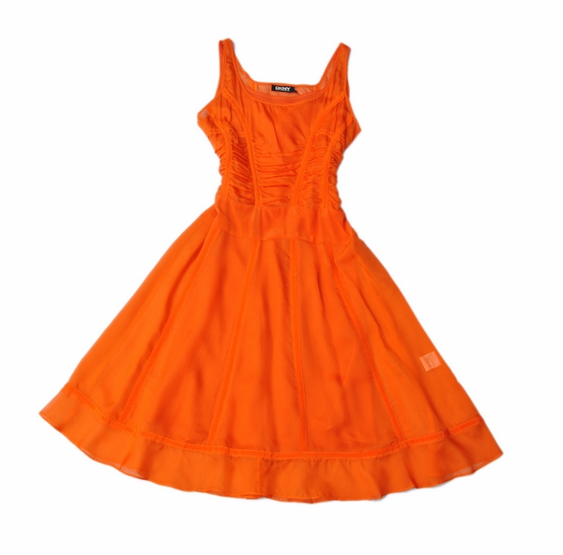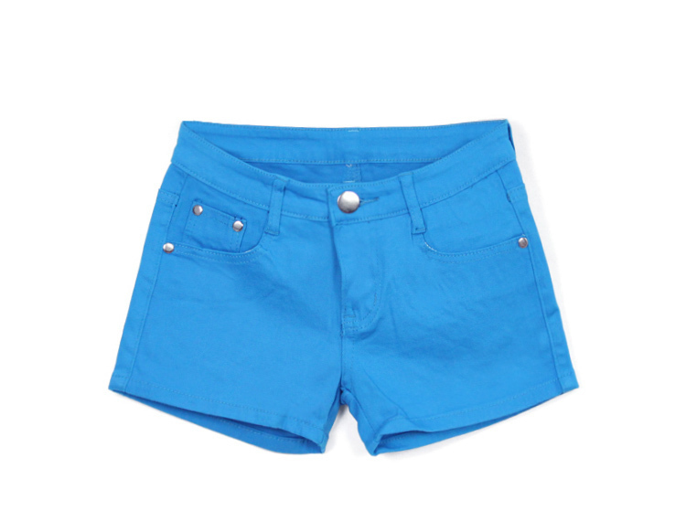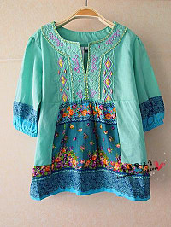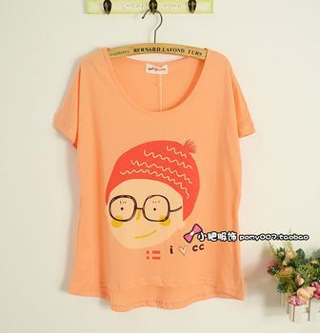
（ ） （ ） （ ） （ ）

- Alice 要和父母去沙滩玩，听一听，她想要什么，请圈出来。（10%）

a.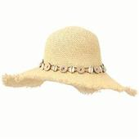 b. 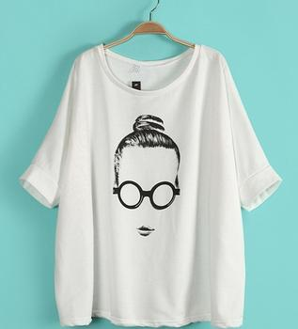 c. 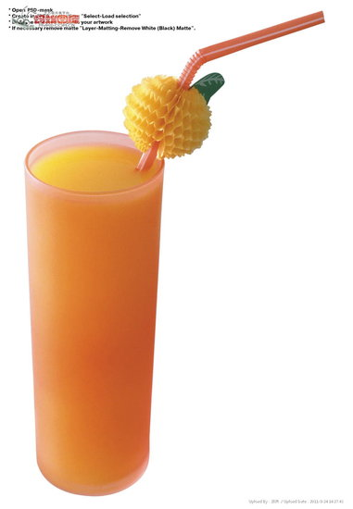 d. 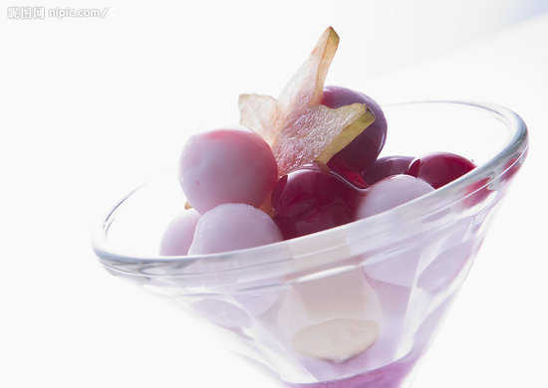

e. f. g. 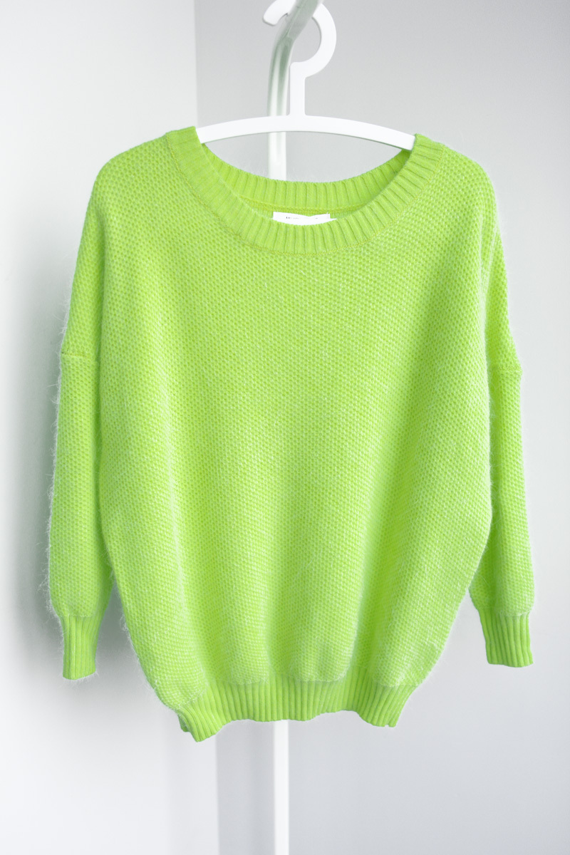 h. 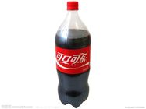
- 请听录音，给下面的图画排序。（10%）

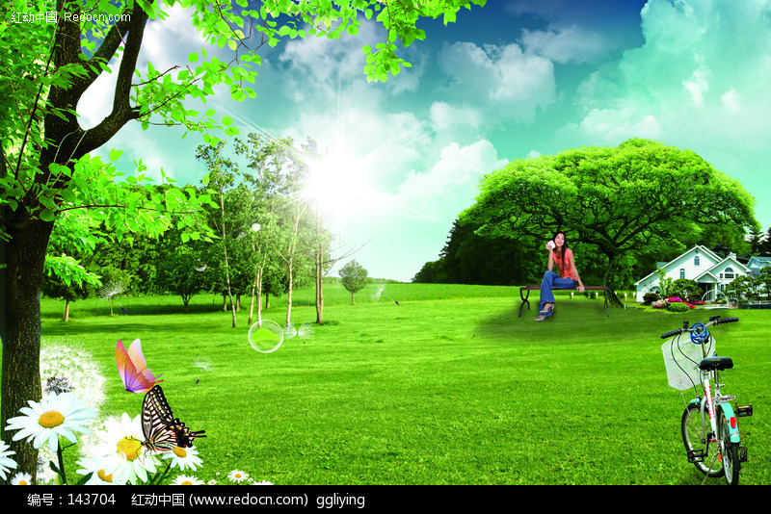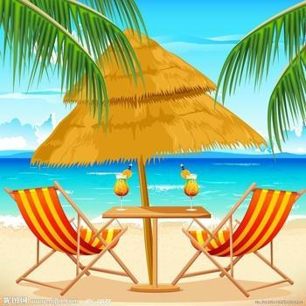
（ ） （ ）
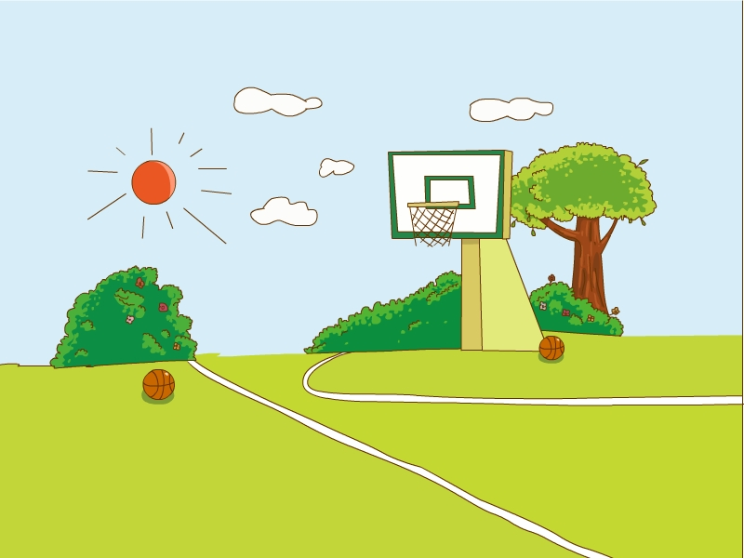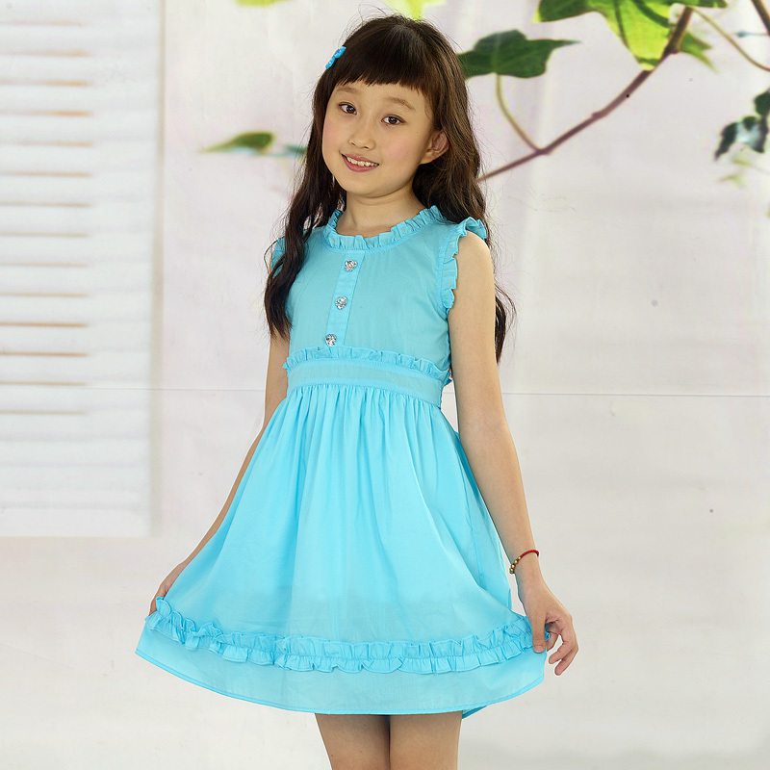
（ ） （ ）

- 请听两段买衣服的对话，勾出正确答案。（10%）

- Kelly needs
a. ( ) a dress b. ( ) a T-shirt c. ( )a blouse

- What colour does she like?
She likes
a. ( ) pink b. ( ) white c.( ) orange

3. Father needs

a. ( ) a dress b. ( ) a T-shirt c. ( )a blouse
4. Father likes

a. ( ) pink b. ( ) white c.( ) red

笔试部分（20%）

- 请看单词画出衣服。(10%)
A . a shirt B. a dress

C. a blouse D. shorts

- 看图，读下面一段话，请将正确的序号填入括号中。(10%)


1. summer 2. spring 3.hot 4. warm 5. shorts 6. T-shirt
7. swimming (游泳)

It is . It is . I need and

a . I like . I am happy.

口语部分（40%）

1. 看图说出单词。（10%）

a b c d

2. 看图，两人小组合作进行对话。(10%)

例句： What do you need?
I need…

- 两人小组合作：请编一个购买衣服的对话并表演。(20%)

单元测评听力材料
一．
1. a sweater
2. shorts.
3. blouse
4.a T-shirt.
二．
Alice and her parents are going to the beach.
Mum: Alice, what do you need?
Alice: It’s very hot. I need a hat. I need a T-shirt.
I need a cup of juice. I need an ice cream!
三．
1. It’s hot. I need a cup of juice.
2.Look at my dress. It’s nice.
3.It’s warm. I need a blouse.
4.Let’s go to the playground. Oh! I need a ball.
四．
1. Shop assistant: Good morning! Can I help you?
Girl :Good morning! I need a dress.
Shop assistant: Look at this blue dress. It’s nice.
Girl : I don’t like blue.
Shop assistant: What colour do you like?
Girl : I like white.
Shop assistant: This white dress is nice.
Girl : OK. I like this white dress.
Mum: How much?
Shop assistant: One hundred.
Mum: OK.

2. Boy: Can I help you?
Father: I need a T-shirt.
Boy: What color do you like?
Father: I like red.
Boy: Here you are.
Father: Thank you. How much is it?
Boy: Ten Yuan.
Father: OK, I need a dress too.
Boy: What colour do you like?
Father: I like purple.
Boy: Here you are. One hundred Yuan.
Father: The total is One hundred and ten. Here you are. Bye bye.
Boy: Bye bye.

