六年级英语试题
（时间：60分钟）
等级：

同学们，你们好！本次英语试题共分为两部分：听力部分和读写部分。听录音前要认真阅读题目要求，仔细观察图片。快来检测一下你有哪些收获吧！

Part I Listening 第一部分 听力

共四大题

I. Listen and choose.（听一听，选出你所听到的单词或词组。）
（ ）1. A. young | B. younger | （ ）2. A. show | B. shadow
（ ）3. A. broken | B. become | （ ）4. A. smaller | B. stronger
（ ）5. A. hotel | B. hurt | （ ）6. A. went | B. want
（ ）7. A. watched | B. washed | （ ）8. A. camping | B. swimming
（ ）9. A. had a cold | B. hurt my foot | （ ）10. A. drank | B. drink
II. Listen and number.（听录音，标序号。）

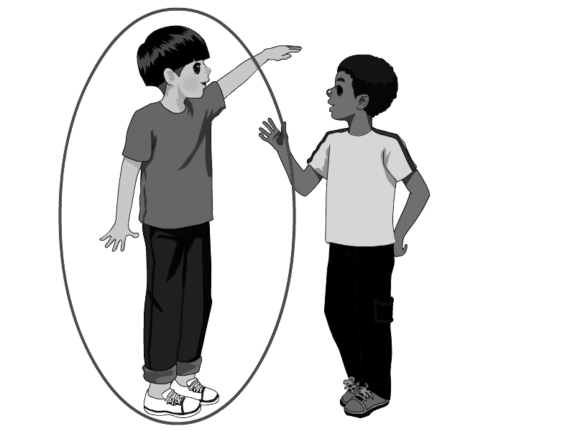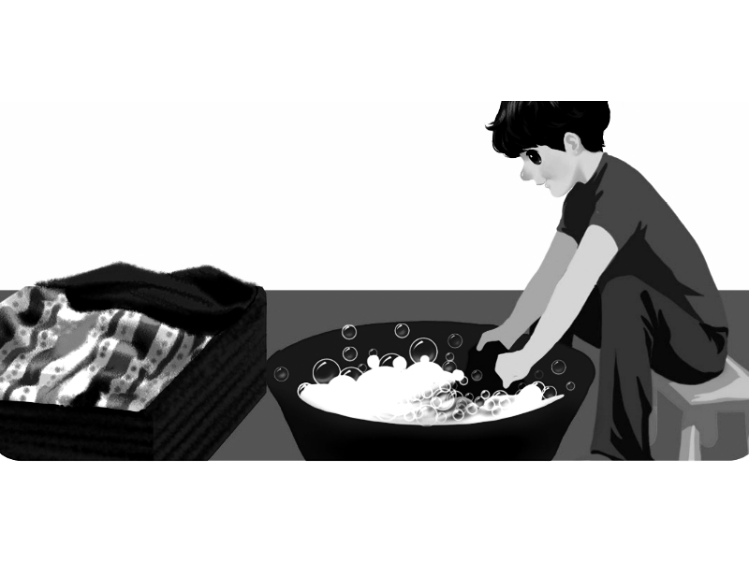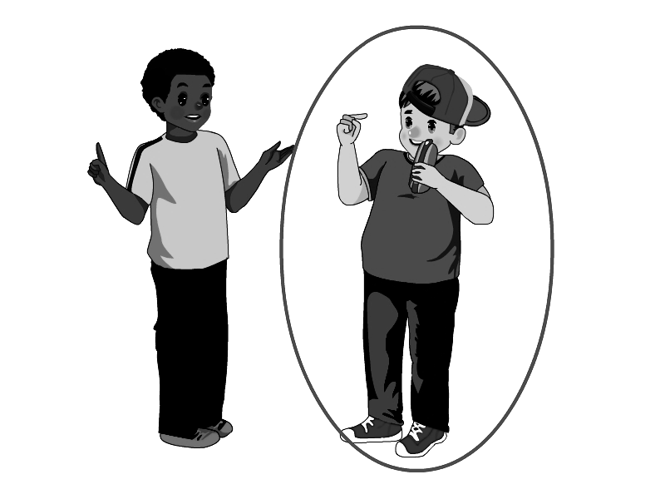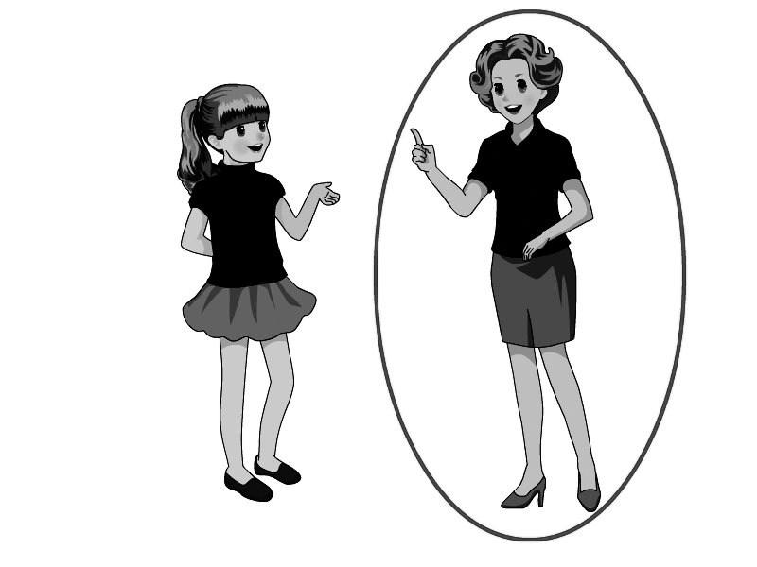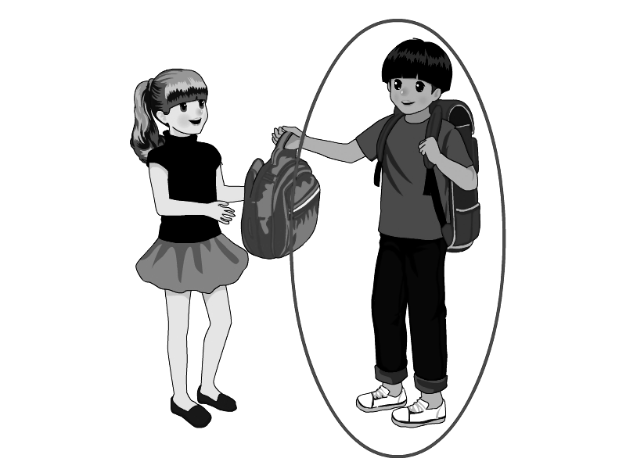
（ ） （ ） （ ） （ ） （ ）

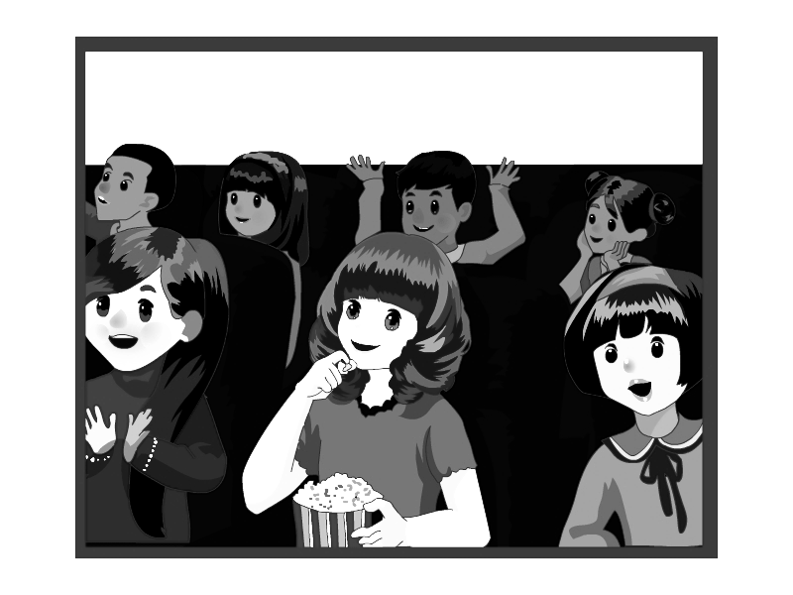
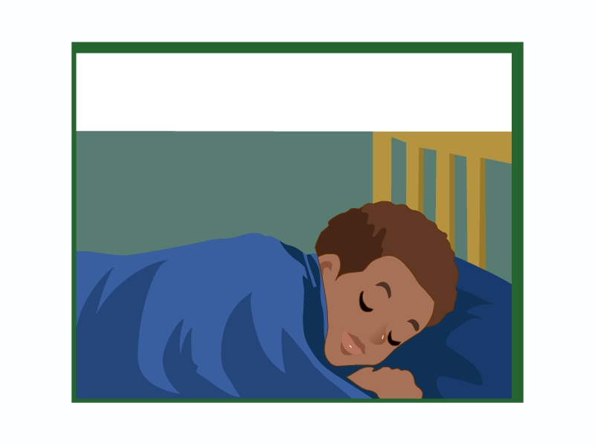
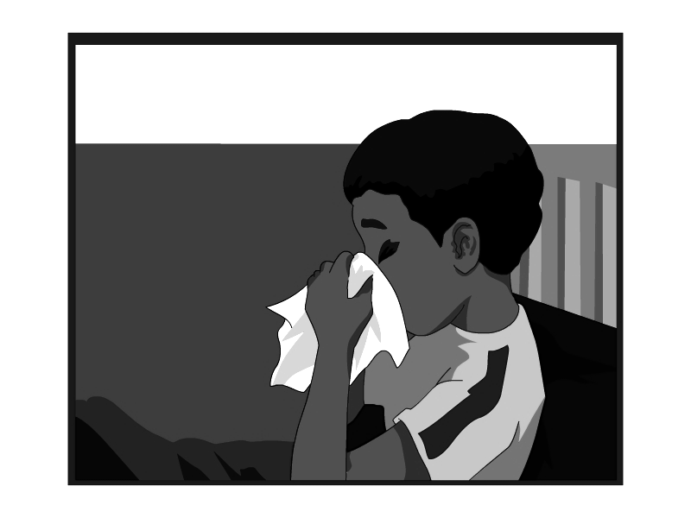
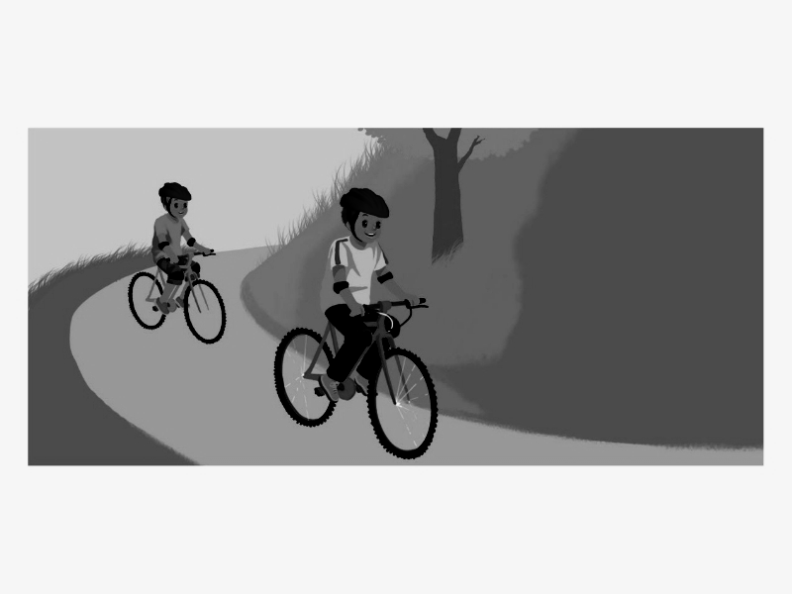
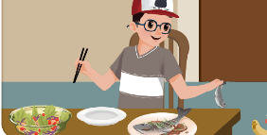
III. Listen and judge. (听录音，判断你所听到的句子是否与图片相符，相符的写”T”，不相符的写“F”。)

1.（ ） 2.（ ） 3.（ ） 4.（ ） 5.（ ）

IV. Listen and fill in the blanks. ( 听录音，补全对话。)

Mike: Hi, Grandpa. How was your weekend?

Grandpa: It was good, thank you.
- watched TV
- washed my clothes
- cleaned my room
- drank tea
- stayed at home

Mike: What did you do?

Grandpa: Well, I with your grandma. We

in the afternoon and .

What about you?

Mike: Err, I was busy. I and .

Grandpa: You are a good boy!

Part II Reading and writing 第二部分 读写
共六大题

V. Read and find. (找出与所给单词画线部分发音相同的单词。)
( ) 1. face A. dad B. name C. cat
( ) 2. look A. cool B. book C. food
( ) 3. who A. what B. where C. whose
( ) 4.snow A. window B.cow C. now
( ) 5. pen A. red B. he C. me
( ) 6. cap A. grape B. cake C. fat
( ) 7. house A. cloud B. slow C. grow
( ) 8. teacher A. fish B. lunch C. sheep
VI. Read and choose.（读一读，选一选。）
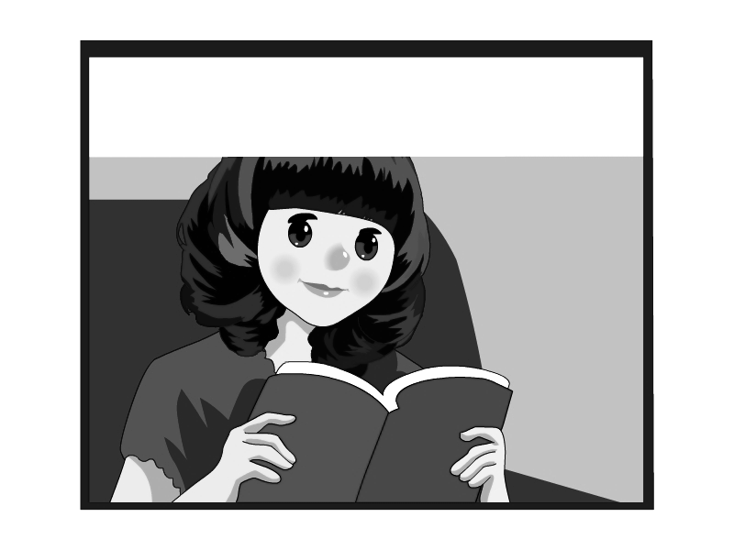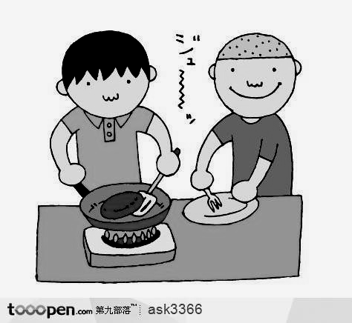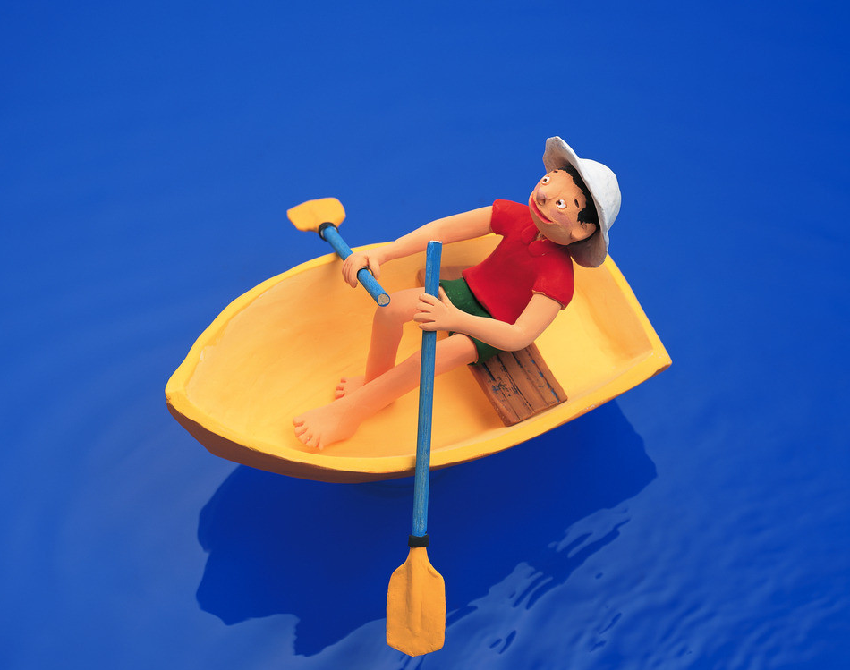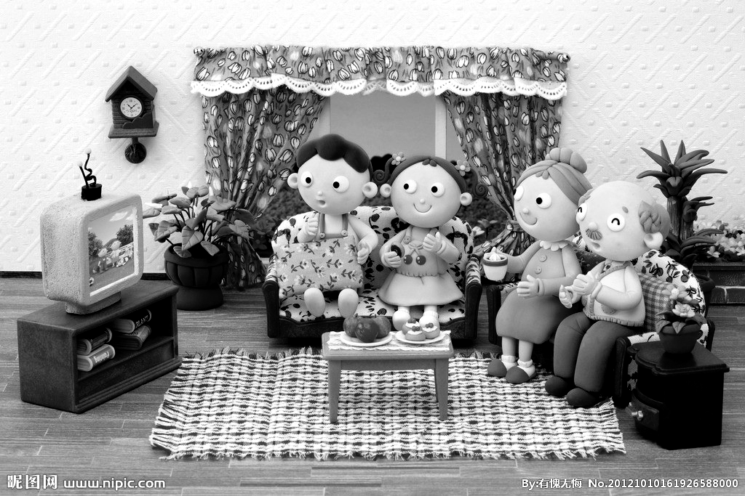
( ) ( ) ( ) ( ) ( )
- Last night my father cooked dinner.
- My sister listened to music.
- Amy read a book last Sunday.
- John went boating last Labour Day holiday.
- My family watched TV together.
VII. Read, circle and write.（读一读，圈一圈，写一写。）
1. A: How (heavier / heavy) is Tom?
B: He is 48 kilograms.
2. My hands are (bigger/ big) than yours.
3. A: What did you do the day before yesterday?
B: I (study / studied) English at home.
4. I’m (thin / thinner) than you.
5. A: (What / How) old are you?
B: I’m 12 years old.
6. I’m (longer \ stronger) than my brother.

VIII. Read and choose. （单项选择。）
( ) 1. A: What size are your shoes? B: .
A. Size 37. B. I’m 48 kilograms. C. I’m 1.60metres.
( ) 2. A: is stronger than you? B: My father.
A. How B. What C. Who
( ) 3. A: I’m 12. You’re 13. I’m one year than you.
B: Yes, you’re right.
A. younger B. older C. young
( ) 4. A: How was your last Saturday? B: .
A. I’m fine, thanks. B. I stayed at home. C. It was good.
( ) 5. It’s than walking.
A. faster B. fast C. the faster.
( ) 6. A: Did she have a cold yesterday? B: .
A. Yes, she didn’t. B. No, I didn’t. C. No, she didn’t.
( ) 7. A: What did you do the day before yesterday? B: .
A. He watched TV B. Amy stayed at home. C. I played football.
( ) 8. A: Did Amy a film yesterday?
A. saw B. see C. seed
( ) 9. A: Where did you go last year?
B: .
A. He went shopping. B. I went to Xinjiang. C. She goes to Beijing.
( ) 10. A: ?
B: Yes, I did.
A. Did you go fishing yesterday?
B. Do you usually go fishing on the weekend?
C. Are you listening to music?

IX. Read and match.（读一读，连一连。）
Whose shoes are bigger, Mike’s or Jim’s? She’s a doctor.
Did you go to the bookstore last Monday? Yes, it was.
How do you feel now? I feel better now.
Was it interesting? Mike’s.
What does your mother do? Yes, I did.

X. Read and write.（阅读短文，完成下面的问题。）
My name is Lin Ling. I’m 12 years old. My friend Chen Ping is one year younger than me. Last months, we bought shoes together for our holiday. I wear size 36, she wear size 37. We bought the same style. On the holiday, we went to a beautiful small village by train .We arrived on Monday and ate some fresh fish from the lake. On Tuesday we had some tasty fruit. Grapes are my favourite. On Wednesday we tasted some new vegetables. On Thursday I drank some carrot juice. It was fresh and healthy. On Friday I went hiking with my friends. I was very happy this holiday.
- How old is Lin Ling?
____________________________________________________
- Are Chen Ping’s feet bigger than Lin Ling’s?
_______________________________________________________
- How did they go to the village？
_______________________________________________________
- What did they do on Tuesday?
________________________________________________________
- Did they go hiking on Friday?

六年级英语评分标准及部分参考答案
听 力
I．（每小题1分，计10分）
1-5 B A B A B 6-10 A A A A B

II．（每小题2分，计10分）
4 2 5 1 3

III．（每小题2分，计10分）
F T T T F

IV．（每小题2分，计10分）
E D A B C
读 写

V．（每小题1分，计8分）
B B C A A C A B
VI．（每小题2分，计10分）

C A D B E
VII．（每小题2分，计12分。圈对得1分，书写正确得1分。）

1. heavy 2. bigger 3. studied 4. thinner 5. How 6.stronger

VIII．（每小题1分，计10分）

1-5 ACACA 6-10 CCBB A

IX．（每小题2分，计10分）

略。

X．（每小题2分，计10分）

1. She’s 12 years old.

2. Yes, they are.

3. They went to the village by train.

4. They tasted some new vegetables.

5.Yes, they did.

（注：可编辑下载，若有不当之处，请指正，谢谢!）

