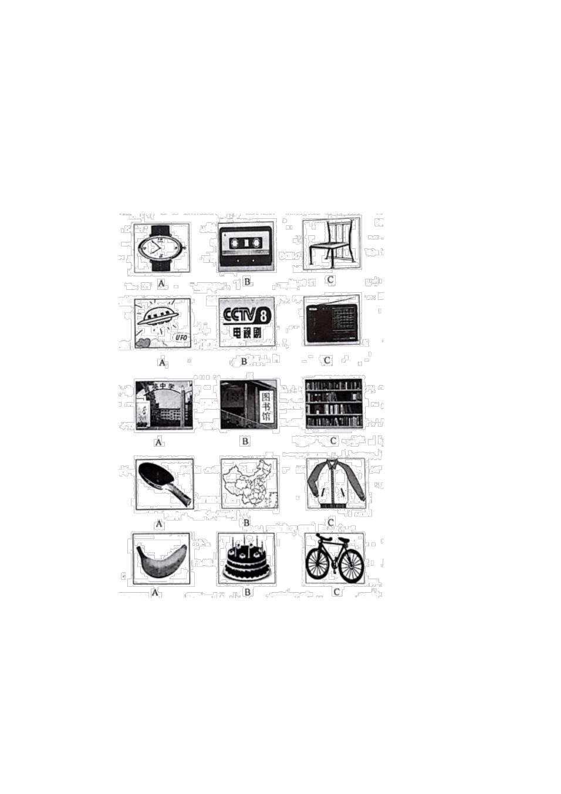

2019 学年度第一学期期末质量检测

六年级英语试题

本试卷分第 I 卷( 选择题 ) 和第 II 卷( 非选择題 ) 两部分。第 I 卷 1 至 6 页，第 II 卷 7 至 8 页，共 120 分。考试

时间 120 分钟。

注意事项 : 请考生认真阅读答题卡上的注意事项。并务必依据有关要求作答。

第 1 卷( 选择题共

75 分)

第一部分听力 ( 共

20 小题:

每题

1 分，满分

20 分)

( 一) 听录音，

符合的图片， 每

选择与你所听到的选项意思

小题读两遍。 (5 分 )

1.

2

3.

4.

5. .

听录音， 选择正确的应答语。 每题读两遍每段对话读两遍。

你将有

20 秒钟的时间阅读下边

5 个小题。 (5

分)

6. A.No, he isn't. B.Yes, he does. C.Yes, Ido.

- A.No.Your skirt is nice. B.The same to you! C.I hank you!

8.A.Hamburgers.B.Apples.C.Milk.

9.A.Yes, they do. B.No, they don't. C.Yes, they

10.A.I'm fine,thank you. B.She is fine, thanks. C.I'm

are.

Jack.



( 三 ) 听五段小对话，选择正确选项每段对话读两遍。你将有 |  |  |  |  |  | 20 秒钟的时间阅读下边 | 5 个小题。 (5 | 分 )
11.What | is | the | boy's last | name?
A.Smith |  | B.Green |  | C.Brown
12.What's the boy's first name?
A.Tom |  | B.Alan |  | C.Mike
l3.What is the girl's telephone number?
A.694-3791 |  | B.385-3791 |  | C.385-2607
14.What color |  | is the girl's bike?
A.Blue |  | B.Black |  | C.Brown
15.What | is thegirl's name?
A.Cindy |  | B.Dale |  | C.Jenny
( 四 ) 录音中有一篇短文 , 短文听两遍， 而后依据短文选择正确答案。 你将有 20 秒钟的时间阅读下边 |  |  |  |  |  |  |  | 5 个小题。
(5 分)
16.What does Mike like?
A.hamburgers |  | B.salad |  | C.hamburgers |  | and salad
17.Who likes |  | ice | cream?
A.Mike's | brother |  | B.Mike | C.Mike's |  | sister
18.When | is | Milk's | mother's | birthday?
A.January21st |  | B.January |  | I1th | C.January22nd
19.Where | is | the | birthday | cake?
A.On the | chair. |  | B.Under | the | table. C.Onthe | table.

- How much is the cake?

A.7 dollars | B.6 | dollars | C.I1dollars
第二部分语言知识运用 |  | ( 共两节，满分 | 25 分)
第一节语音、语法和词汇 |  | (共 15 小题; 每题 1 分，满分 |  | 15 分)
语音知识

选出 21-25 小题的单词中划线部散发音独出心裁的一项。

 | B.back | C.Dale |  | D.f1ag
 | B.luck | C.study | D.pupil
 | B.cups | C.photos |  | D.desks
24. A.book | B.school C.foot |  |  | D.look
 | B.bear | C.pear |  | D.wear
语法和词汇
26.-Alice, | do | you spell |  | ” clock ” ?

- C-L-O-C-K.

A.what

B.how C.who

D.what

color

27.Three

oranges. in

the box,and

some bread___on

the

table.

A.is,is

B.is,are C.are,is

D.are,are

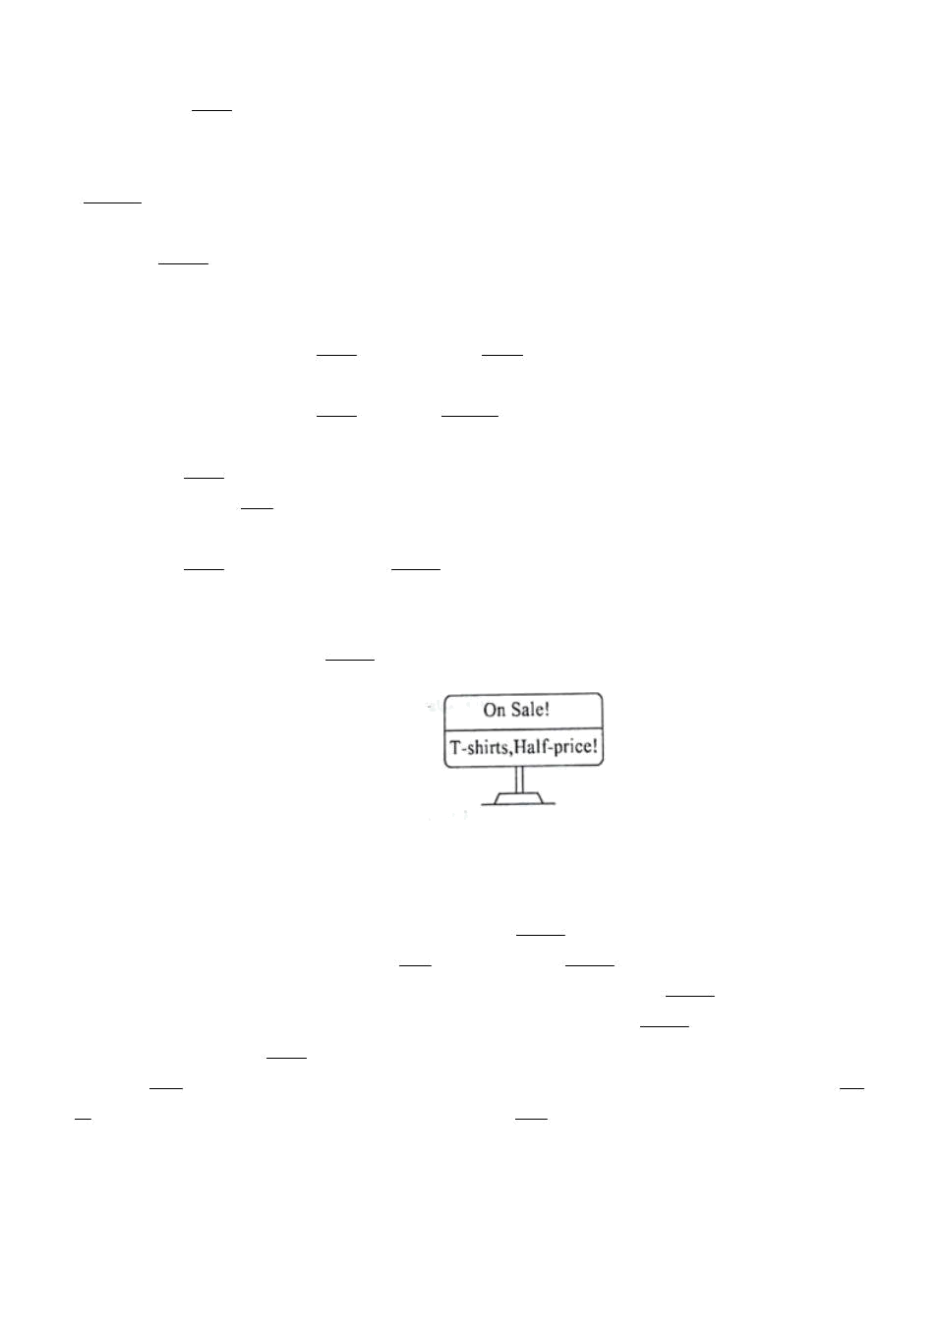

28.It's rally to be alone at home. I like staying with

A.fun B.boring C.interesting D.interested

29.-What's your telephone number?

my friends.

- 6780998.

A.It's |  | B.It's |  |  |  | at C.Its |  |  | D.At
30.-Let's |  |  | basketball.
-Good idea.
A.play |  | B.play the |  |  | C.playing |  | D.to |  |  |  |  | play | the
31.Mom,I'm old enough to wash |  |  |  |  |  |  | own clothes and |  |  |  | You can have a rest after work
A.my; |  | your B.my;yours |  |  |  | C.your; |  |  | my | D.yours;mine
32.I like |  |  | the | model |  | plane, |  | my brother |  |  | .
A. | but; |  | isn't | B. |  | and; | isn't |  | C.but; |  | doesn't | D. | and; doesn't
33.-Tony,here |  |  |  | your bag
-Thank you.And these |  |  |  |  | your |  |  | books.
A.is; |  | are | B.are;is |  |  | C.are;are |  | D.is;is
34.There |  |  | are | months |  | in |  | a | year. | month |  | is | December.
A.twelfth;Twelfth |  |  |  |  | B.twelve |  |  |  |  | ;Twelve
C. | twelfth |  | ;The |  | twelfth |  | D. |  | twelve |  | ;The | twelfth
35.We may |  |  | find the sign |  |  | in a
A.restaurant

- hotel clothes store D.bank

第二节 完形填空 ( 共 10 小题 : 每题 1分. 满分 |  |  |  |  |  |  |  |  |  |  |  |  |  |  |  |  |  | 10 分)
阅读下边短文，掌握其粗心，而后从每题所给的 |  |  |  |  |  |  |  |  |  |  |  |  | 四个选项中 , 选出能填
入短文相应空白处的最正确选项，并在答题卡大将该项涂黑。
 | I'm | Ann. |  | I'm | English. |  | I'm | twelve. |  | I was |  | born |  | 36 | May |  | 17th, | 2006. |  | I learn |  |  | Chines
e | at Beijing |  |  | No.3 Middle |  |  | School. |  | I | 37a | good |  | friend. |  |  | 38 | name is |  | Lucy. |  | She |  | is | 3
9 | too | We are in |  |  | the | same |  | grade. | But |  | we | are not |  |  | in | the same 40 . |  |  |  |  | I'm | in | Clas
s | Two, |  | and | she | is in Class Three. |  |  |  |  | We | have |  | the | same |  | Chinese |  | 41 | Her | name |  | is | Zhan
g | Ying. |  | We | all | like | 42 Lucy's |  |  | parents |  | are |  | both | English |  |  | teachers |  | in | China. |  |  | And | sh
e | has | a | 43.Her |  | name | is | Lily. |  | She | is only |  |  | five | years |  |  | old. | Lucy | and |  | I both |  | like | 4
4 | ,but |  | we | don't | play | them--We |  |  | only | watch |  | them |  | 45TV.
 |  |  | B.in |  | C.on |  | D.for
 |  |  | B.has |  | C.had |  |  | D.am
 |  |  | B.Her |  | C.He |  |  | D.His
 |  |  | B.seven |  | C.twelfth |  |  | D.twelve



B.class C.color D.room

B.brother C.teacher D.family

B.she C.he D.his

B.brother C.daughter D.son

B.painting C.sports D.reading

B.at C.for D.on

第三部分阅读理解 ( 共 20 小题 ; 每题 1.5 分，满分 30 分 )

阅读以下短文，从每题所给的 A.B.C.D 四个选项中，选出能回答所发问题或达成

所给句子的最正确选项，并在答题卡大将该项涂黑。

My | name |  | is | Tom. |  | I'm |  | in | Class |  | 4, | Grade |  | 6. | I'm |  | in | Row | 2. | Tony | is my friend. |  |  | H
e | is | in | my class,too.He is in Row1.My father has a beautiful car .The number is E-053573.His
father
has a beautiful car,too.The number is H-632798.His father often drives him to my home .We ar
e | good |  | friends. |  |  | We | are |  | both |  | fifteen.
46. | Are |  | Tom |  | and | Tony |  | both |  | students?
A. | No, |  | they |  | aren't. |  |  |  | B. |  |  |  | No, | they |  | are.
C. | Yes, |  | they |  | aren't. |  |  |  | D. |  |  |  | Yes, | they |  | are.
47.What row is Tom |  |  |  |  |  | in?
A.He is |  |  | in | Row |  | Four. |  |  | B.He |  |  |  | is | in Row Two.
D. | He |  | is | in Row |  |  | One |  |  |  | D. |  | He |  | is | in | Row Three.
48.What's the number of Tony |  |  |  |  |  |  |  |  | ’s father |  |  | ’ s car?
A.It's |  | E-053573. |  |  |  |  |  |  | B.It's |  |  |  |  | H-632798.
D. It's |  |  | H-632788. |  |  |  |  |  | D.It's |  |  |  |  |  | E-053553.
49.How |  | old |  | is | Tony?
A.He is |  |  | fifteen. |  |  |  |  | B.He is thirteen.
C. He is fourteen. |  |  |  |  |  |  |  | D.He |  |  |  |  | is |  | twelve.
50. What's the number of Tom |  |  |  |  |  |  |  |  | 's |  | father's car? |  |  |  | It's.
A.H,six,three,two,seven,nine,eight
B.E,zero,five,three,five,seven,three
C.E,zero,five,three,five,eight,three
D.H,six,three,three,seven,nine,eight
 |  |  |  | B
Do | you |  | know |  | Alice? |  | She's |  | my |  | friend. |  | She | likes |  |  | sports. |  | She | docs | some | running |  | every
morning. |  |  | She |  | likes |  | playing |  |  | basketball |  |  | and |  | ping-pong |  |  | best.
Her father is a doctor.He lets Alice eat healthy food .Alice like to eat some vegetable and f
ruit. |  | she |  | likes |  | eating |  | some |  | chicken |  |  | and | ice |  | cream, |  | too, | bu | not | much | .Her | favorit
e | foods |  | are apples |  |  | and |  | potatoes. |  |  |  | Does | she |  | like |  | dessert? |  | She | likes | it, | but | doesn'
t | like |  | i | now.

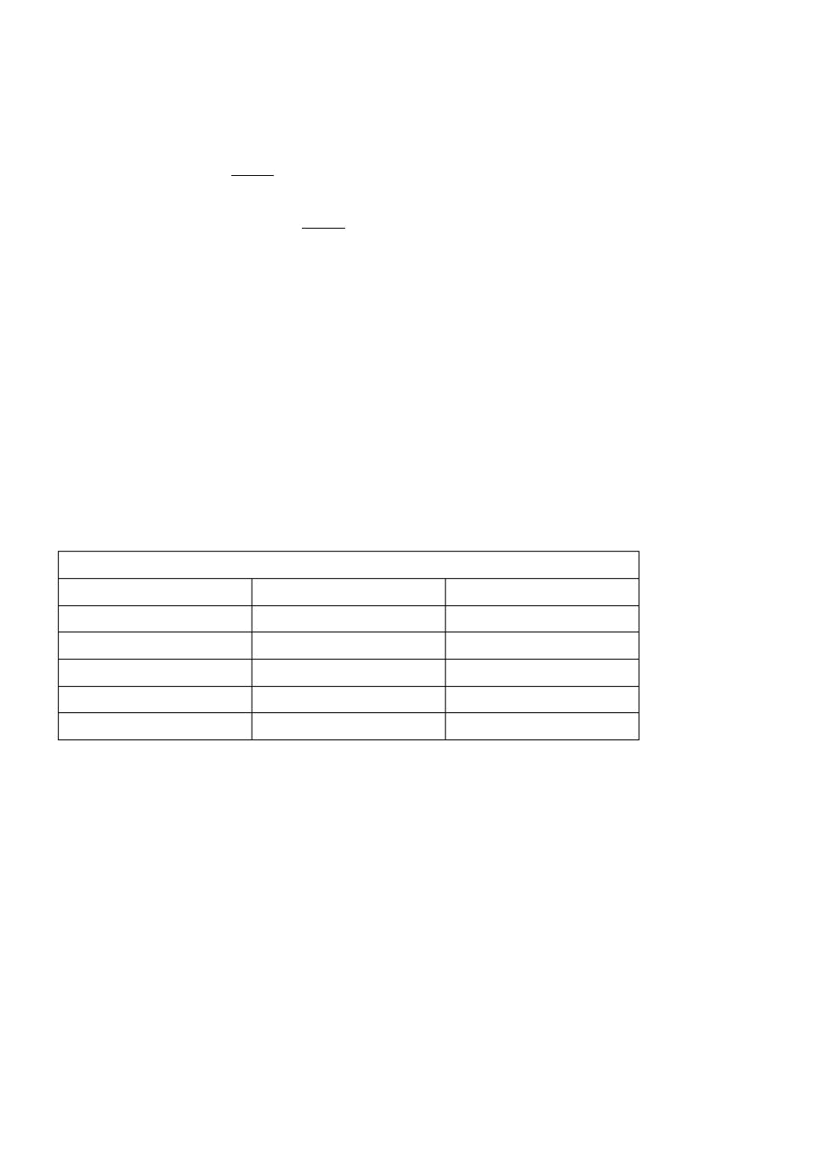

Now | you can |  | know |  | why | the | girl | is | healthy!
51.Alice's |  | favorite |  |  | sports | are_____
A.baseball |  | B.ping-pong |  | C.basketball |  |  |  |  | and ping-pong D.volleyball
52.Alice's father is a
A.doctor |  | B.teacher |  | C.worker |  | D.friend
53.Alice's |  | favorite |  |  | fruit | are
A.tomatoes |  | B.apples |  | C.chicken. |  |  | D.dessert
54.Why | is | Alice | healthy?
A.Because |  | she | likes |  | ice | creams.
B.Because |  | she | doesn't |  | eat | vegetables.
C.Because |  | she | likes |  | sports and |  | often |  | eats vegetables and | fruit.
D.Because |  | she | likes |  | dessert.

55.Which | is right according to |  |  |  | the | passage?
A.Alice | likes | eating |  | hamburgers |  | and ice | cream.
B.Alice doesn't like dessert now
C. Alice | doesn't |  | run | in | the morning.
D.Alice's | father |  | is | a teacher.
 |  |  |  |  | C
 |  |  |  | Fashion |  | Clothes | Store
Clothes |  |  |  | Color |  |  | Price
Socks |  |  |  | white,black |  |  | $2
Sweater |  |  |  | red,white |  |  | $15
Trousers |  |  |  | black |  |  | $11
T-shirt |  |  |  | red,green,black |  |  | $17
Skirt |  |  |  | black,red,white |  |  | $20
56. Which is the cheapest( |  |  |  | 最廉价的 )of all?
A.Skit. | B.T-shirts. |  | C.Trousers. |  | D.Socks.

- How much are two sweaters and a skirt?

A.$55.B.$35.C.$50.D.$20.

58.What can you buy in Fashion Clothes Store?

A.Black |  | trousers. |  |  | B.A |  |  | blue | sweater.
C.A | blue | skirt. |  |  | D.Red |  |  | socks.
59. | You | like | red and |  |  | you | only | have | $15. | You can buy
A.a | sweater |  | B.a skirt |  | C.a |  |  | T-shirt |  | D.trousers
60.What |  | can | you | buy if you |  |  | have | $28?
A.A | sweater |  | and | a | pair | of trousers.
B.Two | T-shirts |  |  | and | a | pair | of socks.

C.Two sweaters.


D.A |  | sweater |  |  | and | two |  | skirts.
 |  |  |  |  |  |  |  |  |  | D
 |  | Vera | is |  | thirteen |  |  | years |  | old. | She |  | was born |  |  | on | December |  | 27th.Mrs |  | Smith |  | is | her | mo
ther |  | Today is |  |  | Vera's |  |  | birthday. |  |  | There |  | is | a | party |  | for | her | Lots | of | her | friends |  | com
e | to her |  |  | birthday |  |  | party. |  |  | A birthday |  |  | cake |  | is | on | the | table. | There |  | are | some |  | banana
s. |  | oranges, |  |  | strawberries |  |  |  | and apples |  |  |  | on | the table, |  |  | too. | But | Vera doesn't |  |  |  | like | the
m. .What does she |  |  |  |  |  |  | want? |  | Car |  | you | guess?
Just |  |  | then |  | Vera | sees |  | a | red |  | card | in |  | her | mother's |  | hand. |  | It | says: | Happy |  | birthday |  | t
o | you, |  | dear Vera. |  |  |  | There |  | is | a | nice |  | present( |  | 礼品 )for |  | you. Open |  |  | the | box | on | your dres
ser |  | and you |  |  | can | find |  | it.
Vera |  |  | runs |  | to | her | dresser |  |  | and opens |  |  |  | the | box | Ah, a |  | nice | T-shirt! |  | How |  | glad | she | i
s!
61.Vera was born on
A.November |  |  |  | 27th |  |  | B.September |  |  |  |  |  |  | 27th
C.December |  |  |  | 27th |  |  | D.December |  |  |  |  |  |  | 29th
62.Mrs |  |  | Smith's |  | present |  |  | is
A.on |  | the |  | desk |  |  | B.in |  |  |  | the |  | box
C.on |  | the |  | table |  |  | D.in |  |  |  | the |  | drawer
63.Vera |  |  | wants
A.apples |  |  | B.bananas |  |  | C.a T-shirt |  |  |  |  |  |  | D.a book
64.Vera |  |  | is | years |  |  |  | old.
A. |  | 13 | B.14 |  | C.15 |  |  | D.16
65.There |  |  | aren't on the table.
A.apples |  |  | B.strawberries |  |  |  | C.oranges |  |  |  | D.books
 |  |  |  |  |  | 第 II |  | 卷 ( 非选择题共 45 |  |  |  |  | 分 )
第四部分 |  |  | 书面表达 ( 共三节 )
第一节词汇 ( 短语 ) |  |  |  |  |  | 运用 ( 共三题，满分 |  |  |  |  | 20分)
(一)单词拼写 (共 5小题 : |  |  |  |  |  |  |  | 每题 |  | 1 分，满分 |  |  | 5 分 )

依据句意和首字母或汉语提示，将单词的正确形式完好地写在答题卡相应的地点上。

- My P number is 281-9178.

67.Running is good |  | for our h
68.I like sports because it |  |  | ’s | ( | 令人放松的 ).
69.This | is not | his | bedroom.It's m
70.What's | this | in | English? | It'san | o
( 二) 补全句子 (共 5 小题 ; 每题 |  |  |  | 1 分，每空 | 0.5 分; | 满分 5分)

依据汉语提示，将下边的句子增补完好。

- 这两位女孩是我的妹妹和表妹。

These two girls are my and my
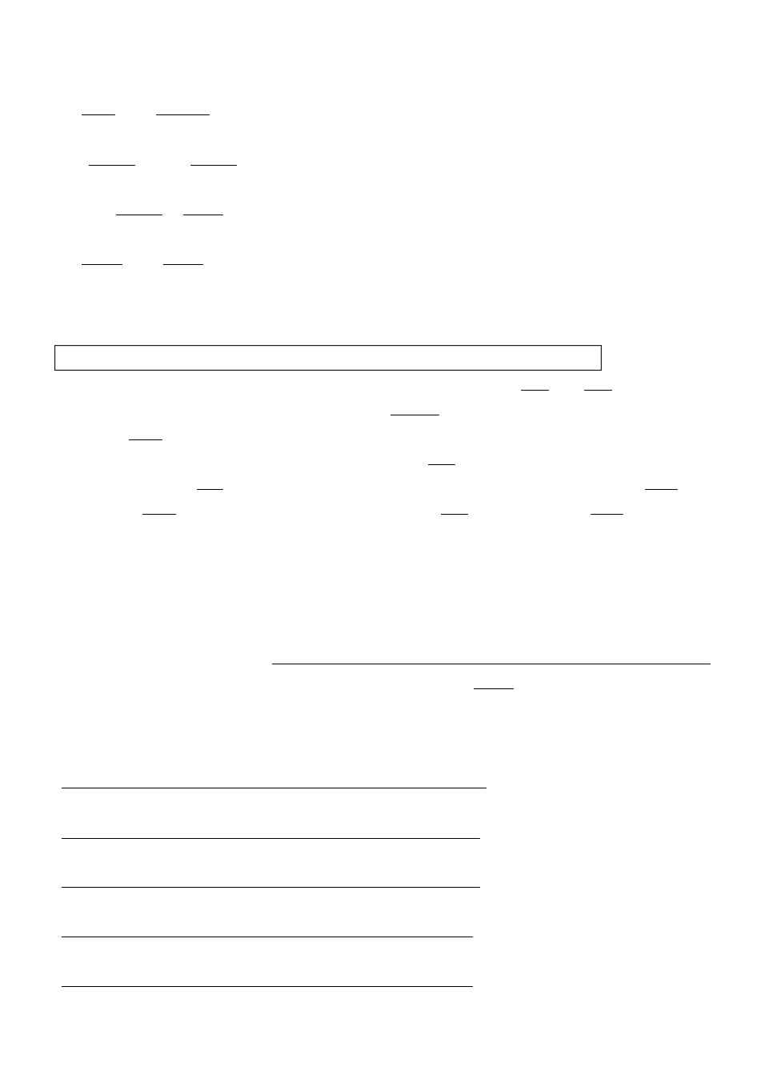

- 这支黑色的钢笔是他的。

The pen is

- 她的房间很整齐 .

Her is very

- 他喜爱面包和牛奶。

He likes and .

75. 这件夹克衫多少钱 ?

How is the .

( 三) 综合填空 (共 10 小题 ; 每题 1 分，满分 10 分)

依据短文内容，用方框中所给词语的适合形式填空 , 使文章通畅、完好。 ( 每词限用一次 )

 |  |  |  | In his last be here |  |  |  |  |  | girl |  | her |  | color who cousin
Hi,I'm |  | Jack |  | Smith. | Jack |  | is |  | my | firs |  | name, |  |  | and | Smith is my 76 name. 77 are two photo
s. | In | the | first |  | photo, |  | you |  | can | see |  |  | two 78 |  |  | The |  | girl | in | the | red |  | jacket |  | is | m
y | sister. 79 |  |  | .name
is | Jane. |  | The girl |  | in |  | the | yellow |  |  | jacket |  |  | is | my | 80. |  | She | is | my | aunt's |  |  | daughter. |  | I
n | the | next |  | photo 81 |  | a | girl |  | and | a | boy. |  |  | The | girl is |  |  | my | cousin, |  | too | She |  | is | 82 a | b
lue | jacket. |  |  | 83 is | the | boy? |  | He is |  | my |  | good |  | friend. 84 name |  |  |  |  | is | Mike.The |  |  | 85 of |  | his | jac
ket | is | black.
第三节 阅读表达 (共 5小题: |  |  |  |  |  |  | 每题 |  | 2 分,满分 10 |  |  |  | 分)
阅读下边的短文，并依据文章后的要求答题。 |  |  |  |  |  |  |  |  |  |  | ( 请注意问题后的词数要求缩写词按一个单词记数 |  |  |  |  |  |  |  |  |  |  |  |  | )
Hello! |  | My | name is |  | Mike. |  | I am |  | from |  | the |  | USA. |  | Now | I am |  | in | China |  | with |  | my | parents. |  | I
like China. |  |  |  | I like | Chinese |  |  | food,too |  |  | I have |  |  | breakfast |  |  | a | home. |  | I have |  | an | egg |  | and | bre
ad. | Ido | not |  | like milk.(88) |  |  |  | I have no time to go home |  |  |  |  |  |  |  | for |  | lunch, |  | so | I have |  |  | it at school.
The lunch |  |  | in | our | school is good.I can have different food |  |  |  |  |  |  |  |  |  |  |  |  | 89 _I eat rice,meat,and vegetab
les.Sometimes I have noodles and dumplings.I have dinner at home with my parents .we have fish ,
meat,vegetables and |  |  |  |  | fruit. |  | Sometimes |  |  |  | we | go out |  |  | to | eat | with |  | our | friends.
86.Where |  | does |  | Mike | have |  | breakfast? |  |  |  | ( 不超出 |  |  | 6个单词)

87. What does Mike have for breakfast? ( 不超出 6 个单词 )

- 把划线句子翻译成汉语。

88. 用适合的词填空。 ( 不超出 1 个单词 )

90.Who does Mike have dinner with? ( 不超出 6 个单词 )

第三节写作 ( 共 1 题，满分 15 分 )

假定你是 LiMing, 请素来你家做客的朋友 Tom介绍你的全家福，照片中有你的父亲、母亲和你自己。而后向他

分别介绍你们全家人喜爱的颜色、运动、和食品等。

注意事项 :

- 语句通畅，书写工整。

- 重点不要遗漏，可适合发挥使行文通畅。

- 字数 : 60 词左右。

六年级英语试题参照答案

第 I 卷( 选择题共 75 分)

涂卡时注意 : 1-45 每题 1 分 : 46-65 每题 1.5 分 )

1-5BCCBA 6-10BCBCA 10-15ABDBA 16-20CCACA

21-25CDCBA 26-30BCBAA 31-35BCDDC 36-40CABDB

41-45CAACD 46-50DBBAB 51-55CABCB 56-60DCAAA

61-65CBCAD

第 II 卷 ( 非选择题共 45 分）

66.phone 67health |  |  | 68relaxing |  | 69 | 70 |  | .orange
 |  |  | 72.black,his |  |  | 73.room,tidy |  | 74.bread,milk
 |  | 76.last 77Here |  |  | 78.girls
79.Her | 80.cousin |  | 81. | 82.in
83Who | 84.His |  | 85.color/colour
86.He | has | breakfast |  | at | home./At |  | home.
87.He | has | an | egg | and | bread/An |  | egg | and bread.

- 我没有时间回家吃午饭，因此我在学校吃。

89.lunch

90.He has dinner with his parents./His parents.

第三节写作 ( 共 1 题，满分 15 分 )

One possible version: 略

评分说明 :

- 评分原则

(1) 评分时， 先依据文章的内容和语言初步确立其期强品位 , 而后以该品位的要求来权衡， 确立或调整品位， 最

后给分。

(2) 评分时，应注意的主要内容为 : 内容重点、应用同汇和语法构造的数目和正确性及上下文的连接性。

- 拼写与标点符号是语言正确性的一个方面，评分时。应视其对社交的影响程度予以考虑。

- 假如书写较差，以致觉响社交，将分数降低一个品位。

2、各品位的给分范围和要求

第一档 (13-15 分 )

很好地达成了试题规定的任务。

覆盖全部内容重点 ; 应用了较丰富的语法构造和词汇 ; 用词正确、句子通順、行文连接、表达清楚，没有或

基本没有语言错误 : 书写工整 : 字数切合要求。完好达到了预期的写作目的。

第二挡 (10-12

分 )

较好地达成了试题规定的任务。

虽遗漏 1、 2 个次重点，但覆盖全部主要内容 ; 应用的语言构造和词汇虽不太丰富，但能知足任务的要求

子较通畅、表达较清楚 ; 有少许语言错误 ; 书写工整 ; 字数基本切合要求。达到了预期的写作目的。

; 句

第三档 (7-9

分 ) 基本达成了试题规定的任务。

虽遗漏一些内容，但覆盖全部主要内容

; 应用的语言构造单调

; 句子不够通畅，行文不够连接

; 语言错误许多

:

书写不够工整，字数较少。整体而言，基本达到了预期的写作目的。

第四档 (0-6 分 ) 未适合达成试题规定的任务。

遗漏或未描绘清楚一些主要内容， 写了一些没关内容 ; 应用的语言构造单调且不规范 ; 句子不通畅， 行文不连接 ;

语言错误多 ; 书写潦草，字数不足 50。信息未能清楚地传达给读者。

